**Unit circle**

Fill in the coordinate pairs of the standard angles, (cos θ, sin θ). Use exact values (radicals and fractions, not decimal approximations). Complete the missing angles.

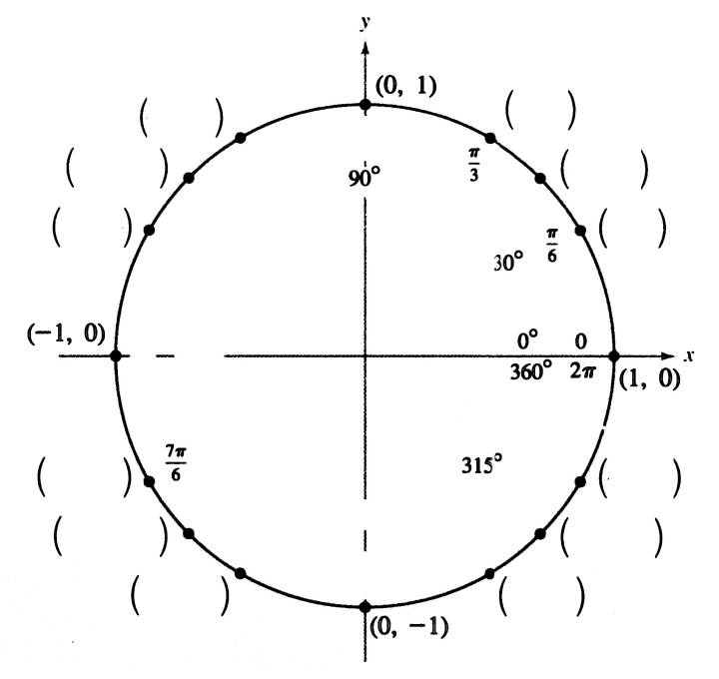

1. 2.

3. 4.

Sinusoidal graph

1. a) Mark the x-axis with degree units from 0 to 360 degrees.

b) Add another set of x values, in radians.

c) Plot points representing the sine values of each angle.

2π

360

180

*x*

*y*