# 1-1_P1_Algebra-sequences

**1a.** *[2 marks]*

In an arithmetic sequence, the first term is 3 and the second term is 7.

Find the common difference.

**1b.** *[2 marks]*

Find the tenth term.

**1c.** *[2 marks]*

Find the sum of the first ten terms of the sequence.

**2a.** *[2 marks]*

In an arithmetic sequence, the first term is 8 and the second term is 5.

Find the common difference.

**2b.** *[2 marks]*

Find the tenth term.

**2c.** *[2 marks]*

Find the sum of the first ten terms.

**3a.** *[2 marks]*

In an arithmetic sequence, the first term is 2 and the second term is 5.

Find the common difference.

**3b.** *[2 marks]*

Find the eighth term.

**3c.** *[2 marks]*

Find the sum of the first eight terms of the sequence.

**4a.** *[2 marks]*

In an arithmetic sequence,  and  .

Find *d* .

**4b.** *[2 marks]*

Find  .

**4c.** *[2 marks]*

Find  .

**5.** *[6 marks]*

Three consecutive terms of a geometric sequence are , 6 and .

Find the possible values of .

**6a.** *[2 marks]*

In an arithmetic sequence, the third term is 10 and the fifth term is 16.

Find the common difference.

**6b.** *[2 marks]*

Find the first term.

**6c.** *[3 marks]*

Find the sum of the first 20 terms of the sequence.

**7a.** *[1 mark]*

Consider the infinite geometric sequence  .

Write down the 10th term of the sequence. Do not simplify your answer.

**7b.** *[4 marks]*

Consider the infinite geometric sequence  .

Find the sum of the infinite sequence.

**8a.** *[1 mark]*

The first three terms of an infinite geometric sequence are 32, 16 and 8.

Write down the value of *r* .

**8b.** *[2 marks]*

Find  .

**8c.** *[2 marks]*

Find the sum to infinity of this sequence.

**9a.** *[3 marks]*

Consider the following sequence of figures.

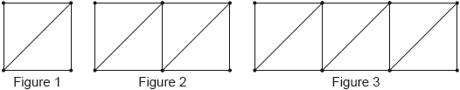

Figure 1 contains 5 line segments.

Given that Figure  contains 801 line segments, show that .

**9b.** *[3 marks]*

Find the total number of line segments in the first 200 figures.

**10a.** *[3 marks]*

Consider the arithmetic sequence  .

Find  .

**10b.** *[3 marks]*

Consider the arithmetic sequence  .

Find the value of *n* so that  .

**11.** *[6 marks]*

An arithmetic sequence has the first term  and a common difference .

The 13th term in the sequence is . Find the value of .

**12a.** *[2 marks]*

An arithmetic sequence has  and , where  and .

Show that .

**12b.** *[6 marks]*

Let  and . Find the value of 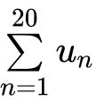.

**13a.** *[3 marks]*

The first three terms of a geometric sequence are , , , for .

Find the common ratio.

**13b.** *[5 marks]*

Solve 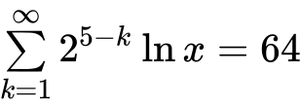.

**14a.** *[5 marks]*

The following diagram shows [AB], with length 2 cm. The line is divided into an infinite number of line segments. The diagram shows the first three segments.

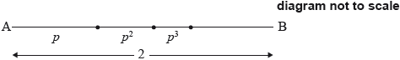

The length of the line segments are , where .

Show that 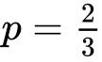.

**14b.** *[9 marks]*

The following diagram shows [CD], with length , where . Squares with side lengths , where , are drawn along [CD]. This process is carried on indefinitely. The diagram shows the first three squares.

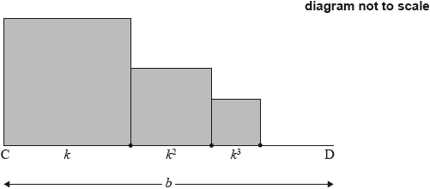

The **total** sum of the areas of all the squares is . Find the value of .

**15a.** *[2 marks]*

The first two terms of an infinite geometric sequence are *u*1 = 18 and *u*2 = 12sin2 *θ* , where 0 < *θ* < 2 , and *θ* ≠ .

Find an expression for *r* in terms of *θ*.

**15b.** *[3 marks]*

Find the possible values of *r*.

**15c.** *[4 marks]*

Show that the sum of the infinite sequence is 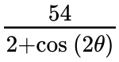.

**15d.** *[6 marks]*

Find the values of *θ* which give the greatest value of the sum.

**16a.** *[2 marks]*

The first two terms of an infinite geometric sequence, in order, are

, where .

Find .

**16b.** *[2 marks]*

Show that the sum of the infinite sequence is .

**16c.** *[4 marks]*

The first three terms of an arithmetic sequence, in order, are

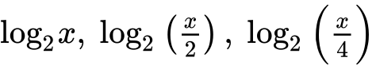, where .

Find , giving your answer as an integer.

**16d.** *[2 marks]*

Let  be the sum of the first 12 terms of the arithmetic sequence.

Show that .

**16e.** *[3 marks]*

Given that  is equal to half the sum of the infinite geometric sequence, find , giving your answer in the form , where .

**17a.** *[2 marks]*

Ann and Bob play a game where they each have an eight-sided die. Ann’s die has three green faces and five red faces; Bob’s die has four green faces and four red faces. They take turns rolling their own die and note what colour faces up. The first player to roll green wins. Ann rolls first. Part of a tree diagram of the game is shown below.

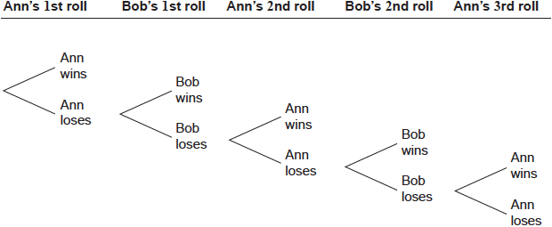

Find the probability that Ann wins on her first roll.

**17b.** *[7 marks]*

Find the probability that Ann wins the game.

**18a.** *[4 marks]*

The sums of the terms of a sequence follow the pattern



Given that , find  and .

**18b.** *[4 marks]*

Find a general expression for .

**19a.** *[4 marks]*

The sides of a square are 16 cm in length. The midpoints of the sides of this square are joined to form a new square and four triangles (diagram 1). The process is repeated twice, as shown in diagrams 2 and 3.

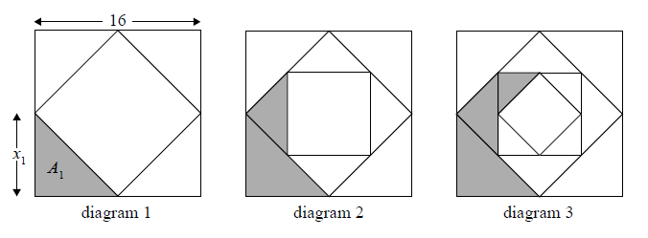

Let  denote the length of one of the equal sides of each new triangle.

Let  denote the area of each new triangle.

The following table gives the values of  and , for . **Copy** and complete the table. *(Do* ***not*** *write on this page.)*



1

2

3



8

4



32

16

**19b.** *[4 marks]*

The process described above is repeated. Find .

**19c.** *[7 marks]*

Consider an initial square of side length . The process described above is repeated indefinitely. The total area of the shaded regions is . Find the value of .

**20a.** *[2 marks]*

The first three terms of a infinite geometric sequence are , where .

Write down an expression for the common ratio, .

**20b.** *[2 marks]*

Hence, show that  satisfies the equation .

**20c.** *[3 marks]*

Find the two possible values of .

**20d.** *[3 marks]*

Find the possible values of .

**20e.** *[3 marks]*

The sequence has a finite sum.

State which value of  leads to this sum **and** justify your answer.

**20f.** *[3 marks]*

The sequence has a finite sum.

Calculate the sum of the sequence.