**3.1, 3.2, & 3.3 Unit Circle Trigonometry-mild (Calculator, Paper 2)**

**1a.** The following diagram shows a circle with centre O and radius 40 cm.

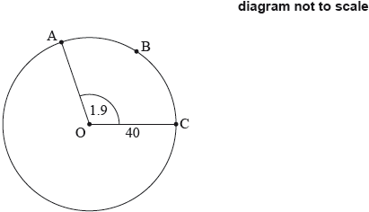

The points A, B and C are on the circumference of the circle and .

Find the length of arc ABC. *[2 marks]*

**1b.** Find the perimeter of sector OABC. *[2 marks]*

**1c.** Find the area of sector OABC. *[2 marks]*

**2a.** The following diagram shows a circle with centre  and radius  cm.

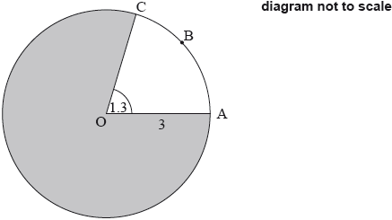

Points A, B, and C lie on the circle, and .

Find the length of arc . *[2 marks]*

**2b.** Find the area of the shaded region. *[4 marks]*

**3a.** The following diagram shows a circle with centre  and radius .

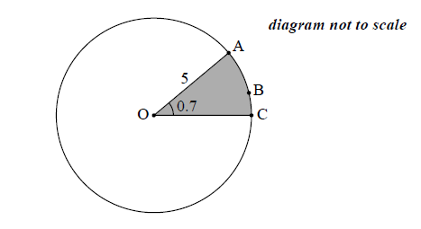

The points A, B, and C lie on the circumference of the circle, and  radians.

Find the length of the arc . *[2 marks]*

**3b.** Find the perimeter of the shaded sector. *[2 marks]*

**3c.** Find the area of the shaded sector. *[2 marks]*

**4a.** The diagram below shows a circle centre O, with radius *r*. The length of arc ABC is  and 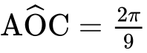.

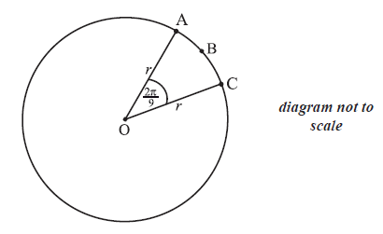

Find the value of *r*. *[2 marks]*

**4b.** Find the perimeter of sector OABC. *[2 marks]*

**4c.** Find the area of sector OABC. *[2 marks]*

**5a.** The circle shown has centre O and radius 3.9 cm.

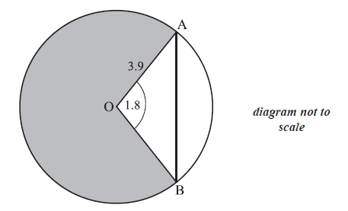

Points A and B lie on the circle and angle AOB is 1.8 radians.

Find AB. *[3 marks]*

**5b.** Find the area of the shaded region. *[4 marks]*

**6a.** The diagram shows a circle, centre O, with radius 4 cm. Points A and B lie on the circumference of the circle and AÔB = *θ* , where 0 ≤ *θ* ≤ .

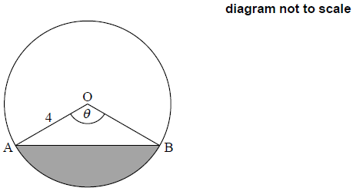

Find the area of the shaded region, in terms of *θ*. *[3 marks]*

**6b.** The area of the shaded region is 12 cm2. Find the value of *θ*. *[3 marks]*

**7a.** The following diagram shows a circle, centre O and radius  mm. The circle is divided into five equal sectors.

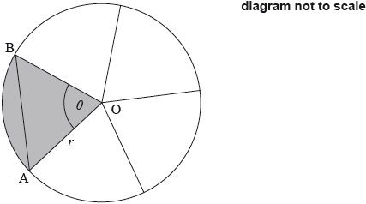

One sector is OAB, and .

Write down the **exact** value of  in radians. *[1 mark]*

**7b.** The area of sector AOB is .

Find the value of . *[3 marks]*

**7c.** Find AB. *[3 marks]*

**8a.** The following diagram shows a circle with centre  and radius  cm.

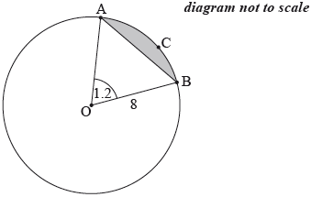

The points ,  and  are on the circumference of the circle, and  radians.

Find the length of arc . *[2 marks]*

**8b.** Find . *[3 marks]*

**8c.** Hence, find the perimeter of the shaded segment . *[2 marks]*

**9a.** Consider the following circle with centre O and radius 6.8 cm.

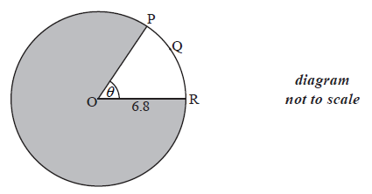

The length of the arc PQR is 8.5 cm.

Find the value of  . *[2 marks]*

**9b.** Find the area of the shaded region. *[4 marks]*

**10.** The following diagram shows the chord [AB] in a circle of radius 8 cm, where .

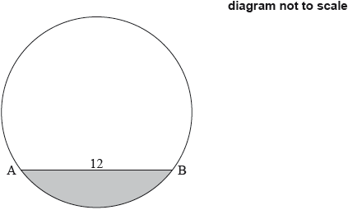

Find the area of the shaded segment. *[7 marks]*

**11a.** A circle centre O and radius  is shown below. The chord [AB] divides the area of the circle into two parts. Angle AOB is  .

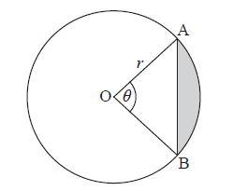

Find an expression for the area of the shaded region. *[3 marks]*

**11b.** The chord [AB] divides the area of the circle in the ratio 1:7. Find the value of . *[5 marks]*

**12a.** The following diagram shows a circle with centre O and radius  cm.

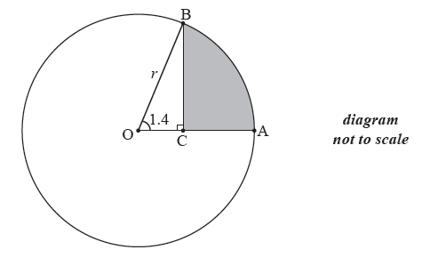

Points A and B are on the circumference of the circle and  radians .

The point C is on [OA] such that 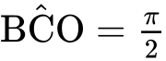 radians .

Show that  . *[1 mark]*

**12b.** The area of the shaded region is  cm2 . Find the value of  . *[7 marks]*

**13a.** The following diagram shows a square , and a sector  of a circle centre , radius . Part of the square is shaded and labelled .

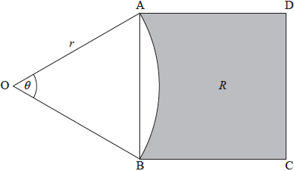



Show that the area of the square  is . *[4 marks]*

**13b.** When , the area of the square  is equal to the area of the sector .

(i)     Write down the area of the sector when .

(ii)     Hence find . *[4 marks]*

**14a.** The following diagram shows a triangle ABC.

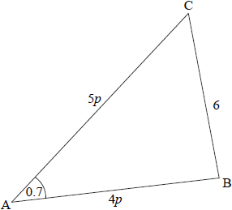

 ,  radians ,  ,  , where  .

(i)     Show that  .

(ii)    Find *p*. *[4 marks]*

**14b.** Consider the circle with centre B that passes through the point C. The circle cuts the line CA at D, and  is obtuse. Part of the circle is shown in the following diagram.

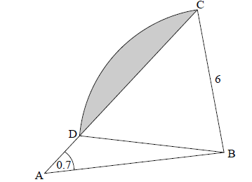

Write down the length of BD. *[1 mark]*

**14c.** Find  . *[4 marks]*

**14d.** (i)     Show that  radians, correct to 2 decimal places.

(ii)    Hence, find the area of the shaded region. *[6 marks]*