# **3.4 Periodic-functions, trigonometry** (Paper 2, with calculator)

**1a.** Let , for .

(i)     Write down the amplitude of .

(ii)     Find the period of . *[3 marks]*

**1b.** On the following grid sketch the graph of .

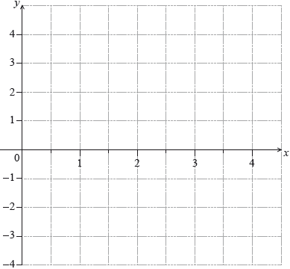 *[4 marks]*

**2a.** Let  , 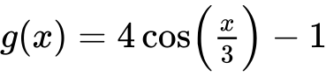 . Let  .

Find an expression for  . *[3 marks]*

**2b.** Write down the period of  . *[1 mark]*

**2c.** Write down the range of  . *[2 marks]*

**3a.** Let .

Write down the amplitude of . *[1 mark]*

**3b.** Find the period of . *[2 marks]*

**3c.** On the following grid, sketch the graph of , for .

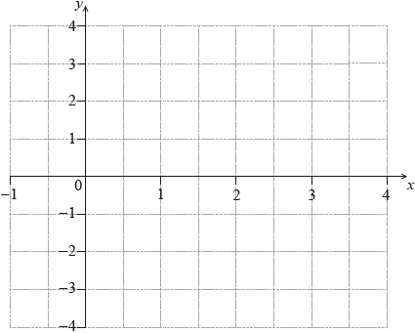 *[4 marks]*

**4a.** The following diagram shows part of the graph of .

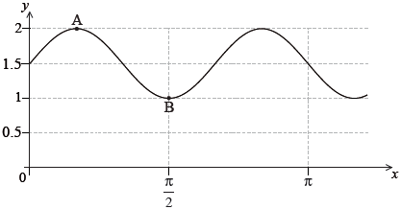

The point 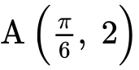 is a maximum point and the point 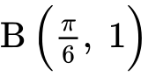 is a minimum point.

Find the value of ; *[2 marks]*

**4b.** ; *[2 marks]*

**4c.** . *[2 marks]*

**5a.** The depth of water in a port is modelled by the function , for , where  is the number of hours after high tide.

At high tide, the depth is 9.7 metres.

At low tide, which is 7 hours later, the depth is 5.3 metres.

Find the value of . *[2 marks]*

**5b.** Find the value of . *[2 marks]*

**5c.** Use the model to find the depth of the water 10 hours after high tide. *[2 marks]*

**6a.** *[2 marks]*

The height,  metros, of a seat on a Ferris wheel after  minutes is given by



Find the height of the seat when .

**6b.** *[3 marks]*

The seat first reaches a height of 20 m after  minutes. Find .

**6c.** *[3 marks]*

Calculate the time needed for the seat to complete a full rotation, giving your answer correct to one decimal place.

**7a.** *[3 marks]*

The population of deer in an enclosed game reserve is modelled by the function , where  is in months, and  corresponds to 1 January 2014.

Find the number of deer in the reserve on 1 May 2014.

**7b.** *[2 marks]*

Find the rate of change of the deer population on 1 May 2014.

**7c.** *[1 mark]*

Interpret the answer to part (i) with reference to the deer population size on 1 May 2014.

**8a.** Let 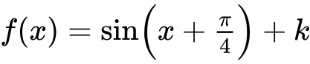. The graph of *f* passes through the point 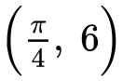.

Find the value of . *[3 marks]*

**8b.** Find the minimum value of . *[2 marks]*

**8c.** Let . The graph of *g* is translated to the graph of  by the vector 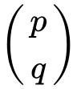.

Write down the value of  and of . *[2 marks]*

**9a.** The diagram below shows part of the graph of a function  .

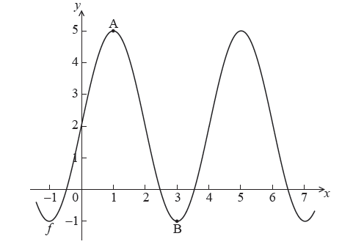

The graph has a maximum at A(, ) and a minimum at B(, ) .

The function  can be written in the form  . Find the value of

(a)     

(b)     

(c)      . *[6 marks]*

**10a.** Let  . The diagram below shows part of the graph of *f* , for  .

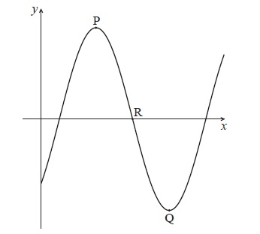

The graph has a local maximum at P(3, 5) , a local minimum at Q(7, − 5) , and crosses the *x*-axis at R.

Write down the value of

(i)      ;

(ii)     . *[2 marks]*

**10b.** Find the value of *b* . *[2 marks]*

**10c.** Find the *x*-coordinate of R. *[2 marks]*

**11a.** Let , for . The following diagram shows the graph of .

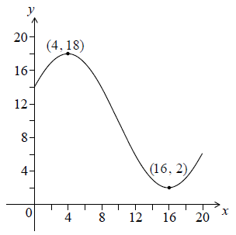

The graph has a maximum at  and a minimum at .

Write down the value of . *[2 marks]*

**11b.** Find . *[2 marks]*

**11c.** Find . *[2 marks]*

**11d.** Solve . *[2 marks]*

**12a.** *[6 marks]*

The graph of  , for  , is shown below.

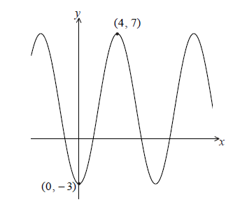

There is a minimum point at (0, −3) and a maximum point at (4, 7) .

Find the value of

(i)     *p* ;

(ii)    *q* ;

(iii)   *r*.

**12b.** *[1 mark]*

The equation  has exactly **two** solutions. Write down the value of *k*.