**5_4P1 Probability spicy**

**1a.** Pablo drives to work. The probability that he leaves home before 07:00 is .

If he leaves home before 07:00 the probability he will be late for work is .

If he leaves home at 07:00 or later the probability he will be late for work is .

**Copy** and complete the following tree diagram. *[3 marks]*

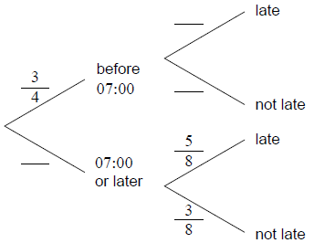

**1b.** Find the probability that Pablo leaves home before 07:00 and is late for work. *[2 marks]*

**1c.** Find the probability that Pablo is late for work. *[3 marks]*

**1d.** Given that Pablo is late for work, find the probability that he left home before 07:00. *[3 marks]*

**1e.** Two days next week Pablo will drive to work. Find the probability that he will be late at least once. *[3]*

**2a.** Ann and Bob play a game where they each have an eight-sided die. Ann’s die has three green faces and five red faces; Bob’s die has four green faces and four red faces. They take turns rolling their own die and note what colour faces up. The first player to roll green wins. Ann rolls first. Part of a tree diagram of the game is shown below.

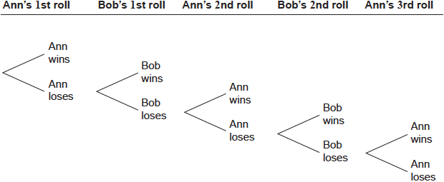

Find the probability that Ann wins on her first roll. *[2 marks]*

**2b.** Find the probability that Ann wins the game. *[7 marks]*

**3a.** *[2 marks]*

Adam travels to school by car () or by bicycle (). On any particular day he is equally likely to travel by car or by bicycle.

The probability of being late () for school is  if he travels by car.

The probability of being late for school is  if he travels by bicycle.

This information is represented by the following tree diagram.

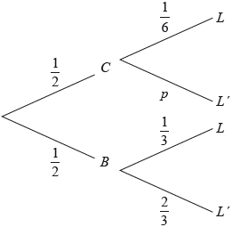

Find the value of .

**3b.** *[2 marks]*

Find the probability that Adam will travel by car and be late for school.

**3c.** *[4 marks]*

Find the probability that Adam will be late for school.

**3d.** *[3 marks]*

Given that Adam is late for school, find the probability that he travelled by car.

**3e.** *[4 marks]*

Adam will go to school three times next week.

Find the probability that Adam will be late exactly once.

**4a.** Bill and Andrea play two games of tennis. The probability that Bill wins the first game is .

If Bill wins the first game, the probability that he wins the second game is .

If Bill loses the first game, the probability that he wins the second game is .

**Copy** and complete the following tree diagram.

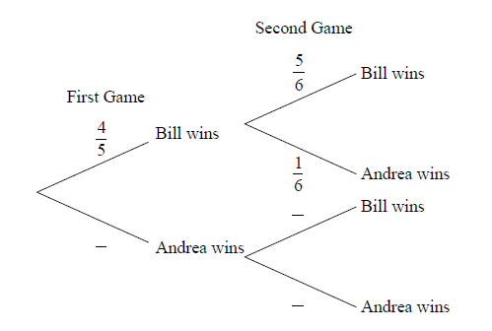 *[3 marks]*

**4b.** Find the probability that Bill wins the first game and Andrea wins the second game. *[2 marks]*

**4c.** Find the probability that Bill wins at least one game. *[4 marks]*

**4d.** Given that Bill wins at least one game, find the probability that he wins both games. *[5 marks]*

**5a.** Jar A contains three red marbles and five green marbles. Two marbles are drawn from the jar, one after the other, without replacement.

Find the probability that

  (i)     none of the marbles are green;

  (ii)     exactly one marble is green. *[5 marks]*

**5b.** Find the expected number of green marbles drawn from the jar. *[3 marks]*

**5c.** Jar B contains six red marbles and two green marbles. A fair six-sided die is tossed. If the score is  or , a marble is drawn from jar A. Otherwise, a marble is drawn from jar B.

(i)     Write down the probability that the marble is drawn from jar B.

(ii)     Given that the marble was drawn from jar B, write down the probability that it is red. *[2 marks]*

**5d.** Given that the marble is red, find the probability that it was drawn from jar A. *[6 marks]*

**6a.** *[4 marks]*

A running club organizes a race to select girls to represent the club in a competition.

The times taken by the group of girls to complete the race are shown in the table below.

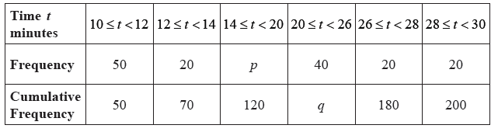

Find the value of  and of  .

**6b.** *[3 marks]*

A girl is chosen at random.

  (i)     Find the probability that the time she takes is less than  minutes.

  (ii)     Find the probability that the time she takes is at least  minutes.

**6c.** *[4 marks]*

A girl is selected for the competition if she takes less than  minutes to complete the race.

Given that  of the girls are not selected,

  (i)     find the number of girls who are not selected;

  (ii)     find  .

**6d.** *[4 marks]*

Girls who are not selected, but took less than  minutes to complete the race, are allowed another chance to be selected. The new times taken by these girls are shown in the cumulative frequency diagram below.

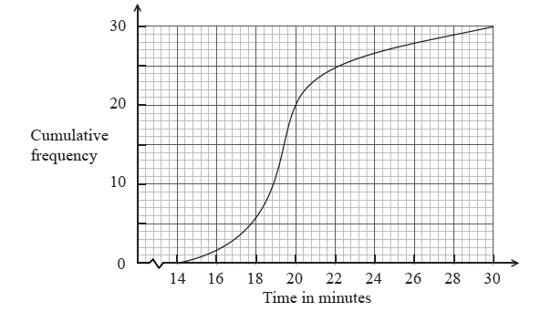

(i)     Write down the number of girls who were allowed another chance.

(ii)     Find the percentage of the whole group who were selected.

**7a.** *[5 marks]*

Bag A contains three white balls and four red balls. Two balls are chosen at random without replacement.

(i)     Copy and complete the following tree diagram.

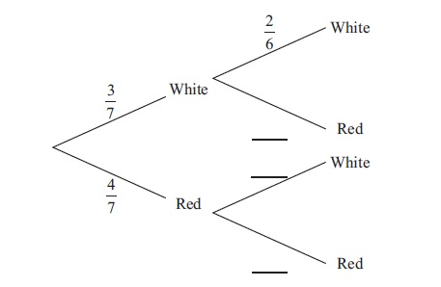

(ii)    Find the probability that two white balls are chosen.

**7b.** *[5 marks]*

Bag A contains three white balls and four red balls. Two balls are chosen at random without replacement.

Bag B contains four white balls and three red balls. When two balls are chosen at random without replacement from bag B, the probability that they are both white is  .

A standard die is rolled. If 1 or 2 is obtained, two balls are chosen without replacement from bag A, otherwise they are chosen from bag B.

Find the probability that the two balls are white.

**7c.** *[4 marks]*

Bag A contains three white balls and four red balls. Two balls are chosen at random without replacement.

Bag B contains four white balls and three red balls. When two balls are chosen at random without replacement from bag B, the probability that they are both white is  .

A standard die is rolled. If 1 or 2 is obtained, two balls are chosen without replacement from bag A, otherwise they are chosen from bag B.

Given that both balls are white, find the probability that they were chosen from bag A.

**8a.** *[5 marks]*

In a group of 16 students, 12 take art and 8 take music. One student takes neither art nor music. The Venn diagram below shows the events art and music. The values *p* , *q* , *r* and *s* represent numbers of students.

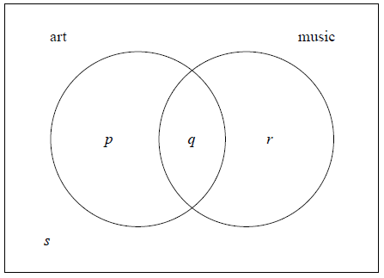

(i)     Write down the value of *s* .

(ii)    Find the value of *q* .

(iii)   Write down the value of *p* and of *r* .

**8b.** *[4 marks]*

(i)     A student is selected at random. Given that the student takes music, write down the probability the student takes art.

(ii)    **Hence**, show that taking music and taking art are **not** independent events.

**8c.** *[4 marks]*

Two students are selected at random, one after the other. Find the probability that the first student takes **only** music and the second student takes **only** art.

**9a.** José travels to school on a bus. On any day, the probability that José will miss the bus is  .

If he misses his bus, the probability that he will be late for school is  .

If he does not miss his bus, the probability that he will be late is  .

Let *E* be the event “he misses his bus” and *F* the event “he is late for school”.

The information above is shown on the following tree diagram.

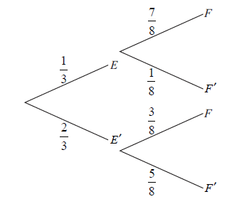

Find

(i)      ;

(ii)     . *[4 marks]*

**9b.** Find the probability that

(i)     José misses his bus and is not late for school;

(ii)    José missed his bus, given that he is late for school. *[5 marks]*

**9c.** The cost for each day that José catches the bus is 3 euros. José goes to school on Monday and Tuesday.

Copy and complete the probability distribution table.

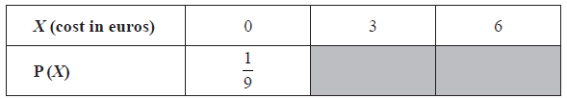 *[3 marks]*

**9d.** The cost for each day that José catches the bus is 3 euros. José goes to school on Monday and Tuesday.

Find the expected cost for José for both days. *[2 marks]*

**10a.** *[3 marks]*

In a class of 100 boys, 55 boys play football and 75 boys play rugby. Each boy must play at least one sport from football and rugby.

(i)     Find the number of boys who play both sports.

(ii)    Write down the number of boys who play only rugby.

**10b.** *[4 marks]*

One boy is selected at random.

(i)     Find the probability that he plays only one sport.

(ii)    Given that the boy selected plays only one sport, find the probability that he plays rugby.

**10c.** *[2 marks]*

Let *A* be the event that a boy plays football and *B* be the event that a boy plays rugby.

Explain why *A* and *B* are **not** mutually exclusive.

**10d.** *[3 marks]*

Show that *A* and *B* are **not** independent.

**11a.** *[2 marks]*

A **four-sided** die has three blue faces and one red face. The die is rolled.

Let *B* be the event a blue face lands down, and *R* be the event a red face lands down.

Write down

(i)     P(*B*);  
(ii)    P(*R*).

**11b.** *[2 marks]*

If the blue face lands down, the die is not rolled again. If the red face lands down, the die is rolled once again. This is represented by the following tree diagram, where *p*, *s*, *t* are probabilities.

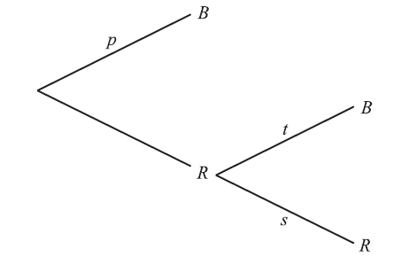

Find the value of *p*, of *s* and of *t*.

**11c.** *[3 marks]*

Guiseppi plays a game where he rolls the die. If a blue face lands down, he scores 2 and is finished. If the red face lands down, he scores 1 and rolls one more time. Let *X* be the total score obtained.

(i)     Show that 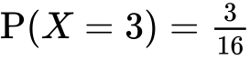 .  
(ii)    Find  .

**11d.** *[5 marks]*

(i)     Construct a probability distribution table for *X*.

(ii)    Calculate the expected value of *X*.

**11e.** *[4 marks]*

If the total score is 3, Guiseppi wins . If the total score is 2, Guiseppi gets nothing.

Guiseppi plays the game twice. Find the probability that he wins exactly .