# Pretest: Vectors, calculus, binomial distributions, review

**2a.** *[3 marks]*

Consider the points A(5, 2, 1), B(6, 5, 3), and C(7, 6, a+1),  .

Find

(i)  ;

(ii)  .

**2b.** *[4 marks]*

Let  be the angle between  and  .

Find the value of  for which  .

**2c.** *[8 marks]*

i. Show that 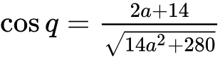 .

ii. Hence, find the value of a for which  .

**3a.** *[2 marks]*

The line *L* passes through the point  and is parallel to the vector 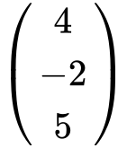 .

Write down a vector equation for line *L* .

**3b.** *[6 marks]*

The line *L* intersects the *x*-axis at the point P. Find the *x*-coordinate of P.

**4a.** *[6 marks]*

Let 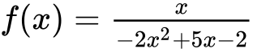 for  ,  ,  . The graph of  is given below.

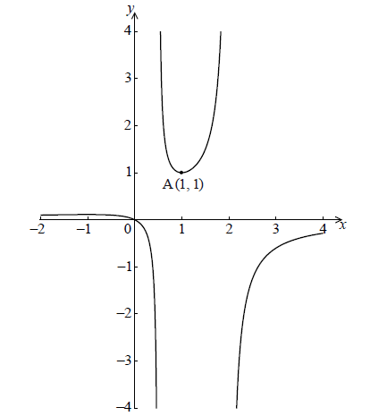

The graph of  has a local minimum at A(, ) and a local maximum at B.

Use the quotient rule to show that 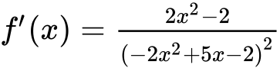 .

**4b.** *[7 marks]*

Hence find the coordinates of B.

**4c.** *[3 marks]*

Given that the line  does not meet the graph of *f* , find the possible values of *k* .

**5a.** *[2 marks]*

Let  , for  .

Find  .

**5b.** *[4 marks]*

On the grid below, sketch the graph of  .

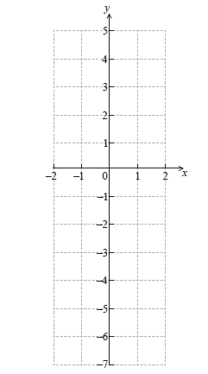

**6a.** *[2 marks]*

Let  , where *a* , *b* and *c* are real numbers. The graph of *f* passes through the point (2, 9) .

Show that  .

**6b.** *[7 marks]*

The graph of *f* has a local minimum at  .

Find two other equations in *a* , *b* and *c* , giving your answers in a similar form to part (a).

**6c.** *[4 marks]*

Find the value of *a* , of *b* and of *c* .

**7a.** *[4 marks]*

Let  . The line *L* is the tangent to the curve of *f* at (4, 6) .

Find the equation of *L* .

**7b.** *[6 marks]*

Let 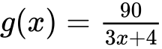 , for  . The following diagram shows the graph of *g* .

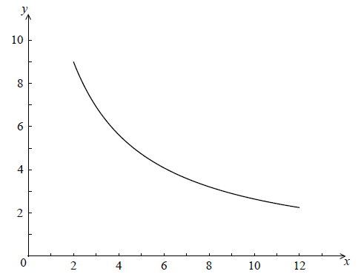

Find the area of the region enclosed by the curve of *g* , the *x*-axis, and the lines  and  . Give your answer in the form  , where  .

**7c.** *[3 marks]*

The graph of *g* is reflected in the *x*-axis to give the graph of *h* . The area of the region enclosed by the lines *L* ,  ,  and the *x*-axis is 120  .

Find the area enclosed by the lines *L* ,  ,  and the graph of *h* .

**8a.** Let 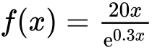 , for  .

Sketch the graph of *f* . *[3 marks]*

**8b.** *[3 marks]*

(i) Write down the *x*-coordinate of the maximum point on the graph of *f* .

(ii) Write down the interval where *f* is increasing.

**8c.** *[5 marks]*

Show that 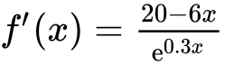 .

**8d.** *[4 marks]*

Find the interval where the rate of change of *f* is increasing.

**9a.** *[3 marks]*

The following table shows the probability distribution of a discrete random variable *X* .



Find the value of *k* .

**9b.** *[3 marks]*

Find  .

**10a.** *[2 marks]*

The random variable *X* has the following probability distribution, with  .  
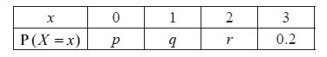

Find the value of *r* .

**10b.** *[6 marks]*

Given that  , find the value of *p* and of *q* .

**11a.** *[4 marks]*

The probability of obtaining “tails” when a biased coin is tossed is . The coin is tossed ten times. Find the probability of obtaining **at least** four tails.

**11b.** *[3 marks]*

The probability of obtaining “tails” when a biased coin is tossed is 0.57. The coin is tossed ten times. Find the probability of obtaining the fourth tail on the tenth toss.

**12a.** *[4 marks]*

A factory makes lamps. The probability that a lamp is defective is 0.05. A random sample of 30 lamps is tested.

Find the probability that there is at least one defective lamp in the sample.

**12b.** *[4 marks]*

A factory makes lamps. The probability that a lamp is defective is 0.05. A random sample of 30 lamps is tested.

Given that there is at least one defective lamp in the sample, find the probability that there are at most two defective lamps.

**13.** *[6 marks]*

The random variable X has the following probability distribution.

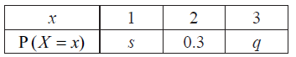

Given that  , find *q* .

**14a.** *[1 mark]*

The probability distribution of a discrete random variable *X* is given by

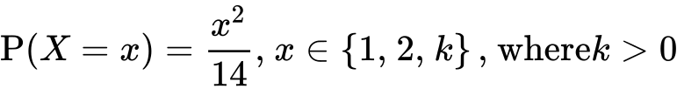

.

Write down  .

**14b.** *[4 marks]*

Show that  .

**14c.** *[2 marks]*

Find  .

**15a.** *[2 marks]*

A box holds 240 eggs. The probability that an egg is brown is 0.05.

Find the expected number of brown eggs in the box.

**15b.** *[2 marks]*

Find the probability that there are 15 brown eggs in the box.

**15c.** *[3 marks]*

Find the probability that there are at least 10 brown eggs in the box.

**16a.** *[3 marks]*

Two fair 4-sided dice, one red and one green, are thrown. For each die, the faces are labelled 1, 2, 3, 4. The score for each die is the number which lands face down.

List the pairs of scores that give a sum of 6.

**16b.** *[3 marks]*

The probability distribution for the sum of the scores on the two dice is shown below.  
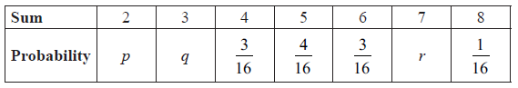

Find the value of *p* , of *q* , and of *r* .

**16c.** *[6 marks]*

Fred plays a game. He throws two fair 4-sided dice four times. He wins a prize if the sum is 5 on three or more throws.

Find the probability that Fred wins a prize.

**17a.** *[2 marks]*

Let , for . The following diagram shows part of the graph of .

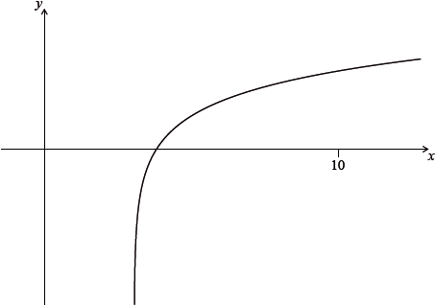

Find the equation of the vertical asymptote to the graph of .

**17b.** *[2 marks]*

Find the -intercept of the graph of .

**17c.** *[3 marks]*

The region enclosed by the graph of , the -axis and the line  is rotated ° about the -axis. Find the volume of the solid formed.

**18a.** *[2 marks]*

The first three terms of a geometric sequence are , and .

Find the value of .

**18b.** *[2 marks]*

Find the value of .

**18c.** *[3 marks]*

Find the least value of  such that .

**19a.** *[3 marks]*

An environmental group records the numbers of coyotes and foxes in a wildlife reserve after  years, starting on 1 January 1995.

Let  be the number of coyotes in the reserve after  years. The following table shows the number of coyotes after  years.

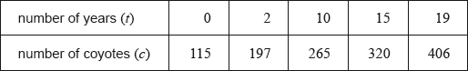

The relationship between the variables can be modelled by the regression equation .

Find the value of  and of .

**19b.** *[3 marks]*

Use the regression equation to estimate the number of coyotes in the reserve when .

**19c.** *[3 marks]*

Let  be the number of foxes in the reserve after  years. The number of foxes can be modelled by the equation 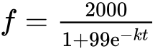, where  is a constant.

Find the number of foxes in the reserve on 1 January 1995.

**19d.** *[4 marks]*

During which year were the number of coyotes the same as the number of foxes?

**20a.** *[2 marks]*

Given that  and , write down the value of  and of .

**20b.** *[4 marks]*

Hence or otherwise solve .

**21a.** *[2 marks]*

The following diagram shows the graph of a function .

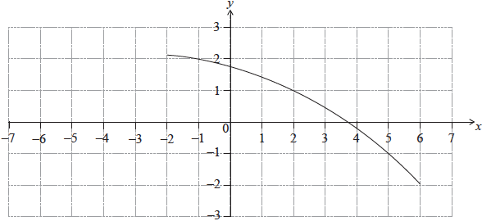

Find .

**21b.** *[3 marks]*

Find .

**21c.** *[2 marks]*

On the same diagram, sketch the graph of .

**22a.** Let .

Show that the discriminant of  is . *[3 marks]p*

**22b.** Find the values of  so that  has two **equal** roots. *[3 marks]*

**23.** *[5 marks]*

Let 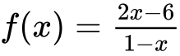, for .

For the graph of 

(i) find the -intercept;

(ii) write down the equation of the vertical asymptote;

(iii) find the equation of the horizontal asymptote.

**24a.** *[3 marks]*

Let , for .

On the following grid, sketch the graph of .

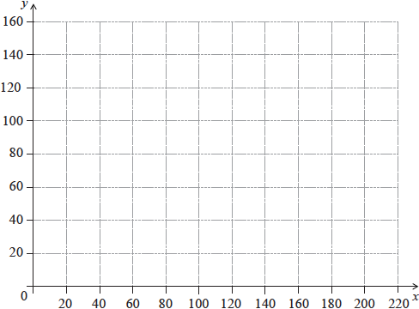

**24b.** *[3 marks]*

Robin and Pat are planning a wedding banquet. The cost per guest,  dollars, is modelled by the function , for , where  is the number of guests.

Calculate the **total** cost for  guests.