# **Test: Vectors, calculus, binomial distributions, review**

**1a.** Consider the points A(5, 2, 1), B(6, 5, 3), and C(7, 6, a+1),  .

Find

(i)  ;

(ii)  . *[3 marks]*

**1b.** Let  be the angle between  and  .

Find the value of *a* for which  . *[4 marks]*

**1c.** i. Show that 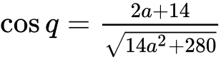 .

ii. Hence, find the value of *a* for which  . *[8 marks]*

**2a.** Let  , where *a*, *b* and *c* are real numbers. The graph of *f* passes through the point (2, 9) .

Show that  . *[2 marks]*

**2b.** The graph of *f* has a local minimum at  .

Find two other equations in *a* , *b* and *c* , giving your answers in a similar form to part (a). *[7 marks]*

**2c.** Find the value of *a*, of *b* and of *c* . *[4 marks]*

**3.** Let  . The line *L* is the tangent to the curve of *f* at (4, 6) .

Find the equation of *L*. *[4 marks]*

**4a.** The random variable *X* has the following probability distribution, with  .  
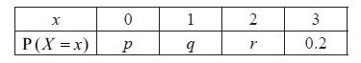

Find the value of *r* . *[2 marks]*

**4b.** Given that  , find the value of *p* and of *q* . *[6 marks]*

**5a.** A box holds 240 eggs. The probability that an egg is brown is 0.05.

Find the expected number of brown eggs in the box. *[2 marks]*

**5b.** Find the probability that there are 15 brown eggs in the box. *[2 marks]*

**5c.** Find the probability that there are at least 10 brown eggs in the box. *[3 marks]*

**6a.** The first three terms of a geometric sequence are , and .

Find the value of . *[2 marks]*

**6b.** Find the value of . *[2 marks]*

**6c.** Find the least value of  such that . *[3 marks]*

**7a.** An environmental group records the numbers of coyotes and foxes in a wildlife reserve after  years, starting on 1 January 1995.

Let  be the number of coyotes in the reserve after  years. The following table shows the number of coyotes after  years.

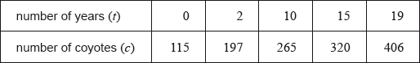

The relationship between the variables can be modelled by the regression equation .

Find the value of  and of . *[3 marks]*

**7b.** Use the regression equation to estimate the number of coyotes in the reserve when . *[3 marks]*

**7c.** Let  be the number of foxes in the reserve after  years. The number of foxes can be modelled by the equation 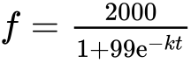, where  is a constant.

Find the number of foxes in the reserve on 1 January 1995. *[3 marks]*

**7d.** During which year were the number of coyotes the same as the number of foxes? *[4 marks]*

**8a.** Given that  and , write down the value of  and of . *[2 marks]*

**8b.** Hence or otherwise solve . *[4 marks]*

**9a.** The following diagram shows the graph of a function .

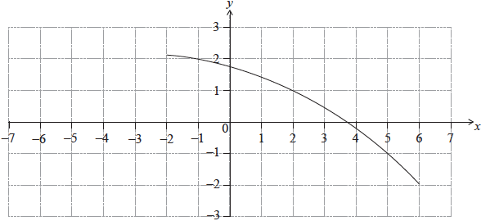

Find . *[2 marks]*

**9b.** Find . *[3 marks]*

**9c.** On the same diagram, sketch the graph of . *[2 marks]*

**10a.** Let , for .

On the following grid, sketch the graph of . *[3 marks]*

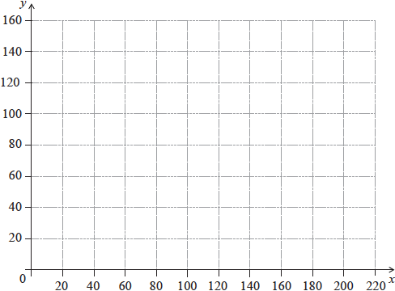

**10b.** Robin and Pat are planning a wedding banquet. The cost per guest, *G* dollars, is modelled by the function , for , where  is the number of guests.

Calculate the **total** cost for  guests. *[3 marks]*