# BECA / Huson / 12.1 IB Math SL Name:

# 26 October 2017

# **Classwork: Quadratics**

**1a.** *[2 marks]*

The following diagram shows part of the graph of a quadratic function *f* .  
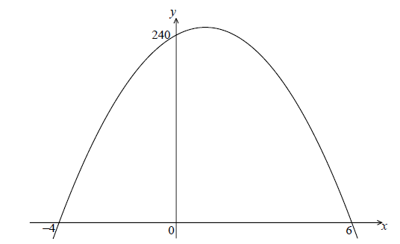

The *x*-intercepts are at  and  , and the *y*-intercept is at  .

Write down  in the form  .

**1b.** *[4 marks]*

Find another expression for  in the form  .

**1c.** *[2 marks]*

Show that  can also be written in the form  .

**1d.** *[7 marks]*

A particle moves along a straight line so that its velocity,  , at time *t* seconds is given by  , for  .

(i) Find the value of *t* when the speed of the particle is greatest.

(ii) Find the acceleration of the particle when its speed is zero.

**2a.** *[3 marks]*

Let  , for  .

Find  .

**2b.** *[3 marks]*

Let  be a quadratic function such that  . The line  is the axis of symmetry of the graph of  .

Find  .

**2c.** *[4 marks]*

The function  can be expressed in the form  .

(i) Write down the value of  .

(ii) Find the value of  .

**2d.** *[6 marks]*

Find the value of  for which the tangent to the graph of  is parallel to the tangent to the graph of  .

# BECA / Huson / 12.1 IB Math SL Name:

# 26 October 2017

# **Do Now: IB Exam problem**

**3a.** *[2 marks]*

Let  and  .

Find  .

**3b.** *[3 marks]*

The vector 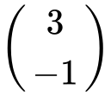 translates the graph of  to the graph of *h* .

Find the coordinates of the vertex of the graph of *h* .

**3c.** *[2 marks]*

Show that  .

**3d.** *[5 marks]*

The line  is a tangent to the graph of *h* at the point P. Find the *x*-coordinate of P.

**4a.** *[2 marks]*

The number of bacteria in two colonies,  and , starts increasing at the same time.

The number of bacteria in colony  after  hours is modelled by the function .

Write down the initial number of bacteria in colony .

**4b.** *[3 marks]*

Find the number of bacteria in colony  after four hours.

**4c.** *[3 marks]*

How long does it take for the number of bacteria in colony  to reach ?

**4d.** *[3 marks]*

The number of bacteria in colony  after  hours is modelled by the function .

After four hours, there are  bacteria in colony . Find the value of .

**4e.** *[4 marks]*

The number of bacteria in colony  after  hours is modelled by the function .

The number of bacteria in colony  first exceeds the number of bacteria in colony  after  hours, where . Find the value of .