# BECA / Huson / 12.1 IB Math SL Name: 13 November 2017

# Homework: Vectors (Paper 1 problems)

**1a.** Let  and . *[5 marks]*

Find

(i) ;

(ii) ;

(iii) .

**1b.** Find the angle between  and . *[2 marks]*

**2a.** The following diagram shows two perpendicular vectors ***u*** and ***v***.

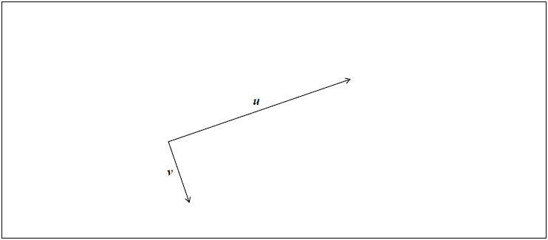

Let . Represent  on the diagram above. *[2 marks]*

**2b.** Given that 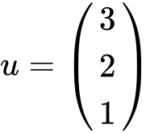 and 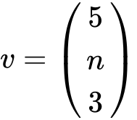, where , find *n*. *[4 marks]*

**3a.** The vectors ***a*** = 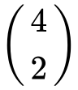 and ***b*** = 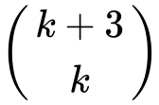 are perpendicular to each other. *[4 marks]*

Find the value of .

**3b.** Given that ***c*** = ***a*** + 2***b***, find ***c***. *[3 marks]*

**4.** Let ***u*** ***i***  ***j***  ***k*** and ***v*** = *m****j***+ *n****k***, where . Given that ***v*** is a unit vector perpendicular to ***u***, find the possible values of  and of . *[7 marks]*

**5.** The following diagram shows triangle .

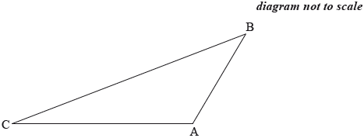

Let 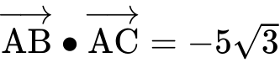 and 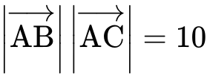. Find the area of triangle . *[6 marks]*

**6a.** Consider the vectors 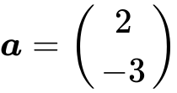 and 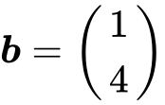 . *[6 marks]*

(a) Find

(i)  ;

(ii)  . *[4 marks]*

**6b.** Let  , where  is the zero vector.

(b) Find  . *[2 marks]*

**7a.** *[2 marks]*

**Note: In this question, distance is in metres and time is in seconds.**

Two particles  and  start moving from a point A at the same time, along different straight lines.

After  seconds, the position of  is given by ***r*** = 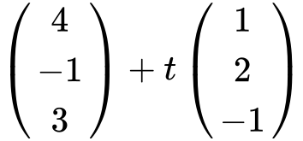.

Find the coordinates of A.

**7b.** *[3 marks]*

Two seconds after leaving A,  is at point B.

Find ;

**7c.** *[2 marks]*

Find 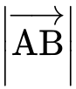.

**7d.** *[5 marks]*

Two seconds after leaving A,  is at point C, where 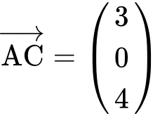.

Find .

**7e.** *[4 marks]*

Hence or otherwise, find the distance between  and  two seconds after they leave A.