BECA / Huson / 12.1 IB Math SL Name:

17 November 2017

**Homework: Calculus review**

**1.** Let 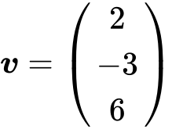 and 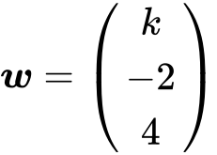 , for  . The angle between ***v*** and ***w*** is  .

Find the value of  . *[7 marks]*

**2a.** The following diagram shows the obtuse-angled triangle ABC such that 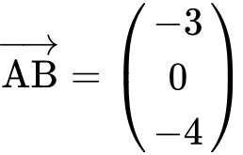 and 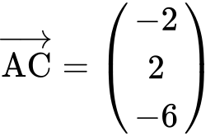 . *[3 marks]*

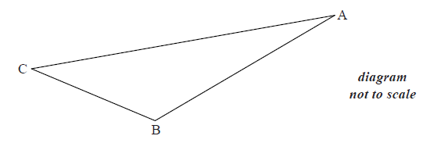

(i) Write down  .

(ii) Find  .

**2b.** (i) Find  . *[7 marks]*

(ii) Hence, find  .

**2c.** The point D is such that 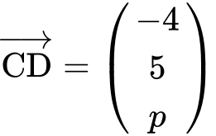 , where  . *[6 marks]*

(i) Given that 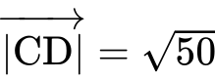 , show that  .

(ii) Hence, show that 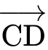 is perpendicular to  .

**3.** *[6 marks]*

Let . The line  is the tangent to the curve of  at .

Find the equation of  in the form .

**4a.** *[2 marks]* Let 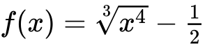.

Find .

**5a.** The population of deer in an enclosed game reserve is modelled by the function , where  is in months, and  corresponds to 1 January 2014.

Find the number of deer in the reserve on 1 May 2014. *[3 marks]*

**5b.** Find the rate of change of the deer population on 1 May 2014. *[2 marks]*

**5c.** Interpret the answer to part (i) with reference to the deer population size on 1 May 2014. *[1 mark]*

**6a.** *[2 marks]* Let 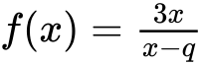, where .

Write down the equations of the vertical and horizontal asymptotes of the graph of .

**6b.** The vertical and horizontal asymptotes to the graph of  intersect at the point .

Find the value of . *[2 marks]*

**6c.** *[4 marks]*

The point  lies on the graph of . Show that 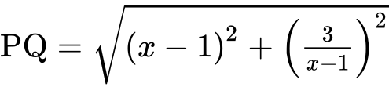.

**6d.** Hence find the coordinates of the points on the graph of  that are closest to . *[6 marks]*

**7a.** The following diagram shows the graph of , for .

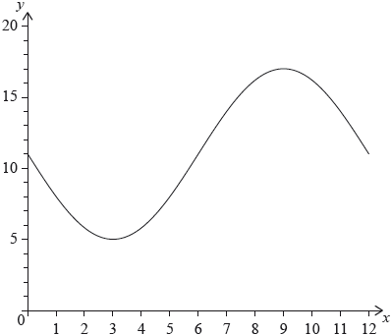

The graph of  has a minimum point at  and a maximum point at . [*6 marks]*

(i) Find the value of .

(ii) Show that .

(iii) Find the value of .

**7b.** The graph of  is obtained from the graph of  by a translation of 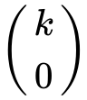. The maximum point on the graph of  has coordinates . *[3 marks]*

(i) Write down the value of .

(ii) Find .

**7c.** *[6 marks]* The graph of  changes from concave-up to concave-down when .

(i) Find .

(ii) Hence or otherwise, find the maximum positive rate of change of .

**8a.** *[2 marks]*

Line  passes through points  and  .

Find  .

**8b.** *[2 marks]*

Find an equation for  in the form  .

**8c.** *[7 marks]*

Line  has equation 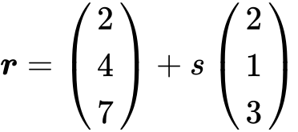 .

Find the angle between  and  .

**9a.** *[6 marks]* The diagram below shows part of the graph of  .

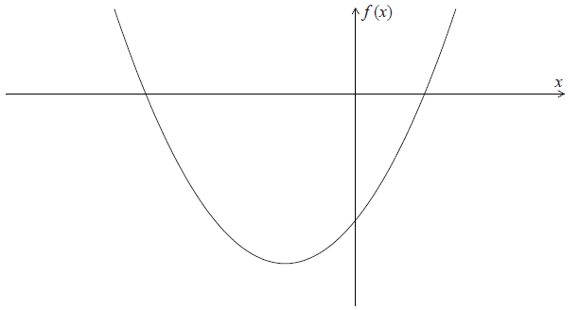

(a) Write down the -intercepts of the graph of  .

(b) Find the coordinates of the vertex of the graph of  .

**9b.** Write down the -intercepts of the graph of  . *[2 marks]*

**9c.** Find the coordinates of the vertex of the graph of  . *[4 marks*

**10a.** *[3 marks]*

Let  , for  .

Find  .

**10b.** *[3 marks]*

Let  be a quadratic function such that  . The line  is the axis of symmetry of the graph of  .

Find  .

**10c.** *[4 marks]*

The function  can be expressed in the form  .

(i) Write down the value of  .

(ii) Find the value of  .

**10d.** *[6 marks]*

Find the value of  for which the tangent to the graph of  is parallel to the tangent to the graph of  .