BECA / Huson / IB Math Name:

22 November 2017

Pre-Exam: Sequences & geometry

**1a.** The first three terms of an arithmetic sequence are 5, 6.7 , 8.4 .

Find the common difference. *[2 marks]*

**1b.** Find the 28th term of the sequence. *[2 marks]*

**1c.** Find the sum of the first 28 terms. *[2 marks]*

**2a.** The first term of a geometric sequence is 200 and the sum of the first four terms is 324.8.

Find the common ratio. *[4 marks]*

**2b.** *[2 marks]* Find the tenth term.

**3a.** In an arithmetic sequence,  and  .

Find *d* . *[2 marks]*

**3b.** Find  . *[2 marks]*

**3c.** Find  . *[2 marks]*

**4a.** In an arithmetic sequence  ,  and  .

Find the value of the common difference. *[3 marks]*

**4b.** Find the value of *n* . *[2 marks]*

**5a.** The first three terms of an infinite geometric sequence are 32, 16 and 8.

Write down the value of *r* . *[1 mark]*

**5b.** Find  . *[2 marks]*

**5c.** Find the sum to infinity of this sequence. *[2 marks]*

**6a.** Consider the arithmetic sequence 3, 9, 15,  , 1353 .

Write down the common difference. *[1 mark]*

**6b.** Find the number of terms in the sequence. *[3 marks]*

**6c.** Find the sum of the sequence. *[2 marks]*

**7a.** The following diagram shows  , where RQ = 9 cm,  and  .

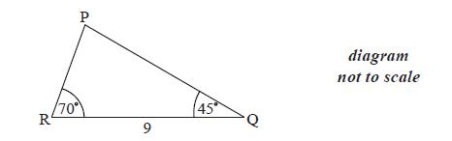

Find  . *[1 mark]*

**7b.** Find PR . *[3 marks]*

**7c.** Find the area of  . *[2 marks]*

**8a.** Consider the following circle with centre O and radius 6.8 cm.

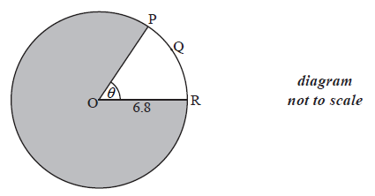

The length of the arc PQR is 8.5 cm.

Find the value of  . *[2 marks]*

**8b.** Find the area of the shaded region. *[4 marks]*

**9a.** Consider the triangle ABC, where AB =10 , BC = 7 and  =  .

Find the two possible values of  . *[4 marks]*

**9b.** Hence, find  , given that it is acute. *[2 marks]*

**10a.** The following diagram shows triangle ABC .

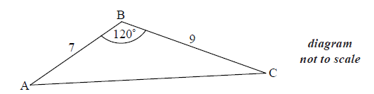

AB = 7 cm, BC = 9 cm and  .

Find AC . *[3 marks]*

**10b.** Find  . *[3 marks]*

**11a.** The following diagram shows the triangle ABC.

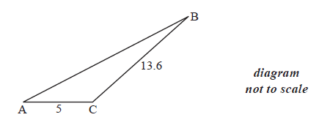

The angle at C is obtuse, ,  and the area is  .

Find  . *[4 marks]*

**11b.** Find AB. *[3 marks]*

**12a.** Let  , for  .

Use the quotient rule to show that 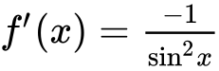 . *[5 marks]*

**12b.** Find  . *[3 marks]*

**12c.** In the following table,  and  . The table also gives approximate values of  and  near  .

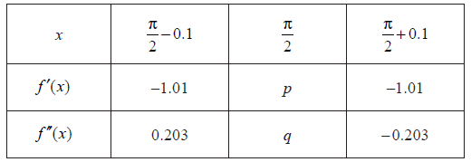

Find the value of *p* and of *q*. *[3 marks]*

**12d.** Use information from the table to explain why there is a point of inflexion on the graph of *f* where  . *[2 marks]*

**13a.** Let  and  .

Find  . *[2 marks]*

**13b.** Find  . *[2 marks]*

**13c.** Given that  can be written as  , find the value of *k*,  . *[3 marks]*