**Homework** -- **SAT problem solving practice test 01 (online at MajorTests.com)**

**1.** Of the following, which is greater than ½ ?

A. 2/5  B. 4/7  C. 4/9  D. 5/11  E. 6/13

**2.** If an object travels at five feet per second, how many feet does it travel in one hour?

A. 30  B. 300  C. 720  D. 1800  E. 18000

**3.** What is the average (arithmetic mean) of all the multiples of ten from 10 to 190 inclusive?

A. 90  B. 95  C. 100  D. 105  E. 110

**4.** A cubical block of metal weighs 6 pounds. How much will another cube of the same metal weigh if its sides are twice as long?

A. 48  B. 32  C. 24  D. 18  E. 12

**5.** In a class of 78 students 41 are taking French, 22 are taking German. Of the students taking French or German, 9 are taking both courses. How many students are not enrolled in either course?

A. 6  B. 15  C. 24  D. 33  E. 54

**6.** If f(x) = │(x² – 50)│, what is the value of f(-5) ?

A. 75  B. 25  C. 0  D. -25  E. -75

**7.** ( √2 - √3 )² =

A. 5 - 2√6   B. 5 - √6   C. 1 - 2√6   D. 1 - √2   E. 1

**8.** 230 + 230 + 230 + 230 =

A. 8120  B. 830  C. 232  D. 230  E. 226

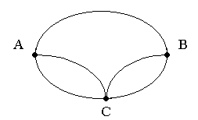

**9.** Amy has to visit towns B and C in any order. The roads connecting these towns with her home are shown on the diagram. How many different routes can she take starting from A and returning to A, going through both B and C (but not more than once through each) and not travelling any road twice on the same trip?

1. 10   B. 8   C. 6   D. 4   E. 2

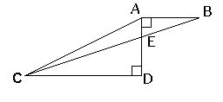

**10.** In the figure above AD = 4, AB = 3 and CD = 9. What is the area of triangle AEC ?

A. 18  B. 13.5  C. 9  D. 4.5  E. 3