BECA / Huson / IB Math Name:

22 November 2017

Pre-Exam: Vector algebra and differential calculus

**1a.** In the following diagram,  = ***p***, 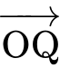 = ***q*** and 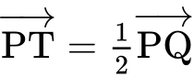.

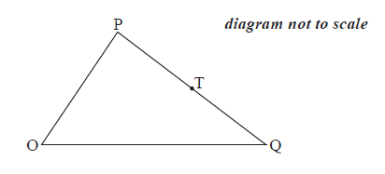

Express each of the following vectors in terms of ***p*** and ***q***,

; *[2 marks]*

**1b.** . *[3 marks]*

**2a.** Consider the points A(, , ) , B(, , ) , and C(, , ) ,  . Find

(i)  ; *[3 marks]*

(ii)  .

**2b.** Let  be the angle between  and  .

Find the value of  for which  . *[4 marks]*

**2c.** Show that 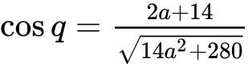 . *[8 marks]*

**2d.** Hence, find the value of a for which  . *[4 marks]*

**3a.** The following diagram shows quadrilateral ABCD, with 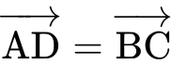 , 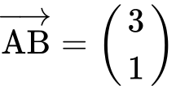 , and 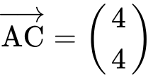 .

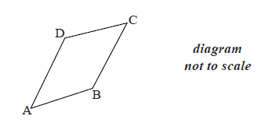

Find  . *[2 marks]*

**3b.** Show that 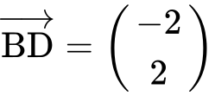 . *[2 marks]*

**3c.** Show that vectors  and  are perpendicular. *[3 marks]*

**4a.** Let  , where *a* , *b* and *c* are real numbers. The graph of *f* passes through the point (2, 9) .

Show that  . *[2 marks]*

**4b.** The graph of *f* has a local minimum at  .

Find two other equations in *a* , *b* and *c* , giving your answers in a similar form to part (a). *[7 marks]*

**4c.** Find the value of *a* , of *b* and of *c* . *[4 marks]*

**5a.** Let 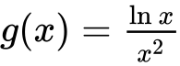 , for  .

Use the quotient rule to show that 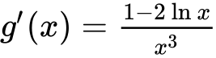 . *[4 marks]*

**5b.** The graph of *g* has a maximum point at A. Find the *x*-coordinate of A. *[3 marks]*

**6a.** The following diagram shows part of the graph of a quadratic function *f* .

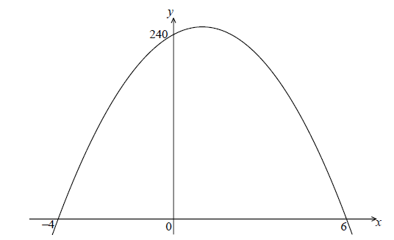

The *x*-intercepts are at  and  , and the *y*-intercept is at  .

Write down  in the form  . *[2 marks]*

**6b.** Find another expression for  in the form  . *[4 marks]*

**6c.** Show that  can also be written in the form  . *[2 marks]*

**6d.** A particle moves along a straight line so that its velocity,  , at time *t* seconds is given by  , for  . *[7 marks]*

(i) Find the value of *t* when the speed of the particle is greatest.

(ii) Find the acceleration of the particle when its speed is zero.

**7a.** The following diagram shows the graph of  .

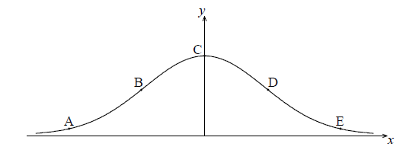

The points A, B, C, D and E lie on the graph of *f* . Two of these are points of inflexion.

Identify the **two** points of inflexion. *[2 marks]*

**7b.** (i) Find  . *[5 marks]*

(ii) Show that  .

**7c.** Find the *x*-coordinate of each point of inflexion. *[4 marks]*

**7d.** Use the second derivative to show that one of these points is a point of inflexion. *[4 marks]*

**8a.** Let  .

Find  . *[4 marks]*

**8b.** Find the gradient of the graph of *g* at  . *[3 marks]*

**9a.** Let  . *[3 marks]*

There are two points of inflexion on the graph of *f* . Write down the *x*-coordinates of these points.

**9b.** Let  . Explain why the graph of *g* has no points of inflexion. *[2 marks]*

**10a.** Let  . Part of the graph of *f* is shown below.

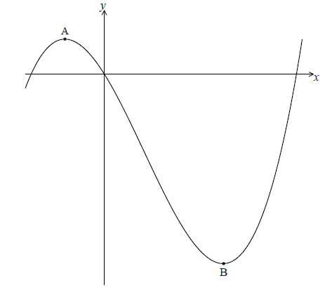

There is a maximum point at A and a minimum point at B(3, − 9) .

Find the coordinates of A. *[8 marks]*

**10b.** Write down the coordinates of *[6 marks]*

(i) the image of B after reflection in the *y*-axis;

(ii) the image of B after translation by the vector 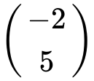 ;

(iii) the image of B after reflection in the *x*-axis followed by a horizontal stretch with scale factor  .

**11a.** Let  , for  .

Use the quotient rule to show that 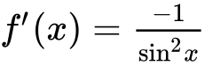 . *[5 marks]*

**11b.** Find  . *[3 marks]*

**11c.** In the following table,  and  . The table also gives approximate values of  and  near  .

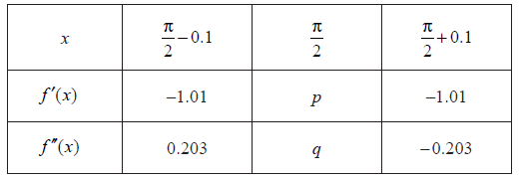

Find the value of *p* and of *q*. *[3 marks]*

**11d.** Use information from the table to explain why there is a point of inflexion on the graph of *f* where  . *[2 marks]*

**12.** Let  . The point  lies on the curve of *f* . At P, the normal to the curve is parallel to 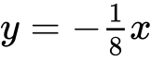 . Find the value of *k*. *[6 marks]*