BECA / Huson / 12.1 IB Math SL Name:

8 December 2017

**Homework**: Challenging vector and calculus problems

**1a.** Consider the points  and .

Find . *[2 marks]*

**1b.** Let C be a point such that 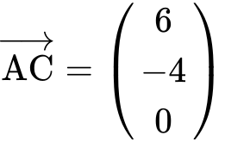.

Find the coordinates of C. *[2 marks]*

**1c.** The line  passes through B and is parallel to (AC).

Write down a vector equation for . *[2 marks]*

**1d.** Given that 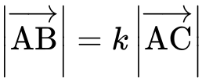, find . *[3 marks]*

**1e.** The point D lies on  such that 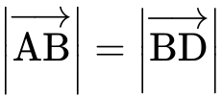. Find the possible coordinates of D. *[6 marks]*

**2a.** *[3 marks]* A line  passes through the points  and .

(i) Show that 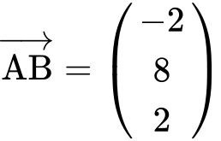.

(ii) Write down a vector equation for .

**2b.** A line  has equation 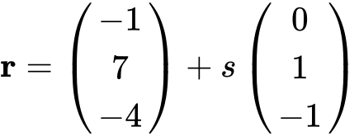. The lines  and  intersect at a point .

Show that the coordinates of  are . *[5 marks]*

**2c.** A point  lies on line  so that 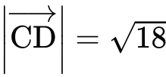 and 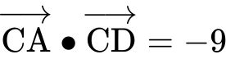. Find . *[7 marks]*

**3a.** A line  passes through points  and . *[3 marks]*

(i) Show that 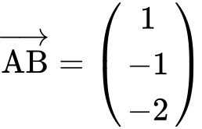.

(ii) Find 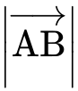.

**3b.** The following diagram shows the line  and the origin . The point  also lies on .

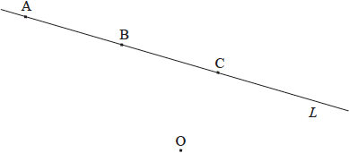

Point  has position vector 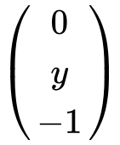.

Show that . *[4 marks]*

**3c.** (i) Find 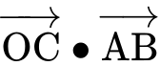.

(ii) Hence, write down the size of the angle between  and . *[3 marks]*

**3d.** Hence or otherwise, find the area of triangle . *[4 marks]*

**4a.** Let . The following diagram shows part of the graph of .

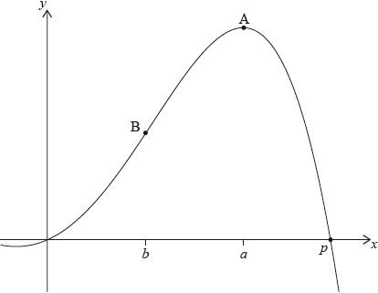

There are -intercepts at  and at . There is a maximum at A where , and a point of inflexion at B where .

Find the value of . *[2 marks]*

**4b.** Write down the coordinates of A. *[2 marks]*

**4c.** Write down the rate of change of  at A. *[1 mark]*

**4d.** Find the coordinates of B. *[4 marks]*

**4e.** Find the the rate of change of  at B. *[3 marks]*

**4f.** Let  be the region enclosed by the graph of  , the -axis, the line  and the line . The region  is rotated 360° about the -axis. Find the volume of the solid formed. *[3 marks]*

**5a.** Let . *[4 marks]*

(i) Find the first four derivatives of .

(ii) Find .

**5b.** Let , where . *[5 marks]*

(i) Find the first three derivatives of .

(ii) Given that 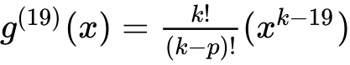, find .

**5c.** Let  and . *[7 marks]*

(i) Find .

(ii) Hence, show that 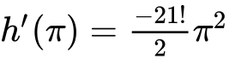.

**6a.** *[6 marks]* The following diagram shows the graph of , for .

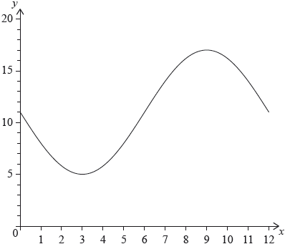

The graph of  has a minimum point at  and a maximum point at .

(i) Find the value of .

(ii) Show that .

(iii) Find the value of .

**6b.** *[3 marks]* The graph of  is obtained from the graph of  by a translation of 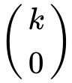. The maximum point on the graph of  has coordinates .

(i) Write down the value of .

(ii) Find .

**6c.** *[6 marks]* The graph of  changes from concave-up to concave-down when .

(i) Find .

(ii) Hence or otherwise, find the maximum positive rate of change of .