BECA / Huson / 12.1 IB Math Name:

15 November 2018

Exam: Vector algebra and differential calculus (cumulative review)

**1a.** Consider the points A(, , ) , B(, , ) , and C(, , a) ,  . Find

(i)  ; *[3 marks]*

(ii)  .

**1b.** Find the magnitude (length) of . *[2 marks]*

**2a.** Let 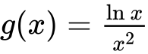 , for  .

Use the quotient rule to show that 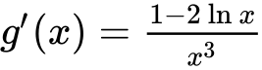 . *[4 marks]*

**2b.** The graph of *g* has a maximum point at A. Find the *x*-coordinate of A. *[3 marks]*

**3a.** Let  .

Find  . *[4 marks]*

**3b.** Find the gradient of the graph of *g* at  . *[3 marks]*

**4a.** The following diagram shows quadrilateral ABCD, with 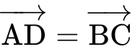 , 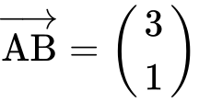 , and 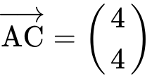 .

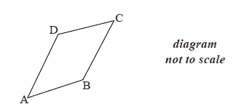

Find  . *[2 marks]*

**4b.** Show that 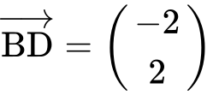 . *[2 marks]*

**5a.** Let $f\left(x\right)=\frac{1}{3}x^{3}-x^{2}-3x$. Part of the graph of *f* is shown below.

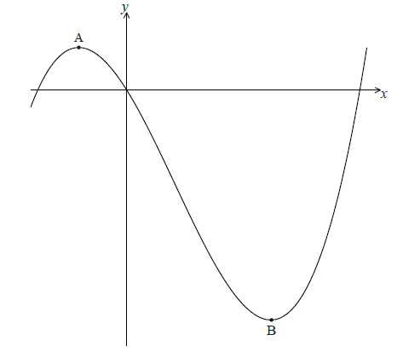

There is a maximum point at A and a minimum point at B(3, − 9) .

Find the coordinates of A. *[8 marks]*

**5b.** Write down the coordinates of *[6 marks]*

(i) the image of B after reflection in the *y*-axis;

(ii) the image of B after translation by the vector 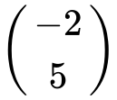 ;

(iii) the image of B after reflection in the *x*-axis followed by a horizontal stretch with scale factor  .

**6a.** Let  , for  .

Use the quotient rule to show that 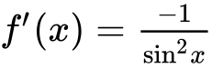 . *[5 marks]*

**6b.** Find  . *[3 marks]*

**7a.** In an arithmetic sequence, *u*1 = 3 and *u*3 = 11.

Find *d* . *[2 marks]*

**7b.** Find  . *[2 marks]*

**7c.** Find  . *[2 marks]*

**8a.** The first three terms of an infinite geometric sequence are 27, 9 and 3.

Write down the value of *r* . *[1 mark]*

**8b.** Find  . *[2 marks]*

**8c.** Find the sum to infinity of this sequence. *[2 marks]*