# 0202HW_Calculus_review

**1a.** *[1 mark]*

Write down the gradient of the curve of  at P.

**1b.** *[3 marks]*

Find the equation of the normal to the curve of  at P.

**1c.** *[2 marks]*

Determine the concavity of the graph of  when  **and** justify your answer.

**2a.** *[3 marks]*

Find the value of .

**2b.** *[3 marks]*

Find the value of .

**2c.** *[8 marks]*

The line  is a tangent to the curve of . Find the values of .

**3a.** *[2 marks]*

Find .

**3b.** *[3 marks]*

Find .

**4.** *[7 marks]*

Let . Find the term in  in the expansion of the derivative, .

**5a.** *[2 marks]*

Find the value of .

**5b.** *[2 marks]*

Write down the coordinates of A.

**5c.** *[1 mark]*

Write down the rate of change of  at A.

**5d.** *[4 marks]*

Find the coordinates of B.

**5e.** *[3 marks]*

Find the the rate of change of  at B.

**5f.** *[3 marks]*

Let  be the region enclosed by the graph of  , the -axis, the line  and the line . The region  is rotated 360° about the -axis. Find the volume of the solid formed.

**6a.** *[3 marks]*

Let ***u*** 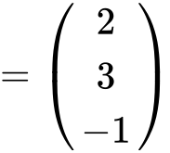 and ***w*** 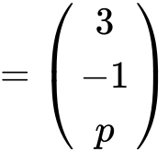 . Given that ***u*** is perpendicular to ***w*** , find the value of *p* .

**6b.** *[3 marks]*

Let 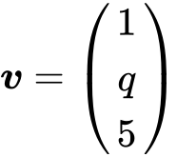 . Given that , find the possible values of  .

**7a.** *[3 marks]*

Find

(i)  ;

(ii)  .

**7b.** *[7 marks]*

Show that 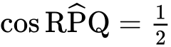 .

**7c.** *[6 marks]*

(i) Find  .

(ii) Hence, find the area of triangle PQR, giving your answer in the form  .

**8a.** *[4 marks]*

(i) Find the correlation coefficient.

(ii) Write down the value of  and of .

**8b.** *[3 marks]*

Elizabeth watches television for an average of  hours per day.

Use your regression line to predict the average number of hours of television watched per day by Elizabeth’s youngest child. Give your answer correct to one decimal place.

**9a.** *[3 marks]*

Find the probability that the dart does **not** hit the board.

**9b.** *[4 marks]*

The contestant scores points as shown in the following table.

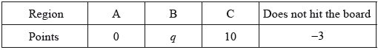

Given that the game is fair, find the value of .

**10a.** *[2 marks]*

Find the median monthly income.

**10b.** *[4 marks]*

(i) Write down the number of families who have a monthly income of  dollars or less.

(ii) Find the number of families who have a monthly income of more than  dollars.

**10c.** *[2 marks]*

The  families live in two different types of housing. The following table gives information about the number of families living in each type of housing and their monthly income .

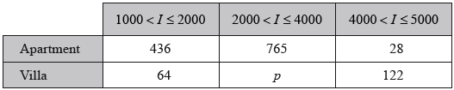

Find the value of .

**10d.** *[2 marks]*

A family is chosen at random.

(i) Find the probability that this family lives in an apartment.

(ii) Find the probability that this family lives in an apartment, given that its monthly income is greater than  dollars.

**10e.** *[2 marks]*

Estimate the mean monthly income for families living in a villa.

Printed for Bronx Early College Academy

© International Baccalaureate Organization 2018

International Baccalaureate® - Baccalauréat International® - Bachillerato Internacional®