BECA / Huson / 12.1 IB Math SL Name:

14 December 2017

**Test**: Vector and calculus

**1a.** Line  passes through points **A**(3, 0, 7) and **B**(4, -1, 8).

Find  . *[2 marks]*

**1b.** Find an equation for  in the form  . *[2 marks]*

**1c.** Line  has equation 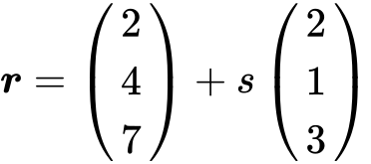 .

Find the angle between  and  . *[7 marks]*

**1d.** The lines  and  intersect at point C. Find the coordinates of C. *[6 marks]*

**2a.** The line  is represented by the vector equation 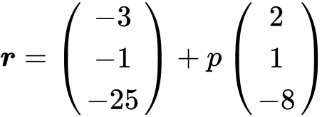 .

A second line  is parallel to  and passes through the point B(, , ) .

Write down a vector equation for  in the form  . *[2 marks]*

**2b.** A third line  is perpendicular to  and is represented by 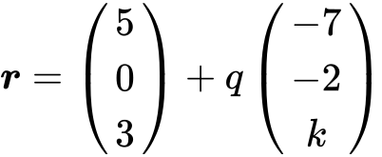 .

Show that  . *[5 marks]*

**2c.** The lines  and  intersect at the point A. Find the coordinates of A. *[6 marks]*

**2d.** The lines and intersect at point C where 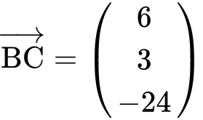 .

(i) Find  .

(ii) Hence, find 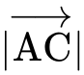 . *[5 marks]*

**3a.** Let 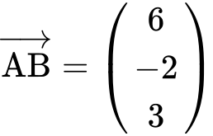 and 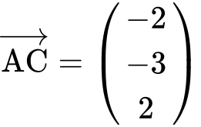 . Find  . *[2 marks]*

**3b.** Find a unit vector in the direction of $\vec{AB}$. *[3 marks]*

**3c.** Show that $\vec{AB}$ is perpendicular to $\vec{AC}$. *[3 marks]*

**4a.** Let 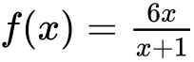 , for  . Find  . *[5 marks]*

**4b.** Let 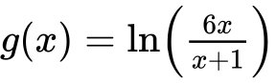 , for  .

Show that 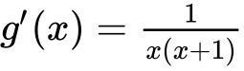 . *[4 marks]*

**5a.** Let  . Write down  . *[1 mark]*

**5b.** The tangent to the graph of *f* at the point  has gradient *m* .

(i) Show that  .

(ii) Find *b* . *[4 marks]*

**5c.** Hence, write down the equation of this tangent. *[1 mark]*

**6a.** The price of a used car depends partly on the distance it has travelled. The following table shows the distance and the price for seven cars on 1 January 2010.

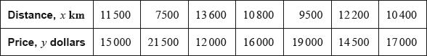

The relationship between  and  can be modelled by the regression equation .

(i) Find the correlation coefficient.

(ii) Write down the value of  and of . *[4 marks]*

**6b.** On 1 January 2010, Lina buys a car which has travelled 11,000 km.

Use the regression equation to estimate the price of Lina’s car, giving your answer to the nearest 100 dollars. *[3 marks]*

**17a.** Let 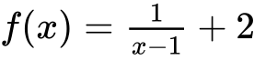, for .

Write down the equation of the horizontal asymptote of the graph of . *[2 marks]*

**17b.** Find . *[2 marks]*

**17c.** Let , for . The graphs of  and  have the same horizontal asymptote.

Write down the value of . *[2 marks]*

**17d.** Given that , find the value of . *[4 marks]*

**17e.** There is a value of , for , for which the graphs of  and  have the same gradient. Find this gradient. *[4 marks]*

**18a.** Let , for .

Find . *[3 marks]*

**18b.** Let  be a function so that . Find . *[3 marks]*

**19a.** The following diagram shows part of the graph of a quadratic function .

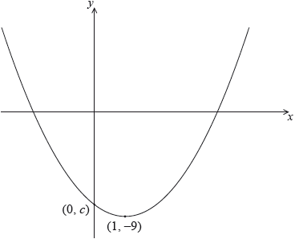The vertex is at , and the graph crosses the *y*-axis at the point .

The function can be written in the form .

Write down the value of  and of . *[2 marks]*

**19b.** Let . The graph of  is obtained by a reflection of the graph of  in the -axis, followed by a translation of 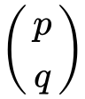.  
Find the value of  and of . *[5 marks]*

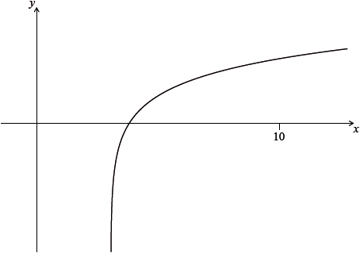 **20a.** Let , for . The diagram shows part of the graph of . Find the equation of the vertical asymptote to the graph of . *[2 marks]*

**20b.** Find the -intercept of the graph of . *[2 marks]*

**21a.** The first three terms of a geometric sequence are , and .

Find the value of . *[2 marks]*

**21b.** Find the value of . *[2 marks]*

**21c.** Find the least value of  such that . *[3 marks]*