BECA / Huson / 12.1 IB Math SL Name:

14 December 2017

**Test**: Vector and calculus **Markscheme**

**1a.** Line  passes through points **A**(3, 0, 7) and **B**(4, -1, 8).

Find  . *[2 marks]*

## Markscheme

appropriate approach ***(M1)***

e.g. 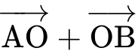 , 

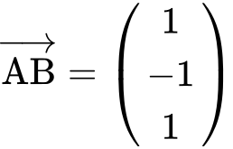 ***A1 N2***  *[2 marks]*

**1b.** Find an equation for  in the form  . *[2 marks]*

## Markscheme

any correct equation in the form  ***A2 N2***

where  is a scalar multiple of 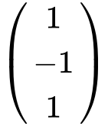

e.g. 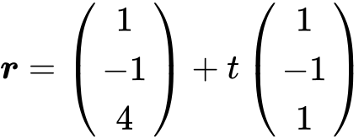 , 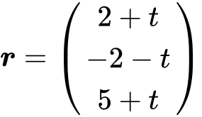 ,  *[2 marks]*

**1c.** Line  has equation 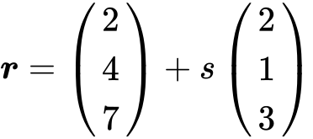 .

Find the angle between  and  . *[7 marks]*

## Markscheme

choosing correct direction vectors 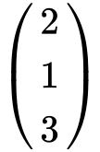 , 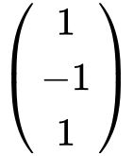  ***(A1)(A1)***

finding scalar product and magnitudes ***(A1)(A1)(A1)***

scalar product  

magnitudes 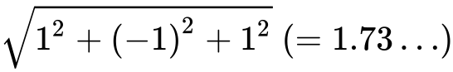 , 

substitution into 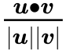 (accept 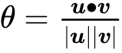 , but not 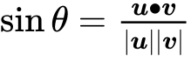 ) ***M1***

e.g. 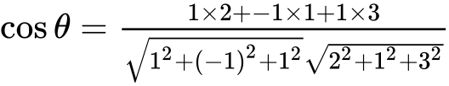 , 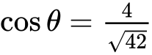

  ***A1 N5***  *[7 marks]*

**1d.** The lines  and  intersect at point C. Find the coordinates of C. *[6 marks]*

## Markscheme

**METHOD 1** (from )

appropriate approach ***(M1)***

e.g.  ,

two **correct** equations ***A1A1***

attempt to solve ***(M1)***

one correct parameter ***A1***

e.g. t = -3, s = -1

C is (0, 3, 4) ***A1 N3***

**2a.** The line  is represented by the vector equation 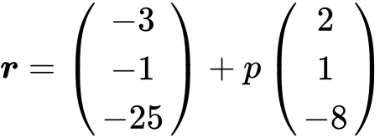 .

A second line  is parallel to  and passes through the point B(, , ) .

Write down a vector equation for  in the form  . *[2 marks]*

## Markscheme

any correct equation in the form  (accept any parameter) ***A2 N2***

e.g. 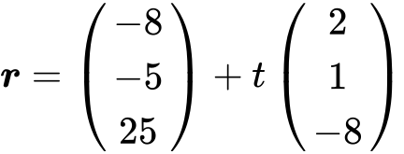

**Note**: Award ***A1*** for  , ***A1*** for  , ***A0*** for  .  *[2 marks]*

**2b.** A third line  is perpendicular to  and is represented by 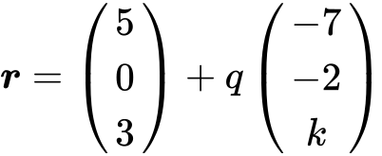 .

Show that  . *[5 marks]*

## Markscheme

recognizing scalar product must be zero (seen anywhere) ***R1***

e.g. 

evidence of choosing direction vectors 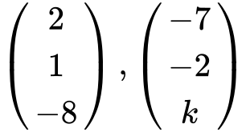 ***(A1)(A1)***

correct calculation of scalar product ***(A1)***

e.g. 

simplification that clearly leads to solution ***A1***

e.g.  , 

 ***AG N0***  *[5 marks]*

**2c.** The lines  and  intersect at the point A. Find the coordinates of A. *[6 marks]*

## Markscheme

evidence of equating vectors ***(M1)***

e.g.  , 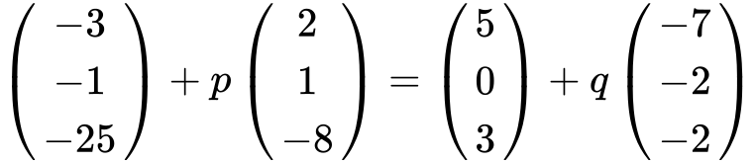

any **two** correct equations ***A1A1***

e.g.  ,  , 

attempting to solve equations ***(M1)***

finding **one** correct parameter ( ,  )  ***A1***

the coordinates of A are  ***A1 N3***  *[6 marks]*

**2d.** The lines and intersect at point C where 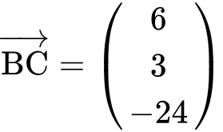 .

(i) Find  .

(ii) Hence, find 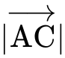 . *[5 marks]*

## Markscheme

(i) evidence of appropriate approach ***(M1)***

e.g. 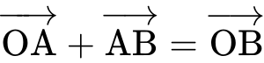 , 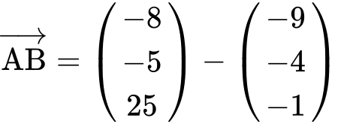

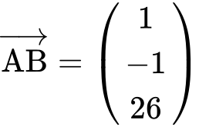 ***A1 N2***

(ii) finding 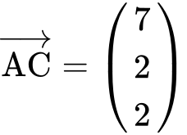 ***A1***

evidence of finding magnitude ***(M1)***

e.g. 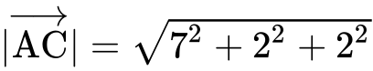

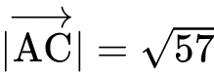 ***A1 N3***  *[5 marks]*

**3a.** Let 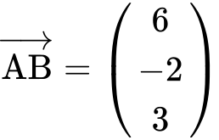 and 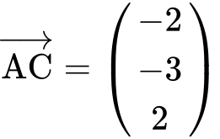 . Find  . *[2 marks]*

## Markscheme

evidence of appropriate approach ***(M1)***

e.g. 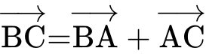 , 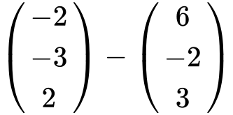

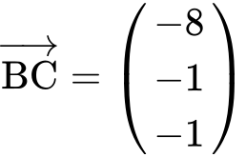 ***A1 N2***

***[2 marks]***

**3b.** Find a unit vector in the direction of $\vec{AB}$. *[3 marks]*

## Markscheme

attempt to find the length of  ***(M1)***

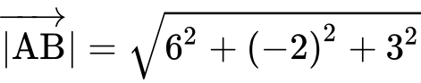  ***(A1)***

unit vector is 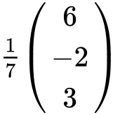 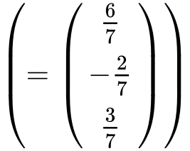 ***A1 N2***

***[3 marks]***

**3c.** Show that $\vec{AB}$ is perpendicular to $\vec{AC}$. *[3 marks]*

## Markscheme

recognizing that the dot product or  being 0 implies perpendicular ***(M1)***

correct substitution in a scalar product formula ***A1***

e.g.  , 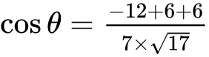

correct calculation ***A1***

e.g. 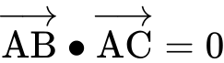 , 

therefore, they are perpendicular ***AG N0***  *[3 marks]*

**4a.** Let 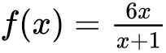 , for  . Find  . *[5 marks]*

## Markscheme

**METHOD 1**

evidence of choosing quotient rule  ***(M1)***

e.g. 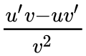

evidence of correct differentiation (must be seen in quotient rule) ***(A1)(A1)***

e.g. 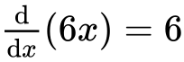 , 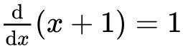

correct substitution into quotient rule ***A1***

e.g. 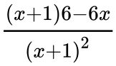 , 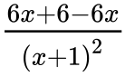

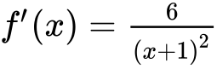 ***A1 N4*** *[5 marks]*

**METHOD 2**

evidence of choosing product rule ***(M1)***

e.g.  , 

evidence of correct differentiation (must be seen in product rule)  ***(A1)(A1)***

e.g.  , 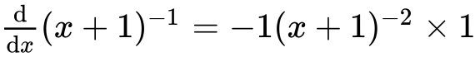

correct working ***A1***

e.g.  , 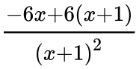

 ***A1 N4*** ***[5 marks]***

**4b.** Let 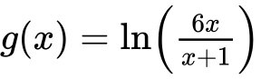 , for  .

## Show that . *[4 marks]*

## Markscheme

**METHOD 1**

evidence of choosing chain rule ***(M1)***

e.g. formula, 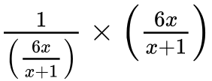

correct reciprocal of 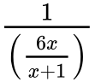 is 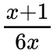 (seen anywhere) ***A1***

correct substitution into chain rule ***A1***

e.g. 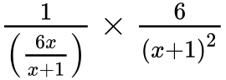 , 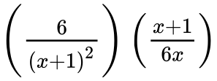

working that clearly leads to the answer ***A1***

e.g. 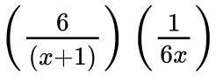 , 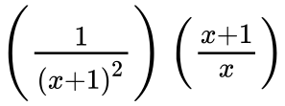 , 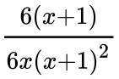

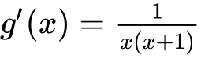 ***AG N0*** ***[4 marks]***

**METHOD 2**

attempt to subtract logs ***(M1)***

e.g.  , 

correct derivatives (must be seen in correct expression) ***A1A1***

e.g. 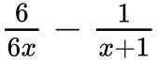 , 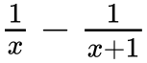

working that clearly leads to the answer ***A1***

e.g. 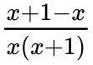 , 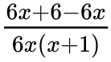 , 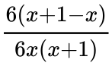

 ***AG N0*** ***[4 marks]***

**5a.** Let  . Write down  . *[1 mark]*

## Markscheme

 ***A1 N1*** ***[1 mark]***

**5b.** The tangent to the graph of *f* at the point  has gradient *m* .

(i) Show that  .

(ii) Find *b* . *[4 marks]*

## Markscheme

(i) evidence of valid approach ***(M1)***

e.g.  , 

correct manipulation ***A1***

e.g.  , 

 ***AG N0***

(ii) evidence of finding   ***(M1)***

e.g. 

 ***A1 N2*** ***[4 marks]***

**5c.** Hence, write down the equation of this tangent. *[1 mark]*

## Markscheme

 ***A1 N1*** ***[1 mark]***

**6a.** The price of a used car depends partly on the distance it has travelled. The following table shows the distance and the price for seven cars on 1 January 2010.

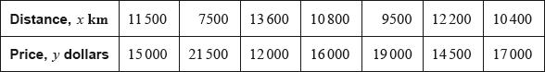

The relationship between  and  can be modelled by the regression equation .

(i) Find the correlation coefficient.

(ii) Write down the value of  and of . *[4 marks]*

## Markscheme

**Note:** There may be slight differences in answers, depending on which values candidates carry through in subsequent parts. Accept answers that are consistent with their working.

(i) valid approach ***(M1)***

*eg*correct value for  (or for  or  seen in (ii))



 ***A1 N2***

(ii) 

 ***A1A1 N2*** ***[4 marks]***

**6b.** On 1 January 2010, Lina buys a car which has travelled 11,000 km.

Use the regression equation to estimate the price of Lina’s car, giving your answer to the nearest 100 dollars. *[3 marks]*

## Markscheme

**Note:** There may be slight differences in answers, depending on which values candidates carry through in subsequent parts. Accept answers that are consistent with their working.

correct substitution into **their** regression equation

*eg* ***(A1)***

 ***(A1)***

 (must be rounded to the nearest 100 dollars) ***A1 N3*** ***[3 marks]***

**17a.** Let 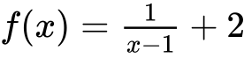, for .

Write down the equation of the horizontal asymptote of the graph of . *[2 marks]*

**17b.** Find . *[2 marks]*

**17c.** Let , for . The graphs of  and  have the same horizontal asymptote.

Write down the value of . *[2 marks]*

**17d.** Given that , find the value of . *[4 marks]*

**17e.** There is a value of , for , for which the graphs of  and  have the same gradient. Find this gradient. *[4 marks]*

**18a.** Let , for .

Find . *[3 marks]*

**18b.** Let  be a function so that . Find . *[3 marks]*

**19a.** The following diagram shows part of the graph of a quadratic function .

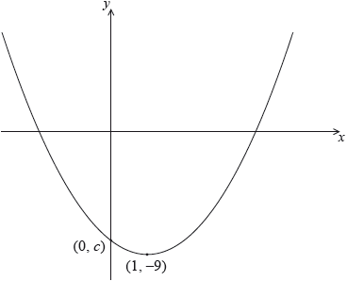The vertex is at , and the graph crosses the *y*-axis at the point .

The function can be written in the form .

Write down the value of  and of . *[2 marks]*

**19b.** Let . The graph of  is obtained by a reflection of the graph of  in the -axis, followed by a translation of 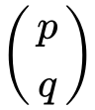.  
Find the value of  and of . *[5 marks]*

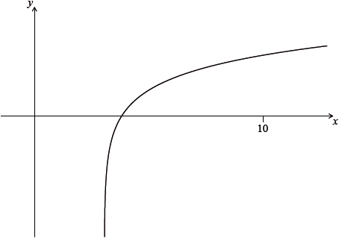 **20a.** Let , for . The diagram shows part of the graph of . Find the equation of the vertical asymptote to the graph of . *[2 marks]*

**20b.** Find the -intercept of the graph of . *[2 marks]*

**21a.** The first three terms of a geometric sequence are , and .

Find the value of . *[2 marks]*

**21b.** Find the value of . *[2 marks]*

**21c.** Find the least value of  such that . *[3 marks]*