**Pre-Test**: Trimester Final Exam

**1a.** Let  and , for .

Find . *[2 marks]*

**1b.** Find . *[3 marks]*

**2a.** The following diagram shows the graph of a function , for .

The points  and  lie on the graph of . There is a minimum point at .

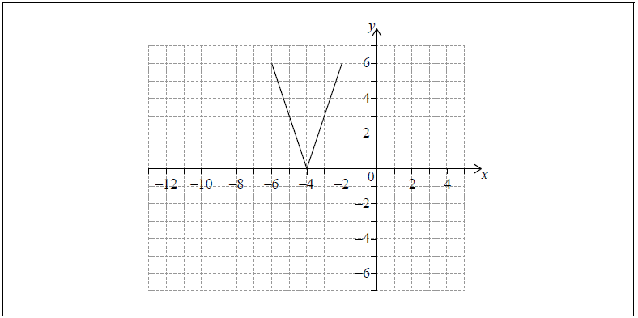

Write down the range of . *[2 marks]*

**2b.** Let .

On the grid above, sketch the graph of . *[2 marks]*

**2c.** Write down the domain of . *[2 marks]*

**3a.** Let  and , for .

Write down . *[1 mark]*

**3b.** Find . *[2 marks]*

**3c.** Find . *[2 marks]*

**4a.** Let  and , for .

Find . *[2 marks]*

**4b.** Find . *[2 marks]*

**4c.** Solve . *[3 marks]*

**5a.** The following diagram shows part of the graph of a quadratic function .

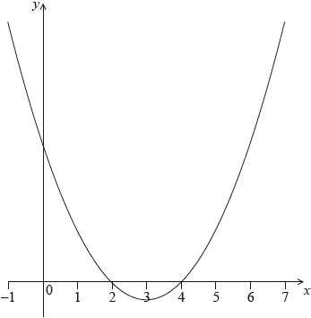

The vertex is at  and the -intercepts at 2 and 4.

The function  can be written in the form .

Write down the value of  and of . *[2 marks]*

**5b.** The function can also be written in the form .

Write down the value of  and of . *[2 marks]*

**5c.** Find the -intercept. *[2 marks]*

**6a.** A quadratic function  can be written in the form . The graph of  has axis of symmetry  and -intercept at 

Find the value of . *[3 marks]*

**6b.** Find the value of . *[3 marks]*

**7a.** *[2 marks]*

Consider . The graph of  has a minimum value when .

The distance between the two zeros of  is 9.

Show that the two zeros are 3 and .

**7b.** *[4 marks]*

Find the value of  and of .

**8a.** *[2 marks]*

Let  and . Write the following expressions in terms of  and .

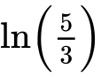.

**8b.** *[4 marks]*

.

**9a.** *[3 marks]*

Find the value of  .

**9b.** *[4 marks]*

Find the value of  .

**10a.** Let  for  . Part of the graph of *f* is shown below.  
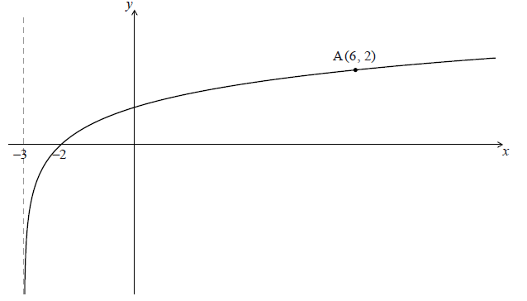

The graph passes through A(6, 2) , has an *x*-intercept at (−2, 0) and has an asymptote at  .

Find *p* . *[4 marks]*

**10b.** The graph of *f* is reflected in the line  to give the graph of *g* .

(i) Write down the *y*-intercept of the graph of *g* .

(ii) Sketch the graph of *g* , noting clearly any asymptotes and the image of A. *[5 marks]*

**10c.** The graph of  is reflected in the line  to give the graph of  .

Find  . *[4 marks]*

**11a.** A population of rare birds, , can be modelled by the equation , where  is the initial population, and  is measured in decades. After one decade, it is estimated that 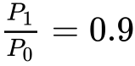.

(i) Find the value of .

(ii) Interpret the meaning of the value of . *[3 marks]*

**11b.** Find the least number of **whole** years for which 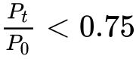. *[5 marks]*

**12a.** Events  and  are independent with  and .

Find . *[2 marks]*

**12b.** Find . *[4 marks]*

**13a.** The following Venn diagram shows the events  and , where  and . The values  and  are probabilities.

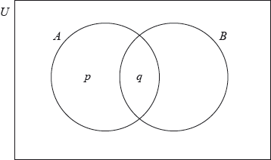

(i) Write down the value of .

(ii) Find the value of . *[3 marks]*

**13b.** Find . *[3 marks]*

**14a.** Let  and  be independent events, with  and , where .

Write down an expression for  in terms of . *[2 marks]*

**14b.** Find . *[3 marks]*

**15a.** Let  and  be independent events, where  and .

Find . *[2 marks]*

**15b.** Find . *[2 marks]*

**15c.** *[1 mark]*

On the following Venn diagram, shade the region that represents .

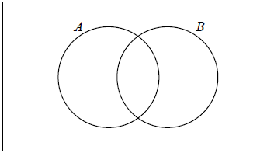

**15d.** *[2 marks]*

Find .

**16a.** *[2 marks]*

Two events  and  are such that  and .

Given that  and  are mutually exclusive, find .

**16b.** *[4 marks]*

Given that  and  are independent, find .

**17a.** Adam travels to school by car () or by bicycle (). On any particular day he is equally likely to travel by car or by bicycle.

The probability of being late () for school is  if he travels by car.

The probability of being late for school is  if he travels by bicycle.

This information is represented by the following tree diagram.

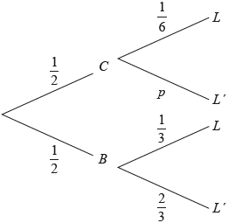

Find the value of . *[2 marks]*

**17b.** Find the probability that Adam will travel by car and be late for school. *[2 marks]*

**17c.** Find the probability that Adam will be late for school. *[4 marks]*

**17d.** Given that Adam is late for school, find the probability that he travelled by car. *[3 marks]*

**17e.** Adam will go to school three times next week.

Find the probability that Adam will be late exactly once. *[4 marks]*

**18a.** *[4 marks]*

A running club organizes a race to select girls to represent the club in a competition.

The times taken by the group of girls to complete the race are shown in the table below.

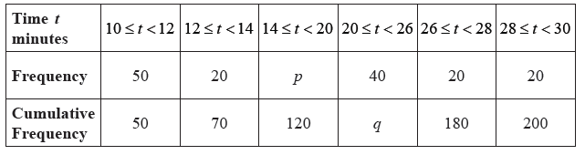

Find the value of  and of  .

**18b.** *[3 marks]*

A girl is chosen at random.

(i) Find the probability that the time she takes is less than  minutes.

(ii) Find the probability that the time she takes is at least  minutes.

**18c.** *[4 marks]*

A girl is selected for the competition if she takes less than  minutes to complete the race.

Given that  of the girls are not selected,

(i) find the number of girls who are not selected;

(ii) find  .