**Pre-Test**: Trimester Final Exam

**1a.** *[2 marks]*

Let  , where *a* , *b* and *c* are real numbers. The graph of *f* passes through the point (2, 9) .

Show that  .

**1b.** *[7 marks]*

The graph of *f* has a local minimum at  .

Find two other equations in *a* , *b* and *c* , giving your answers in a similar form to part (a).

**1c.** *[4 marks]*

Find the value of *a* , of *b* and of *c* .

**2a.** *[3 marks]*

Let  and  .

Find  .

**2b.** *[2 marks]*

Find  .

**2c.** *[2 marks]*

Find  .

**3.** *[4 marks]*

Let  , where  . The function *v* is obtained when the graph of *f* is transformed by

a stretch by a scale factor of  parallel to the *y*-axis,

followed by a translation by the vector 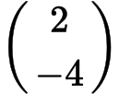 .

Find  , giving your answer in the form  .

**4a.** *[2 marks]*

Let  and  .

Find  .

**4b.** *[1 mark]*

Write down  .

**4c.** *[2 marks]*

Find  .

**5a.** *[4 marks]*

Let  . Part of the graph of *f* is shown below.

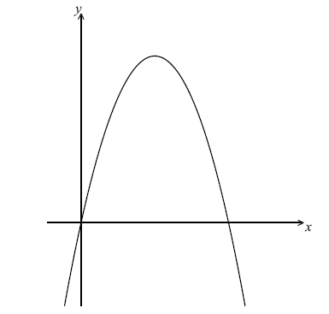

Find the *x*-intercepts of the graph.

**5b.** *[3 marks]*

(i) Write down the equation of the axis of symmetry.

(ii) Find the *y*-coordinate of the vertex.

**6a.** Let  , for  .

Show that  . *[2 marks]*

**6b.** Write down the range of  . *[1 mark]*

**6c.** Let  , for  .

Find the value of  , giving your answer as an integer. *[4 marks]*

**7a.** *[8 marks]*

Let $f\left(x\right)=\frac{1}{3}x^{3}-x^{2}-3x$. Part of the graph of *f* is shown below.

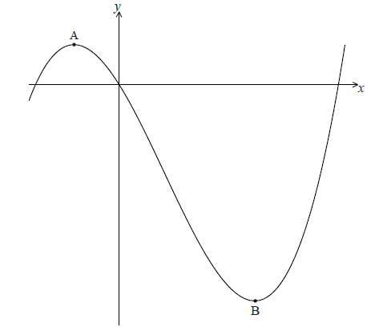

There is a maximum point at A and a minimum point at B(3, − 9) .

Find the coordinates of A.

**7b.** *[6 marks]*

Write down the coordinates of

(i) the image of B after reflection in the *y*-axis;

(ii) the image of B after translation by the vector 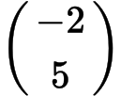 ;

(iii) the image of B after reflection in the *x*-axis followed by a horizontal stretch with scale factor  .

**8a.** *[2 marks]*

Let  . Part of the graph of *f* is shown below.

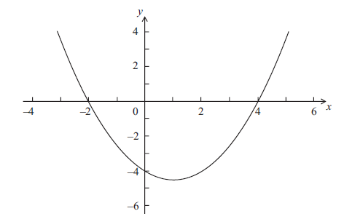

The graph passes through the points (−2, 0), (0, − 4) and (4, 0) .

Write down the value of *q* and of *r*.

**8b.** *[1 mark]*

Write down the **equation** of the axis of symmetry.

**8c.** *[3 marks]*

Find the value of *p*.