**Pre-test: Functions**

**1a.** The quadratic equation  has two equal real roots.

Find the possible values of *k*. *[5 marks]*

**1b. Write down** the values of *k* for which  has two equal real roots. *[2 marks]*

**2a.** Let  .

(i) Show that  .

(ii) Write down the domain of  . *[3 marks]*

**2b.** Solve the equation  . *[4 marks]*

**3a.** Let  . Part of the graph of *f* is shown below.

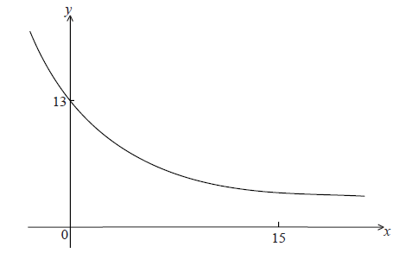

The *y*-intercept is at (0, 13) .

Show that  . *[2 marks]*

**3b.** Given that  (correct to 3 significant figures), find the value of *k*. *[3 marks]*

**3c.** (i) Using your value of *k* , find  .

(ii) Hence, explain why *f* is a decreasing function.

(iii) Write down the equation of the horizontal asymptote of the graph *f* . *[5 marks]*

**3d.** Let  .

Find the area enclosed by the graphs of *f* and *g* . *[6 marks]*

**4a.** Let  , for  . *[2 marks]*

Show that  .

**4b.** Find the value of  and of  . *[3 marks]*

**4c.** The function *f* can also be written in the form  .

(i) Write down the value of *a* and of *b* .

(ii) Hence on graph paper, **sketch** the graph of *f* , for  ,  , using a scale of 1 cm to 1 unit on each axis.

(iii) Write down the equation of the asymptote. *[6 marks]*

**4d.** Write down the value of  . *[1 mark]*

**4e.** The point A lies on the graph of *f* . At A,  .

On your diagram, sketch the graph of  , noting clearly the image of point A. *[4 marks]*

**5a.** Let  , where  .

Find the values of *k* such that  has two equal roots. *[4 marks]*

**5b.** Each value of *k* is equally likely for  . Find the probability that  has no roots

*[4 marks]*