[Christopher Huson]

Dr. Huson

11.1 IB Math SL

7 December 2017

Two Methods to Solve an Equation with Variables as Exponents

The subject of this paper is the solution of an exponential equation. [explain that the problem is selected from the textbook. Include a citation and Works Cited reference.] Two methods of solution are shown: algebra using logarithms and graphing using Desmos.

**The problem**

[briefly identify the source of your problem and why you picked it.]

A screenshot of the textbook exercises is shown in Figure 1.

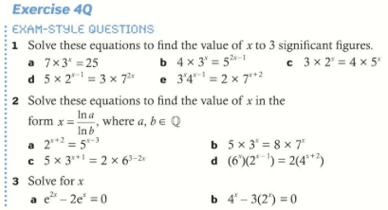

Figure Exercises from textbook page 129 (Oxford)

**Algebraic solution**

The solution of the problem is shown below. The key steps are to take the log of both sides of the equation, and then to bring the variable out of the exponent by using the logarithm power rule. [Write down the steps, centering the equations and using formal mathematical notation, as shown. Close with a brief summarizing statement or introduction to the next section.]

$$3^{x}4^{x-1}=2×7^{x+2}$$

$$\ln\left({3^{x}4}^{x-1}\right)=\ln\left(2×7^{x+2}\right)$$

[etc.]

**Graphical solution using technology**

An alternative to the algebraic methods used above is to solve the equation with technology. In this case, Desmos was used to build graphical models of each side of the equation, shown in Figure 2. The solution is the *x* value of the intersection of the two curves. [note the italicized variable name.]

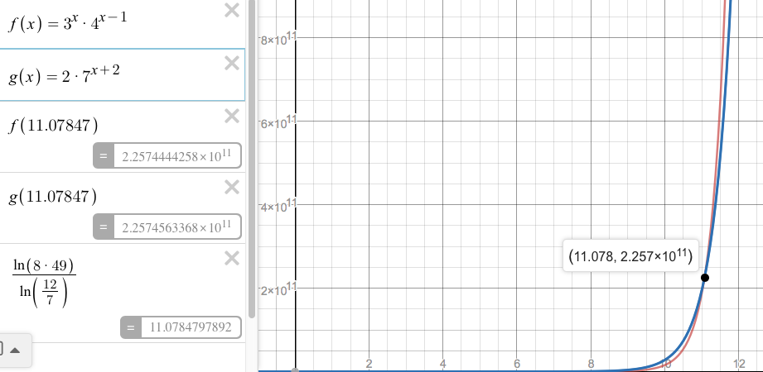

Figure Graph of the two functions (Desmos.com)

**Discussion and comparison of results**

The two methods produced the same solution, as they should, [state the solution]. [compare the methods in a paragraph or two and conclude the paper.]

[The last page should be Works Cited. Various points that you may also want to include are: rounding and accuracy, comparison to a hand-held graphical calculator, etc.]

Use this for your table. It’s neat and in MLA format. In your text, refer to it as “(see table 1)” or “(see fig. 1).”

Table 1

SAT and income for select colleges

|  |  |  |
| --- | --- | --- |
| School | SAT (25th percentile) | Median mid-career salary |
| Adelphi | 1480 | 86,400 |
| Stony Brook | 1660 | 90,900 |
| Fairfield | 1710 | 99,500 |
| Rutgers | 1710 | 91,800 |
| Fordham | 1830 | 90,300 |
| NYU | 1940 | 88,500 |
| Columbia | 2100 | 105,000 |
| Princeton | 2110 | 130,000 |
| Mean | 1818 | 97,800 |

Source: Mike McClenathan, “How Much Is A High SAT Worth? Up To $100K In Future Earnings.” Forbes, Forbes Magazine, 12 June 2012.

Figure 1

Scatter plot of SAT scores versus median mid-career salaries (6 colleges and the mean)

Works Cited

Buchanan, Laurie, et al. *IB Diploma Programme: Mathematics Standard Level*. New York: Oxford, 2012.