**Review:** Probability exam problems

**1a.** In a group of 20 girls, 13 take history and 8 take economics. Three girls take both history and economics, as shown in the following Venn diagram. The values ***p*** and ***q*** represent numbers of girls.

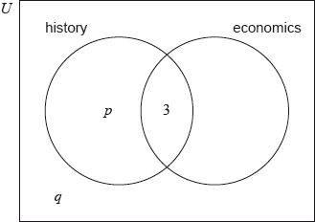

Find the value of ***p***; *[2 marks]*

**1b.** Find the value of ***q***. *[2 marks]*

**1c.** A girl is selected at random. Find the probability that she takes economics but not history. *[2 marks]*

**2a.** Events  and  are independent with  and .

Find . *[2 marks]*

**2b.** Find . *[4 marks]*

**3a.** The following Venn diagram shows the events  and , where  and . The values  and  are probabilities.

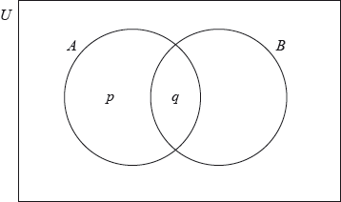

(i) Write down the value of .

(ii) Find the value of . *[3 marks]*

**3b.** Find . *[3 marks]*

**4a.** In a class of 21 students, 12 own a laptop, 10 own a tablet, and 3 own neither.

The following Venn diagram shows the events “own a laptop” and “own a tablet”.

The values , ,  and  represent numbers of students.

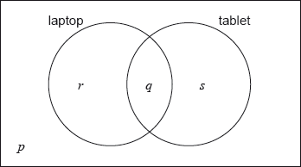

(i) Write down the value of .

(ii) Find the value of .

(iii) Write down the value of  and of . *[5 marks]*

**4b.** A student is selected at random from the class.

(i) Write down the probability that this student owns a laptop.

(ii) Find the probability that this student owns a laptop or a tablet but not both. *[4 marks]*

**4c.** Two students are randomly selected from the class. Let  be the event a “student owns a laptop”.

(i) **Copy** and complete the following tree diagram. (Do **not** write on this page.)

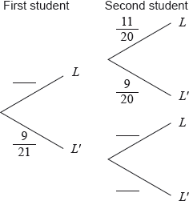

(ii) Write down the probability that the second student owns a laptop given that the first owns a laptop.

*[4 marks]*

**5a.** A factory has two machines, A and B. The number of breakdowns of each machine is independent from day to day.

Let  be the number of breakdowns of Machine A on any given day. The probability distribution for  can be modelled by the following table.



Find . *[2 marks]*

**5b.** (i) A day is chosen at random. Write down the probability that Machine A has no breakdowns.

(ii) Five days are chosen at random. Find the probability that Machine A has no breakdowns on exactly four of these days. *[3 marks]*

**5c.** Let  be the number of breakdowns of Machine B on any given day. The probability distribution for  can be modelled by the following table.



Find . *[2 marks]*

**5d.** On Tuesday, the factory uses both Machine A and Machine B. The variables  and  are independent.

(i) Find the probability that there are exactly two breakdowns on Tuesday.

(ii) Given that there are exactly two breakdowns on Tuesday, find the probability that both breakdowns are of Machine A. *[8 marks]*

**6a.** Let  and  be independent events, with  and , where .

Write down an expression for  in terms of . *[2 marks]*

**6b.** Find . *[3 marks]*