BECA / Huson / 11.1 IB Math SL Name:

8 November 2017

Homework: Introduction to logarithms

*Answer on loose leaf paper. No calculators.*

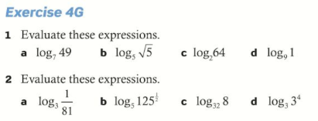

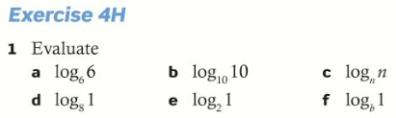

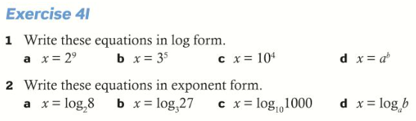

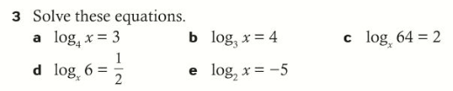

Regents Problems





(express with radicals, fractions, and positive exponents)



