# BECA / Huson / IB Math SL Name:

# 15 November 2017

# Homework: Function operations and quadratics review

**1a.** Write down the value of

(i) ; *[1 mark]*

(ii) 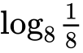; *[1 mark]*

(iii) . *[1 mark]*

**1d.** Hence, solve 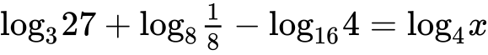. *[3 marks]*

**2a.** The following diagram shows the graph of a function , for .

The points  and  lie on the graph of . There is a minimum point at .

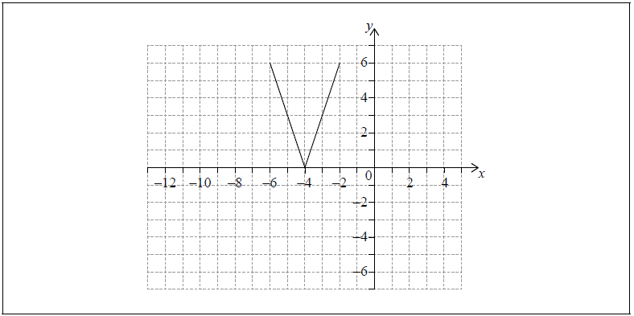

Write down the range of . *[2 marks]*

**2b.** Let .

On the grid above, sketch the graph of . *[2 marks]*

**2c.** Write down the domain of . *[2 marks]*

**3a.** Let  and , for .

Write down . *[1 mark]*

**3b.** Find . *[2 marks]*

**3c.** Find . *[2 marks]*

**4a.** Let  and , for .

Find . *[2 marks]*

**4b.** Find . *[2 marks]*

**4c.** Solve . *[3 marks]*

**5a.** Let , for .

Find . *[3 marks]*

**5b.** Let  be a function so that . Find . *[3 marks]*

**6a.** The following diagram shows part of the graph of a quadratic function .

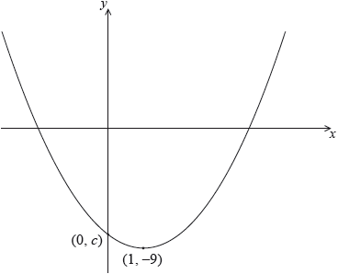

The vertex is at , and the graph crosses the *y*-axis at the point .

The function can be written in the form .

Write down the value of  and of . *[2 marks]*

**6b.** Let . The graph of  is obtained by a reflection of the graph of  in the -axis, followed by a translation of 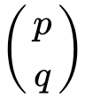.

Find the value of  and of . *[5 marks]*