**6-15 Test Probability Introduction**

**1a.** A bag contains 5 green balls and 3 white balls. Two balls are selected at random without replacement.

Complete the following tree diagram. *[3 marks]*

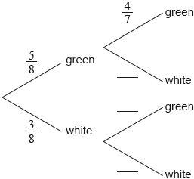

**1b.** Find the probability that exactly one of the selected balls is green. *[3 marks]*

|  |
| --- |
|  |

**2a.** The following Venn diagram shows the events  and , where  and . The values  and  are probabilities.

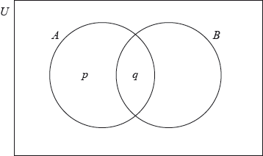

(i)     Write down the value of .

(ii)     Find the value of . *[3 marks]*

**2b.** Find . *[3 marks]*

|  |
| --- |
|  |

**3a.** Two events  and  are such that  and .

Given that  and  are mutually exclusive, find . *[2 marks]*

**3b.** Alternatively, assuming that  and  are independent, find . *[4 marks]*

|  |
| --- |
|  |

**4a.** In a group of 20 girls, 13 take history and 8 take economics. Three girls take both history and economics, as shown in the following Venn diagram. The values  and  represent numbers of girls.

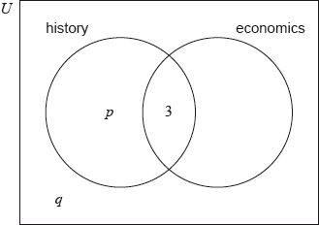

Find the value of ; *[2 marks]*

**4b.** Find the value of . *[2 marks]*

**4c.** A girl is selected at random. Find the probability that she takes economics but not history. *[2 marks]*

|  |
| --- |
|  |

**5a.** A box contains six red marbles and two blue marbles. Anna selects a marble from the box. She replaces the marble and then selects a second marble.

Write down the probability that the first marble Anna selects is red. *[1 mark]*

**5b.** Find the probability that Anna selects two red marbles. *[2 marks]*

**5c.** Find the probability that one marble is red and one marble is blue. *[3 marks]*

|  |
| --- |
|  |

**6a.** Let  and  be independent events, where  and .

Find . *[2 marks]*

**6b.** Find . *[2 marks]*

**6c.** On the following Venn diagram, shade the region that represents .

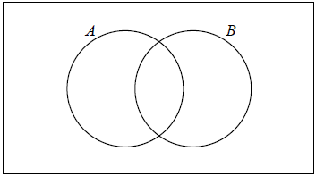 *[1 mark]*

**6d.** Find . *[2 marks]*

|  |
| --- |
|  |

**7a.** Events  and  are independent with  and .

Find . *[2 marks]*

**7b.** Find . *[4 marks]*

|  |
| --- |
|  |

**8a.** The diagram below shows the probabilities for events *A* and *B* , with  .

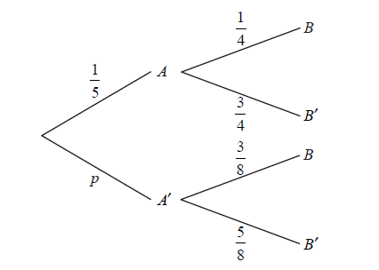

Write down the value of *p* . *[1 mark]*

**8b.** Find  . *[3 marks]*

**8c.** Find  . *[3 marks]*

|  |
| --- |
|  |

**9a.** In a class of 21 students, 12 own a laptop, 10 own a tablet, and 3 own neither.

The following Venn diagram shows the events “own a laptop” and “own a tablet”.

The values , ,  and  represent numbers of students.

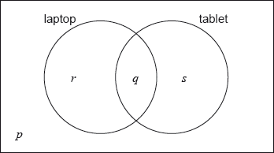

(i)     Write down the value of .

(ii)     Find the value of .

(iii)     Write down the value of  and of . *[5 marks]*

**9b.** A student is selected at random from the class.

(i)     Write down the probability that this student owns a laptop.

(ii)     Find the probability that this student owns a laptop or a tablet but not both. *[4 marks]*

**9c.** Two students are randomly selected from the class. Let  be the event a “student owns a laptop”.

(i)     **Copy** and complete the following tree diagram. (Do **not** write on this page.)

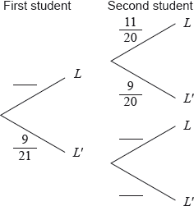

(ii)     Write down the probability that the second student owns a laptop given that the first owns a laptop. *[4 marks]*

**10.** Celeste wishes to hire a taxicab from a company which has a large number of taxicabs.

The taxicabs are randomly assigned by the company.

     The probability that a taxicab is yellow is 0.4.

     The probability that a taxicab is a Fiat is 0.3.

     The probability that a taxicab is yellow or a Fiat is 0.6.

 Find the probability that the taxicab hired by Celeste is **not** a yellow Fiat. *[6 marks]*

**11a.** *[2 marks]*

A factory has two machines, A and B. The number of breakdowns of each machine is independent from day to day.

Let  be the number of breakdowns of Machine A on any given day. The probability distribution for  can be modelled by the following table.



Find .

|  |
| --- |
|  |

**11b.** *[3 marks]*

(i)     A day is chosen at random. Write down the probability that Machine A has no breakdowns.

(ii)     Five days are chosen at random. Find the probability that Machine A has no breakdowns on exactly four of these days.

|  |
| --- |
|  |

**11c.** *[2 marks]*

Let  be the number of breakdowns of Machine B on any given day. The probability distribution for  can be modelled by the following table.



Find .

|  |
| --- |
|  |

**11d.** *[8 marks]*

On Tuesday, the factory uses both Machine A and Machine B. The variables  and  are independent.

(i)     Find the probability that there are exactly two breakdowns on Tuesday.

(ii)     Given that there are exactly two breakdowns on Tuesday, find the probability that both breakdowns are of Machine A.

|  |
| --- |
|  |

**12a.** *[2 marks]*

Let  and  be independent events, with  and , where .

Write down an expression for  in terms of .

|  |
| --- |
|  |

**12b.** *[3 marks]*

Find .

|  |
| --- |
|  |

Printed for Bronx Early College Academy

© International Baccalaureate Organization 2019

International Baccalaureate® - Baccalauréat International® - Bachillerato Internacional®