# **3.4 Periodic-functions, trigonometry** (Paper 1, without calculator)

**1a.** The following diagram shows the graph of  , for  .

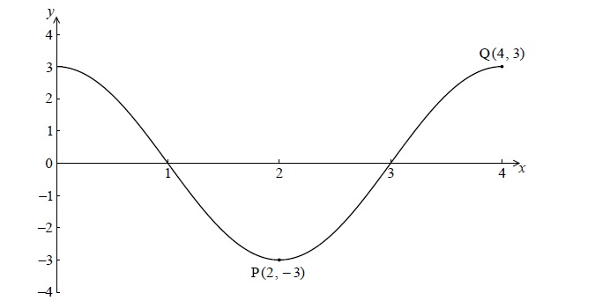

There is a minimum point at P(2, − 3) and a maximum point at Q(4, 3) .

(i)     Write down the value of *a*.

(ii)    Find the value of *b*. *[3 marks]*

**1b.** Write down the gradient of the curve at P. *[1 mark]*

**1c.** Write down the equation of the normal to the curve at P. *[2 marks]*

**2a.** The diagram below shows part of the graph of  , where  .

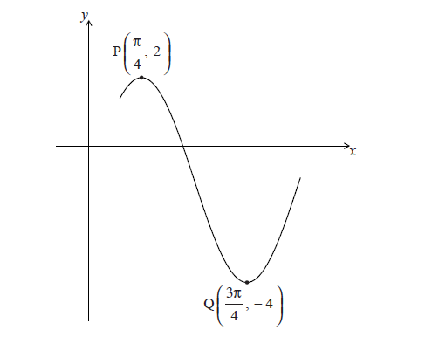

The point 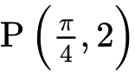 is a maximum point and the point 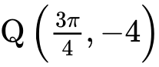 is a minimum point.

Find the value of *a*. *[2 marks]*

**2b.** (i)     Show that the period of *f* is  .

(ii)    Hence, find the value of *b*. *[4 marks]*

**2c.** Given that   , write down the value of *c*. *[1 mark]*

**3a.** Consider  .

Write down the period of *g*. *[1 mark]*

**3b.** On the diagram below, sketch the curve of *g*, for  .

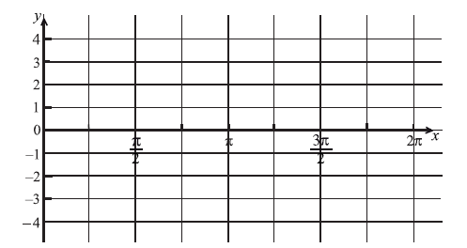 *[3 marks]*

**3c.** Write down the number of solutions to the equation  , for  . *[2 marks]*