**6-5 Problem Set: Trig Unit Circle Practice** (first part without calculator)

**1a.** Let  and  .

Find  . *[2 marks]*

**1b.** Find  . *[2 marks]*

**1c.** Given that  can be written as  , find the value of *k*,  . *[3 marks]*

**2a.** Let  and  . Give your answers to the following in terms of *p* and/or *q .*

Write down an expression for

(i)      ;

(ii)     . *[2 marks]*

**2b.** Find an expression for  . *[3 marks]*

**2c.** Find an expression for  . *[1 mark]*

**3a.** A rectangle is inscribed in a circle of radius 3 cm and centre O, as shown below. *[2 marks]*  
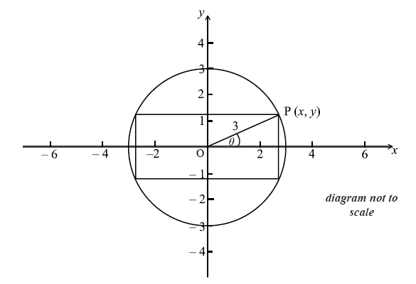

The point P(*x* , *y*) is a vertex of the rectangle and also lies on the circle. The angle between (OP) and the *x*-axis is  radians, where  . Write down an expression in terms of  for

(i)      ;

(ii)     .

**3b.** The point P(*x* , *y*) is a vertex of the rectangle and also lies on the circle. The angle between (OP) and the *x*-axis is  radians, where  . Let the area of the rectangle be *A*.

Show that  . *[3 marks]*

**4a.** The following diagram shows a triangle ABC and a sector BDC of a circle with centre B and radius 6 cm. The points A , B and D are on the same line.

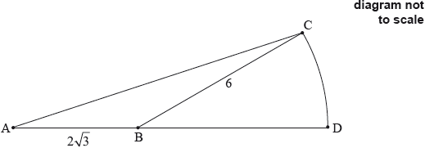

 is obtuse.

Find . *[5 marks]*

**4b.** Find the exact area of the sector BDC. *[3 marks]*

**Calculator section**

**5a.** Consider the following circle with centre O and radius 6.8 cm.

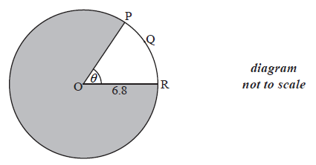

The length of the arc PQR is 8.5 cm.

Find the value of  . *[2 marks]*

**5b.** Find the area of the shaded region. *[4 marks]*

**6a.** The diagram below shows a circle centre O, with radius *r*. The length of arc ABC is  and 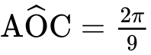.

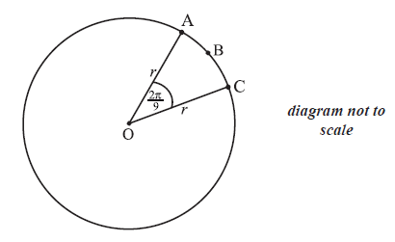

Find the value of *r*. *[2 marks]*

**6b.** Find the perimeter of sector OABC. *[2 marks]*

**6c.** Find the area of sector OABC. *[2 marks]*

**7a.** A circle centre O and radius  is shown below. The chord [AB] divides the area of the circle into two parts. Angle AOB is  .

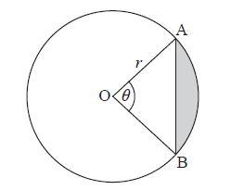

Find an expression for the area of the shaded region. *[3 marks]*

**7b.** The chord [AB] divides the area of the circle in the ratio 1:7. Find the value of  . *[5 marks]*