# Normal distribution

**1a.** *[1 mark]*

The random variable  is normally distributed with a mean of 100. The following diagram shows the normal curve for .

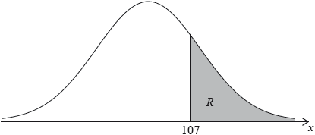

Let  be the shaded region under the curve, to the right of 107. The area of  is 0.24.

Write down .

**1b.** *[3 marks]*

Find .

**1c.** *[2 marks]*

Find .

**2a.** *[2 marks]*

In a large university the probability that a student is left handed is 0.08. A sample of 150 students is randomly selected from the university. Let  be the expected number of left-handed students in this sample.

Find .

**2b.** *[2 marks]*

Hence, find the probability that exactly  students are left handed;

**2c.** *[2 marks]*

Hence, find the probability that fewer than  students are left handed.

**3a.** *[2 marks]*

A random variable  is normally distributed with mean, . In the following diagram, the shaded region between 9 and  represents 30% of the distribution.

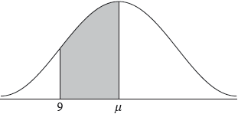

Find .

**3b.** *[3 marks]*

The standard deviation of  is 2.1.

Find the value of .

**3c.** *[5 marks]*

The random variable  is normally distributed with mean  and standard deviation 3.5. The events  and  are independent, and .

Find .

**3d.** *[5 marks]*

Given that , find .

**4a.** *[2 marks]*

The following table shows a probability distribution for the random variable , where .

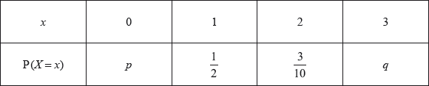

Find .

**4b.** *[2 marks]*

Find .

**4c.** *[1 mark]*

A bag contains white and blue marbles, with at least three of each colour. Three marbles are drawn from the bag, without replacement. The number of blue marbles drawn is given by the random variable .

Write down the probability of drawing three blue marbles.

**4d.** *[1 mark]*

Explain why the probability of drawing three white marbles is .

**4e.** *[3 marks]*

The bag contains a total of ten marbles of which  are white. Find .

**4f.** *[4 marks]*

A game is played in which three marbles are drawn from the bag of ten marbles, without replacement. A player wins a prize if three white marbles are drawn.

Grant plays the game until he wins two prizes. Find the probability that he wins his second prize on his eighth attempt.

Printed for Bronx Early College Academy

© International Baccalaureate Organization 2018

International Baccalaureate® - Baccalauréat International® - Bachillerato Internacional®