**Review:** Probability exam problems

**1.** *[6 marks]*

Celeste wishes to hire a taxicab from a company which has a large number of taxicabs.

The taxicabs are randomly assigned by the company.

The probability that a taxicab is yellow is 0.4.

The probability that a taxicab is a Fiat is 0.3.

The probability that a taxicab is yellow or a Fiat is 0.6.

Find the probability that the taxicab hired by Celeste is **not** a yellow Fiat.

**2a.** *[2 marks]*

Let  and  be independent events, where  and .

Find .

**2b.** *[2 marks]*

Find .

**2c.** *[1 mark]*

On the following Venn diagram, shade the region that represents .

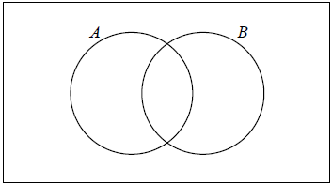

**2d.** *[2 marks]*

Find .