**Classwork: Binomial distributions**

**1a.** A discrete random variable  has the following probability distribution.

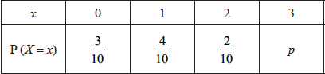

Find . *[3 marks]*

**1b.** Find . *[3 marks]*

**2a.** The following table shows the probability distribution of a discrete random variable .

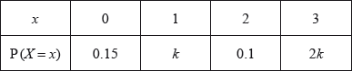

Find the value of . *[3 marks]*

**2b.** Find . *[2 marks]*

**3.** The random variable X has the following probability distribution.

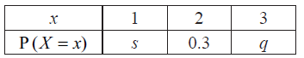

Given that  , find *q* . *[6 marks]*

**4a.** The probability distribution of a discrete random variable *X* is given by

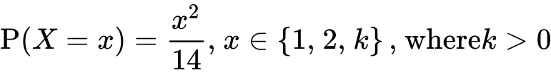.

Write down  . *[1 mark]*

**4b.** Show that  . *[4 marks]*

**4c.** Find  . *[2 marks]*

**5a.** *[3 marks]*

The following diagram shows a board which is divided into three regions ,  and .

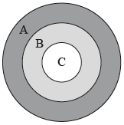

A game consists of a contestant throwing one dart at the board. The probability of hitting each region is given in the following table.

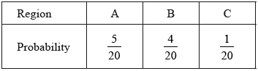

Find the probability that the dart does **not** hit the board.

**5b.** *[4 marks]*

The contestant scores points as shown in the following table.

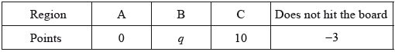

Given that the game is fair, find the value of .

**6a.** In a large university the probability that a student is left handed is 0.08. A sample of 150 students is randomly selected from the university. Let  be the expected number of left-handed students in this sample.

Find . *[2 marks]*

**6b.** Hence, find the probability that exactly  students are left handed; *[2 marks]*

**6c.** Hence, find the probability that fewer than  students are left handed. *[2 marks]*

**7a.** The following table shows a probability distribution for the random variable , where .

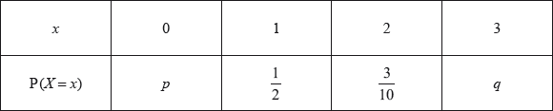

Find . *[2 marks]*

**7b.** Find . *[2 marks]*

**7c.** A bag contains white and blue marbles, with at least three of each colour. Three marbles are drawn from the bag, without replacement. The number of blue marbles drawn is given by the random variable .

Write down the probability of drawing three blue marbles. *[1 mark]*

**7d.** *[1 mark]*

Explain why the probability of drawing three white marbles is .

**7e.** *[3 marks]*

The bag contains a total of ten marbles of which  are white. Find .

**7f.** *[4 marks]*

A game is played in which three marbles are drawn from the bag of ten marbles, without replacement. A player wins a prize if three white marbles are drawn.

Grant plays the game until he wins two prizes. Find the probability that he wins his second prize on his eighth attempt.

**8a.** *[4 marks]*

The probability of obtaining “tails” when a biased coin is tossed is . The coin is tossed ten times. Find the probability of obtaining **at least** four tails.

**8b.** *[3 marks]*

The probability of obtaining “tails” when a biased coin is tossed is 0.57. The coin is tossed ten times. Find the probability of obtaining the fourth tail on the tenth toss.

**9a.** A jar contains 5 red discs, 10 blue discs and  green discs. A disc is selected at random and replaced. This process is performed four times.

Write down the probability that the first disc selected is red. *[1 mark]*

**9b.** *[5 marks]*

Let  be the number of red discs selected. Find the smallest value of  for which .

**10a.** Adam travels to school by car () or by bicycle (). On any particular day he is equally likely to travel by car or by bicycle.

The probability of being late () for school is  if he travels by car.

The probability of being late for school is  if he travels by bicycle.

This information is represented by the following tree diagram.

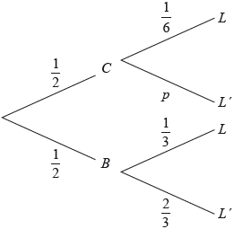

Find the value of . *[2 marks]*

**10b.** Find the probability that Adam will travel by car and be late for school. *[2 marks]*

**10c.** Find the probability that Adam will be late for school. *[4 marks]*

**10d.** Given that Adam is late for school, find the probability that he travelled by car. *[3 marks]*

**10e.** Adam will go to school three times next week.

Find the probability that Adam will be late exactly once. *[4 marks]*

**11a.** A bag contains four gold balls and six silver balls.

Two balls are drawn at random from the bag, with replacement. Let  be the number of gold balls drawn from the bag.

(i) Find  .

(ii) Find  .

(iii) Hence, find  . *[8 marks]*

**11b.** *[2 marks]*

Fourteen balls are drawn from the bag, with replacement.

Find the probability that exactly five of the balls are gold.

**11c.** *[2 marks]*

Find the probability that at most five of the balls are gold.

**11d.** *[3 marks]*

Given that at most five of the balls are gold, find the probability that exactly five of the balls are gold. Give the answer correct to two decimal places.