# 0329Test_statistics

**1a.** *[2 marks]*

Let  and  be independent events, where  and .

Find .

## Markscheme

correct substitution ***(A1)***

*eg* 

 ***A1 N2***

***[2 marks]***

**1b.** *[2 marks]*

Find .

## Markscheme

correct substitution ***(A1)***

*eg* 

 ***A1 N2***

***[2 marks]***

**1c.** *[1 mark]*

On the following Venn diagram, shade the region that represents .

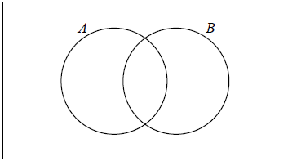

## Markscheme

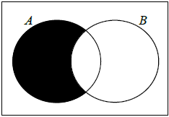 ***A1 N1***

**1d.** *[2 marks]*

Find .

## Markscheme

appropriate approach ***(M1)***

*eg* 

 (may be seen in Venn diagram) ***A1 N2***

***[2 marks]***

**2a.** *[4 marks]*

A factory makes lamps. The probability that a lamp is defective is 0.05. A random sample of 30 lamps is tested.

Find the probability that there is at least one defective lamp in the sample.

## Markscheme

evidence of recognizing binomial (seen anywhere) ***(M1)***

e.g. , 

finding  ***(A1)***

appropriate approach ***(M1)***

e.g. complement, summing probabilities



probability is  ***A1 N3***

***[4 marks]***

**2b.** *[4 marks]*

A factory makes lamps. The probability that a lamp is defective is 0.05. A random sample of 30 lamps is tested.

Given that there is at least one defective lamp in the sample, find the probability that there are at most two defective lamps.

## Markscheme

identifying correct outcomes (seen anywhere) ***(A1)***

*e.g.*  , 1 or 2 defective, 

recognizing conditional probability (seen anywhere) ***R1***

*e.g.*  ,  , P(at most 2|at least 1)

appropriate approach involving conditional probability ***(M1)***

*e.g.* 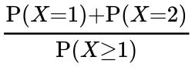 , 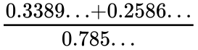 , 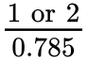



probability is  ***A1 N2***

***[4 marks]***

**3a.** *[2 marks]*

The following table shows the amount of fuel (litres) used by a car to travel certain distances (km).

|  |  |  |  |  |  |
| --- | --- | --- | --- | --- | --- |
| **Distance**  (  *x*  km) | 40 | 75 | 120 | 150 | 195 |
| **Amount of fuel**  (  *y*  litres) | 3.6 | 6.5 | 9.9 | 13.1 | 16.2 |

This data can be modelled by the regression line with equation .

Write down the value of  and of .

## Markscheme



 ***A1A1 N2***

***[2 marks]***

**3b.** *[1 mark]*

Explain what the gradient  represents.

## Markscheme

correct explanation with reference to number of litres

required for  km ***A1 N1***

*eg*  represents the (average) amount of fuel (litres) required to drive  km, (average) litres per kilometre, (average) rate of change in fuel used for each km travelled

***[1 marks]***

**3c.** *[2 marks]*

Use the model to estimate the amount of fuel the car would use if it is driven  km.

## Markscheme

valid approach ***(M1)***

*eg* , sketch



 (litres) ***A1 N2***

***[2 marks]***

**4a.** *[4 marks]*

The vectors ***a*** =  and ***b*** = 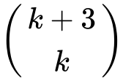 are perpendicular to each other.

Find the value of .

## Markscheme

evidence of scalar product ***M1***

*eg****a***  ***b***, 

recognizing scalar product must be zero ***(M1)***

*eg****a***  ***b*** 

correct working (must involve combining terms) ***(A1)***

*eg* 

 ***A1*** ***N2***

***[4 marks]***

**4b.** *[3 marks]*

Given that ***c*** = ***a*** + 2***b***, find ***c***.

## Markscheme

attempt to substitute **their** value of  (seen anywhere) ***(M1)***

*eg****b*** = 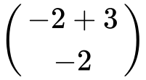, 2***b*** = 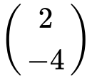

correct working ***(A1)***

*eg*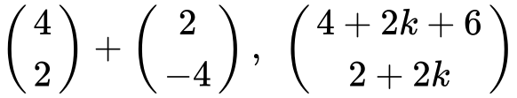

***c*** = 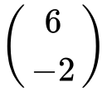 ***A1*** ***N2***

***[3 marks]***

**5a.** *[2 marks]*

A standard die is rolled 36 times. The results are shown in the following table.



Write down the standard deviation.

## Markscheme

 ***A2 N2***

***[2 marks]***

**5b.** *[1 mark]*

Write down the median score.

## Markscheme

median  ***A1 N1***

***[1 mark]***

**5c.** *[3 marks]*

Find the interquartile range.

## Markscheme

 ,  (may be seen in a box plot) ***(A1)(A1)***

 (accept any notation that suggests the interval 3 to 5)  ***A1 N3***

***[3 marks]***

**6a.** *[2 marks]*

Consider a function  such that 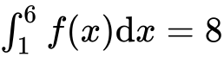.

Find 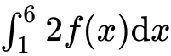.

## Markscheme

appropriate approach ***(M1)***

*eg* 

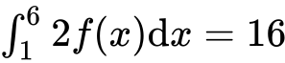 ***A1 N2***

***[2 marks]***

**6b.** *[4 marks]*

Find 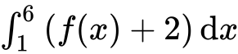.

## Markscheme

appropriate approach ***(M1)***

*eg* 

 (seen anywhere) ***(A1)***

substituting limits into **their** integrated function and subtracting (in any order) ***(M1)***

*eg* 

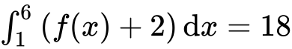 ***A1 N3***

***[4 marks]***

**7a.** *[2 marks]*

A van can take either Route A or Route B for a particular journey.

If Route A is taken, the journey time may be assumed to be normally distributed with mean 46 minutes and a standard deviation 10 minutes.

If Route B is taken, the journey time may be assumed to be normally distributed with mean  minutes and standard deviation 12 minutes.

For Route A, find the probability that the journey takes **more** than  minutes.

## Markscheme

 

 ***A2 N2***

***[2 marks]***

**7b.** *[3 marks]*

For Route B, the probability that the journey takes **less** than  minutes is .

Find the value of  .

## Markscheme

correct approach ***(A1)***

e.g. 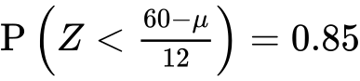 , sketch

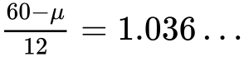 ***(A1)***

 ***A1 N2***

***[3 marks]***

**7c.** *[3 marks]*

The van sets out at 06:00 and needs to arrive before 07:00.

(i) Which route should it take?

(ii) Justify your answer.

## Markscheme

(i) route A ***A1 N1***

(ii) **METHOD 1**

 ***A1***

valid reason ***R1***

e.g. probability of *A* getting there on time is greater than probability of *B*

 ***N2***

**METHOD 2**

 ***A1***

valid reason ***R1***

e.g. probability of *A* getting there late is less than probability of *B*

 ***N2***

***[3 marks]***

**7d.** *[5 marks]*

On five consecutive days the van sets out at 06:00 and takes Route B. Find the probability that

(i) it arrives before 07:00 on all five days;

(ii) it arrives before 07:00 on at least three days.

## Markscheme

(i) let *X* be the number of days when the van arrives before 07:00

 ***(A1)***

 ***A1 N2***

(ii) **METHOD 1**

evidence of adding correct probabilities ***(M1)***

e.g. 

correct values  ***(A1)***

 ***A1 N3***

**METHOD 2**

evidence of using the complement ***(M1)***

e.g.  , 

correct values  ***(A1)***

 ***A1 N3***

***[5 marks]***

**8a.** *[4 marks]*

The weekly wages (in dollars) of 80 employees are displayed in the cumulative frequency curve below.

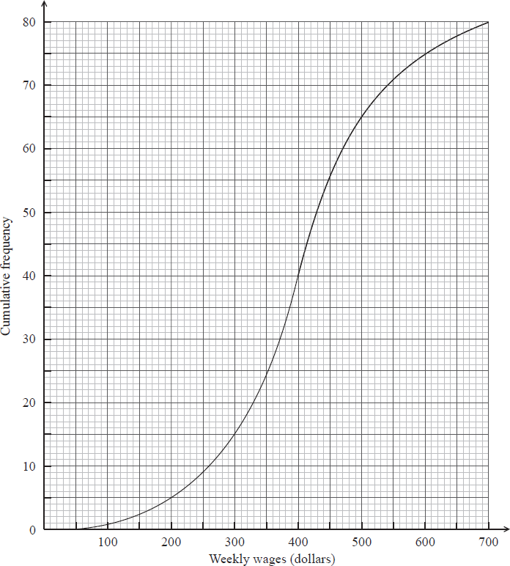

(i) Write down the median weekly wage.

(ii) Find the interquartile range of the weekly wages.

## Markscheme

(i) median weekly wage  (dollars) ***A1 N1***

(ii) lower quartile , upper quartile  ***(A1)(A1)***

 (dollars) (accept any notation suggesting interval  to ) ***A1 N3***

Note: Exception to the ***FT*** rule. Award ***A1(FT)*** for an incorrect IQR **only** if both quartiles are explicitly noted.

***[4 marks]***

**8b.** *[3 marks]*

The box-and-whisker plot below displays the weekly wages of the employees.

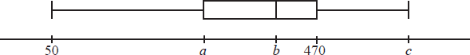

Write down the value of

(i)  ;

(ii)  ;

(iii)  .

## Markscheme

(i)  (dollars) ***A1 N1***

(ii)  (dollars) ***A1 N1***

(iii)  (dollars) ***A1 N1***

***[3 marks]***

**8c.** *[3 marks]*

Employees are paid  per hour.

Find the median number of **hours** worked per week.

## Markscheme

valid approach ***(M1)***

e.g. 

correct substitution ***(A1)***

e.g. 

median hours per week   ***A1 N2***

***[3 marks]***

**8d.** *[5 marks]*

Employees are paid  per hour.

Find the number of employees who work more than  hours per week.

## Markscheme

attempt to find wages for 25 hours per week  ***(M1)***

e.g. 

correct substitution  ***(A1)***

e.g. 

finding wages  ***(A1)***

65 people (earn 500) ***(A1)***

15 people (work more than 25 hours) ***A1 N3***

***[5 marks]***

Printed for Bronx Early College Academy

© International Baccalaureate Organization 2018

International Baccalaureate® - Baccalauréat International® - Bachillerato Internacional®