BECA / Huson / 12.1 IB Math SL Name:

20 March 2019

**7.3 Homework**: **Binomial distribution and review**

**1a.** A discrete random variable  has the following probability distribution.

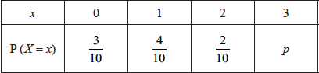

Find . *[3 marks]*

**1b.** Find . *[3 marks]*

**2a.** The random variable *X* has the following probability distribution, with  .  
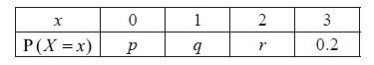

Find the value of *r* . *[2 marks]*

**2b.** Given that  , find the value of *p* and of *q* . *[6 marks]*

**3a.** The following diagram shows the graph of a function . There is a local minimum point at , where .

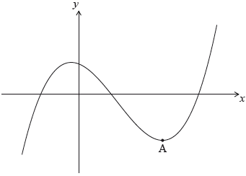

The derivative of  is given by .

Find the -coordinate of . *[5 marks]*

**3b.** The -intercept of the graph is at (). Find an expression for .

The graph of a function  is obtained by reflecting the graph of  in the -axis, followed by a translation of 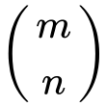. *[6 marks]*

**4a.** Let  be a family of lines with equation given by  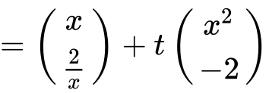, where .

Write down the equation of . *[2 marks]*

**4b.** A line  crosses the -axis at a point .

Show that  has coordinates 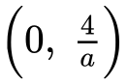. *[6 marks]*

**4c.** The line  crosses the -axis at . Let .

Show that 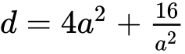. *[2 marks]*

**4d.** There is a minimum value for . Find the value of  that gives this minimum value. *[7 marks]*

**5a.** Part of the graph of  is shown below.

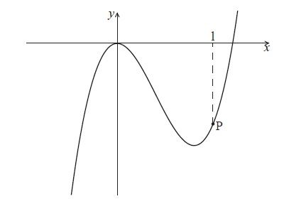

The point P lies on the graph of  . At P, *x* = 1.

Find  . *[2 marks]*

**5b.** The graph of  has a gradient of  at the point P. Find the value of  . *[4 marks]*

**6a.** In this question, you are given that 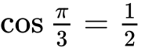 , and 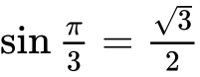 .

The displacement of an object from a fixed point, O is given by  for  .

Find  . *[3 marks]*

**6b.** In this interval, there are only two values of *t* for which the object is not moving. One value is  .

Find the other value. *[4 marks]*

**6c.** Show that  between these two values of *t* . *[3 marks]*

**6d.** Find the distance travelled between these two values of *t* . *[5 marks]*

**7a.** Consider the following sequence of figures.

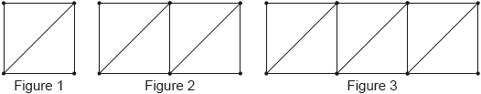

Figure 1 contains 5 line segments.

Given that Figure  contains 801 line segments, show that . *[3 marks]*

**7b.** Find the total number of line segments in the first 200 figures. *[3 marks]*

**8a.** Let  and . Write the following expressions in terms of  and .

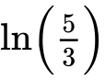. *[2 marks]*

**8b.** . *[4 marks]*

**9.** Three consecutive terms of a geometric sequence are , 6 and .

Find the possible values of . *[6 marks]*