# **7.4 Do Now Quiz: Periodic-functions, trigonometry spiral review** (with calculator)

Solve either the *Mild/Medium* problems (1, 3, 4, 5; 24 points) or the *Spicy* (2, 6; 30 points)

**1a.** *Medium:* Let  . The diagram below shows part of the graph of *f*, for  .

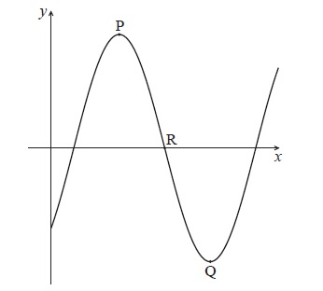

The graph has a local maximum at P(3, 5) , a local minimum at Q(7, − 5) , and crosses the *x*-axis at R.

Write down the value of

(i)      ;

(ii)     . *[2 marks]*

**1b.** Find the value of *b*. *[2 marks]*

**1c.** Find the *x*-coordinate of R. *[2 marks]*

**2a.** *Spicy:* The following diagram shows the graph of , for .

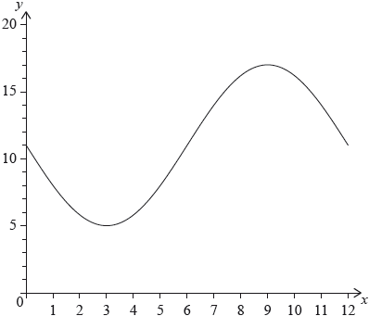

The graph of  has a minimum point at  and a maximum point at . *[6 marks]*

(i)     Find the value of .

(ii)     Show that .

(iii)     Find the value of .

**2b.** The graph of  is obtained from the graph of  by a translation of 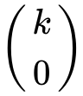. The maximum point on the graph of  has coordinates .

(i)     Write down the value of .

(ii)     Find . *[3 marks]*

**2c.** The graph of  changes from concave-up to concave-down when .

(i)     Find .

(ii)     Hence or otherwise, find the maximum positive rate of change of . *[6 marks]*

**3a.** *Mild:* Consider the following circle with centre O and radius 6.8 cm.

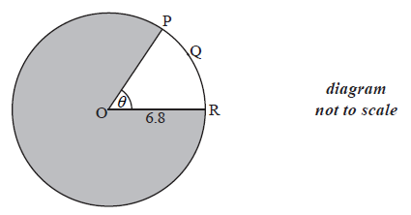

The length of the arc PQR is 8.5 cm.

Find the value of  . *[2 marks]*

**3b.** Find the area of the shaded region. *[4 marks]*

**4a.** *Mild:* Write down the value of

(i)     ; *[1 mark]*

(ii)     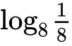; *[1 mark]*

(iii)     . *[1 mark]*

**4b.** Hence, solve 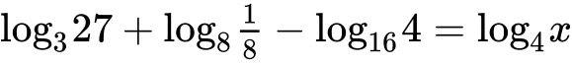. *[3 marks]*

**5a.** *Medium:* Let  .

Given that  , find the value of  . *[3 marks]*

**5b.** Find 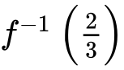. *[4 marks]*

**6a.** *Spicy:* The following diagram shows a triangle ABC.

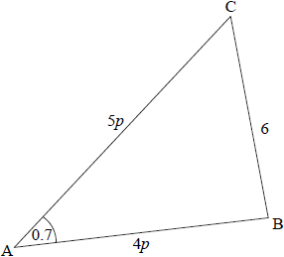

 ,  radians,  ,  , where  .

(i)     Show that  .

(ii)    Find *p*. *[4 marks]*

**6b.** Consider the circle with centre B that passes through the point C. The circle cuts the line CA at D, and  is obtuse. Part of the circle is shown in the following diagram.

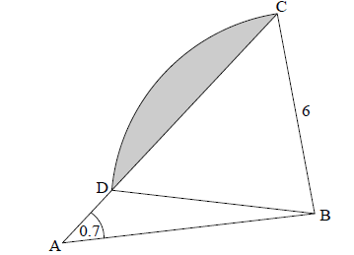

Write down the length of BD. *[1 mark]*

**6c.** Find  . *[4 marks]*

**6d.** (i)     Show that  radians, correct to 2 decimal places.

(ii)    Hence, find the area of the shaded region. *[6 marks]*