**Do Now: Pre-Exam Sequences and series**

**1a.** In an arithmetic sequence, the first term is 3 and the second term is 7.

Find the common difference. *[2 marks]*

**1b.** Find the tenth term. *[2 marks]*

**1c.** Find the sum of the first ten terms of the sequence. *[2 marks]*

**2a.** The first three terms of an arithmetic sequence are .

Find the common difference. *[2 marks]*

**2b.** Find the 30th term of the sequence. *[2 marks]*

**2c.** Find the sum of the first 30 terms. *[2 marks]*

**3a.** The first three terms of a geometric sequence are , and .

Find the value of . *[2 marks]*

**3b.** Find the value of . *[2 marks]*

**3c.** Find the least value of  such that . *[3 marks]*

**4a.** The first three terms of a geometric sequence are , , , for .

Find the common ratio. *[3 marks]*

**4b.** Solve 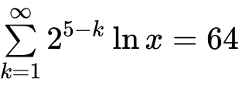. *[5 marks]*

**5.** Consider a geometric sequence where the first term is 768 and the second term is 576.

Find the least value of  such that the th term of the sequence is less than 7. *[6 marks]*

**Homework: Spicy IB Exam problems**

**6a.** Consider the following sequence of figures.

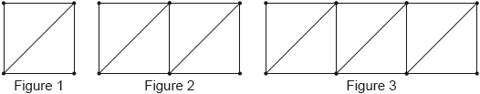

Figure 1 contains 5 line segments.

Given that Figure  contains 801 line segments, show that . *[3 marks]*

**6b.** Find the total number of line segments in the first 200 figures. *[3 marks]*

**7.** An arithmetic sequence has the first term  and a common difference .

The 13th term in the sequence is . Find the value of . *[6 marks]*

**8a.** The first two terms of an infinite geometric sequence, in order, are

, where .

Find . *[2 marks]*

**8b.** Show that the sum of the infinite sequence is . *[2 marks]*

**8c.** The first three terms of an arithmetic sequence, in order, are

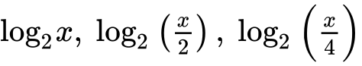, where .

Find , giving your answer as an integer. *[4 marks]*

**8d.** Let  be the sum of the first 12 terms of the arithmetic sequence.

Show that . *[2 marks]*

**8e.** Given that  is equal to half the sum of the infinite geometric sequence, find , giving your answer in the form , where . *[3 marks]*