BECA / Huson / IB Math Name:

18 April 2019

Break packet: Review of function operations and quadratics

**1.** *[6 marks]* The diagram below shows part of the graph of  .

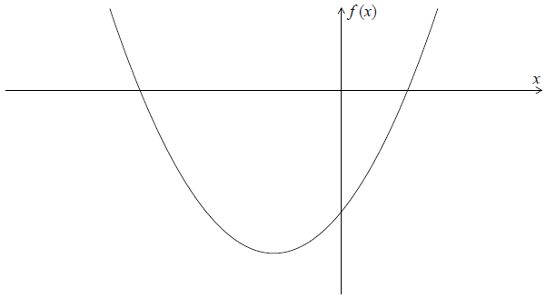

**1a.** *[2 marks]* Write down the -intercepts of the graph of  .

**1b.** *[4 marks]* Find the coordinates of the vertex of the graph of  .

**2a.** *[3 marks]* Let  , for  .

Find  .

**2b.** Let  be a function such that  exists for all real numbers. Given that  , find  . *[3 marks]*

**3a.** Let  and  .

Find  . *[3 marks]*

**3b.** Find  . *[3 marks]*

**4a.** The diagram below shows the graph of a function  , for  .

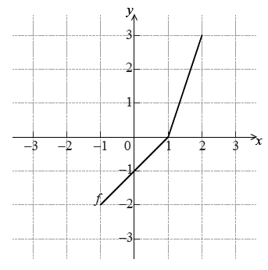

Write down the value of . *[1 mark]*

**4b.** Write down the value of  . *[2 marks]*

**4c.** Sketch the graph of  on the grid below. *[3 marks]*

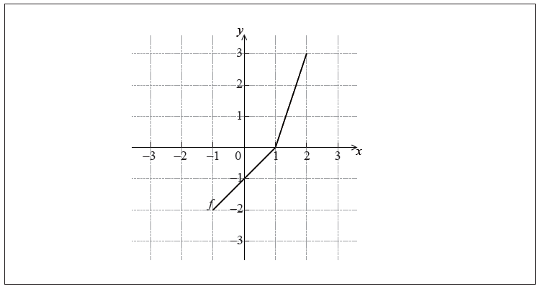

**5a.** Let  and  be functions such that  .

(a) The graph of  is mapped to the graph of  under the following transformations:

vertical stretch by a factor of  , followed by a translation 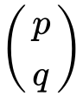 .

Write down the value of *[6 marks]*

(i)  ;

(ii)  ;

(iii)  .

**5b.** Let  . The point A(, ) on the graph of  is mapped to the point  on the graph of  . Find  . *[3 marks]*

**6.** *[6 marks]* The equation  has two distinct real roots. Find the possible values of *k* .

**7a.** *[4 marks]* Consider the function  .

Sketch the graph of *f* , for  .

**7b.** This function can also be written as  .

Write down the value of *p* . *[1 mark]*

**7c.** The graph of *g* is obtained by reflecting the graph of *f* in the *x*-axis, followed by a translation of 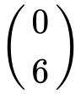 .

Show that  . *[4 marks]*

**7d.** The graphs of *f* and *g* intersect at two points.

Write down the *x*-coordinates of these two points. *[3 marks]*

**8a.** Let  and  .

Find  . *[3 marks]*

**8b.** Find  . *[3 marks]*

**9a.** The diagram below shows the graph of a function  , for  .

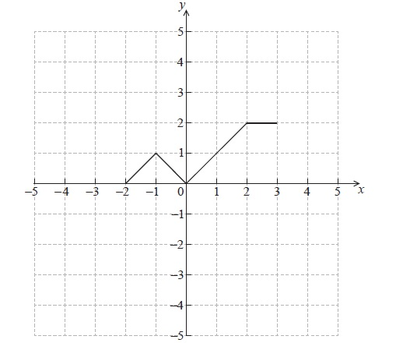

Sketch the graph of  on the grid below. *[2 marks]*

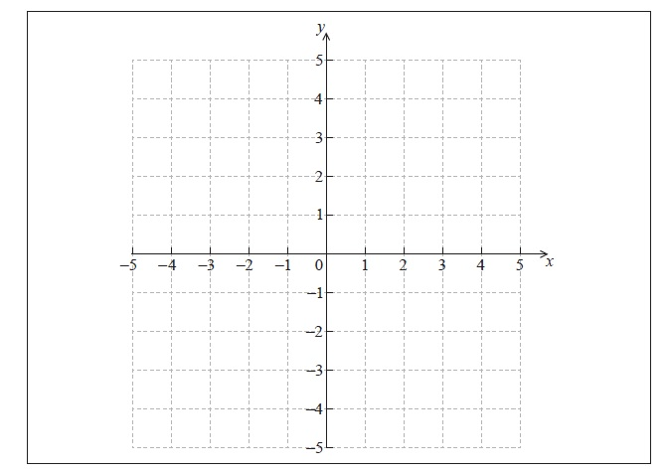

**9b.** The graph of *f* is transformed to obtain the graph of *g* . The graph of *g* is shown below. *[4 marks]*

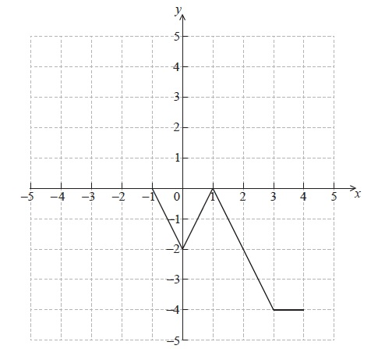

The function *g* can be written in the form  . Write down the value of *a* and of *b* .

**10.** Consider the equation  , where *k* is a real number.

Find the values of *k* for which the equation has two **equal** real solutions. *[7 marks]*

**11a.** Let  . *[4 marks]*

(i) Write down the coordinates of the vertex.

(ii) Hence or otherwise, express the function in the form  .

**11b.** Solve the equation  . *[3 marks]*

**15.** Let  , where  . The function *v* is obtained when the graph of *f* is transformed by

a stretch by a scale factor of  parallel to the *y*-axis,

followed by a translation by the vector 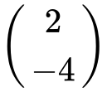 .

Find  , giving your answer in the form  . *[4 marks]*

**12a.** Let  be a quadratic function. Part of the graph of  is shown below.

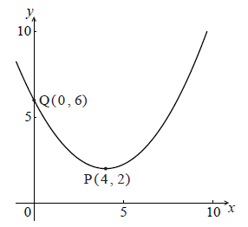

The vertex is at P(, ) and the *y*-intercept is at Q(, ) .

Write down the equation of the axis of symmetry. *[1 mark]*

**12b.** The function *f* can be written in the form  .

Write down the value of *h* and of *k* . *[2 marks]*

**12c.** Find *a* . *[3 marks]*

**13a.** Let  and  .

Find  . *[3 marks]*

**13b.** Find  . *[2 marks]*

**13c.** Find  . *[2 marks]*

**14a.** Jose takes medication. After *t* minutes, the concentration of medication left in his bloodstream is given by  , where *A* is in milligrams per litre.

Write down  . *[1 mark]*

**14b.** Find the concentration of medication left in his bloodstream after 50 minutes. *[2 marks]*

**14c.** At 13:00, when there is no medication in Jose’s bloodstream, he takes his first dose of medication. He can take his medication again when the concentration of medication reaches 0.395 milligrams per litre. What time will Jose be able to take his medication again? *[5 marks]*