Demo Sample Huson 1

Dr. Huson

11.1 IB Math SL

25 March 2019

An Illustration of the Fibonacci Sequence

Create an image in Geogebra based on a spiral layout of the Fibonacci sequence, as shown, for example, in Figure 1. Copy it to MS Word and write a short exposition. You should show the recursive formula for the sequence (use the Equation Editor).

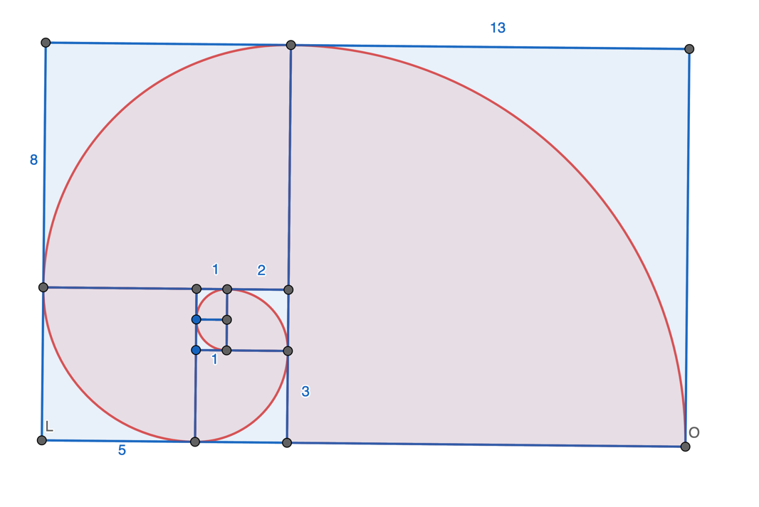

Figure 1: Fibonacci sequence depicted as squares laid out in a spiral pattern

As a further exploration, consider the ratio of consecutive terms in the sequence. At the limit, they go to the Golden Mean.