**Exam: Statistics, sequences, overall review (complete on lined paper)**

**1a.** Consider the following data.

7, 5, 8, 7, 9, 11, 7, 11, 10

Write down the mode. *[1 mark]*

**1b.** Find the value of the range. *[2 marks]*

**1c.** Find the mean. *[2 marks]*

**1d.** Find the median. *[2 marks]*

**2a.** The first three terms of an arithmetic sequence are $u_{1}=7.1, u_{2}=7.8,u_{3}=8.5$.

Find the common difference. *[2 marks]*

**2b.** Find the 18th term of the sequence. *[2 marks]*

**2c.** Find the sum of the first 18 terms. *[2 marks]*

**3a.** Let $f\left(x\right)=e^{0.75x}-3$.

For the graph of *f*:

(i) write down the *y*-intercept;

(ii) find the *x*-intercept;

(iii) write down the equation of the horizontal asymptote. *[4 marks]*

**3b.** On the grid on page 5, sketch the graph of *f*, for $-3≤x≤3$. *[3 marks]*

**4a.** Let $f\left(x\right)=x^{2}-x-12$.

Write down the *y*-intercept of the graph of *f*. *[1 mark]*

**4b.** Solve . *[3 marks]*

**5a.** The following box-and-whisker plot represents the examination scores of a group of students.

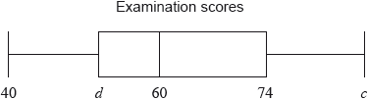

Write down the median score. *[1 mark]*

The range of the scores is 42 marks, and the interquartile range is 23 marks.

**5b.** Find the value of

(i) ;

(ii) . *[4 marks]*

**5c.** What percentage of the data are between 60 and 74? *[1 marks]*

**6.** Three consecutive terms of a geometric sequence are $x-3, 4, and x+3$.

Find the possible values of *x*. *[6 marks]*

**7a.** Let $f\left(x\right)=2\ln{x}$ and $g\left(x\right)=\ln{{3x}^{2}}$.

Express  in the form  , where  . *[4 marks]*

**7b.** The graph of *g* is a transformation of the graph of *f* . Give a full geometric description of this transformation. *[3 marks]*

**8a.** There are 25 items in a data set. The sum of the items is 35.

Find the mean. *[2 marks]*

**8b.** Each value in the set is multiplied by 2. Write down the value of the new mean. *[1 mark]*

**9.** Solve $\log_{2}{x}+\log_{2}\left(x-6\right)=4$, for  . *[7 marks]*

**10a.** Let $f\left(x\right)=8{(x-3)}^{2}$, for *x* > 0.

Find . *[3 marks]*

**10b.** Let  be a function so that . Find . *[3 marks]*

**11a.** The equation $x^{2}+kx+36=0$ has no real solutions.

Find all possible values of *k.* *[6 marks]*

**(continued from page 1)**

**3** Let $f\left(x\right)=e^{0.75x}-3$.

**3b.** On the grid below, sketch the graph of *f*, for $-3≤x≤3$. *[3 marks]*

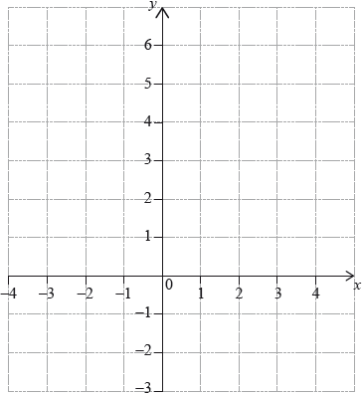

**12a.** The following diagram shows the graph of a function .

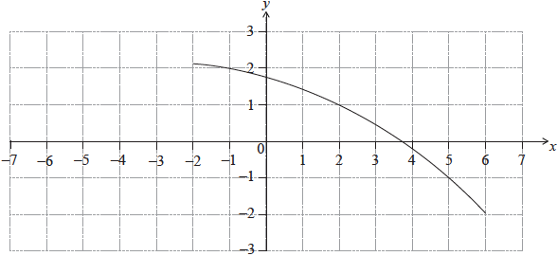

Find . *[2 marks]*

**13b.** Find . *[3 marks]*

**13c.** On the same diagram, sketch the graph of . *[2 marks]*