**Test: Statistics**

**8a.** The weekly wages (in dollars) of 80 employees are displayed in the cumulative frequency curve below.

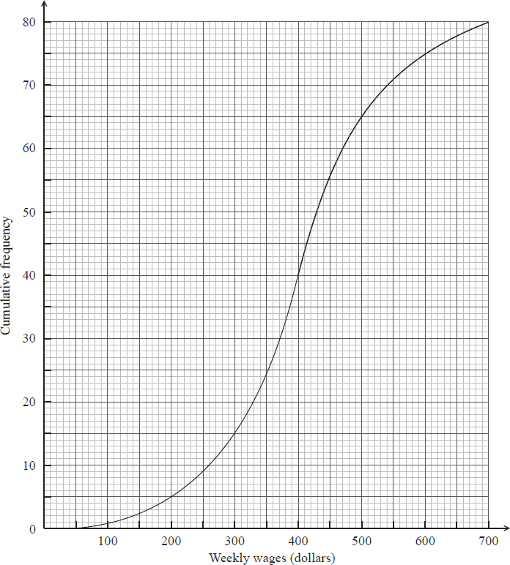

(i) Write down the median weekly wage.

(ii) Find the interquartile range of the weekly wages. *[4 marks]*

**8b.** The box-and-whisker plot below displays the weekly wages of the employees.

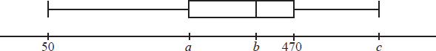

Write down the value of

(i)  ;

(ii)  ;

(iii)  . *[3 marks]*

**8c.** Employees are paid  per hour.

Find the median number of **hours** worked per week. *[3 marks]*

**8d.** Find the number of employees who work more than  hours per week. *[5 marks]*