BECA / Huson / IB Math Name:

22 November 2017

Pre-Exam: Sequences & geometry - **Markscheme**

**1a.** *[2 marks]* The first three terms of an arithmetic sequence are 5 , 6.7 , 8.4 .

Find the common difference.

## Markscheme

valid method ***(M1)***

e.g. subtracting terms, using sequence formula

 ***A1 N2***

***[2 marks]***

**1b.** *[2 marks]* Find the 28th term of the sequence.

## Markscheme

correct substitution into term formula ***(A1)***

e.g. 

28th term is 50.9 (exact) ***A1 N2***

***[2 marks]***

**1c.** *[2 marks]* Find the sum of the first 28 terms.

## Markscheme

correct substitution into sum formula ***(A1)***

e.g.  , 

 (exact) [, ] ***A1 N2***

***[2 marks]***

**2a.** *[4 marks]* The first term of a geometric sequence is 200 and the sum of the first four terms is 324.8.

Find the common ratio.

## Markscheme

correct substitution into sum of a geometric sequence ***(A1)***

e.g. 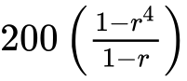 , 

attempt to set up an equation involving a sum and 324.8 ***M1***

e.g. 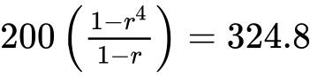 , 

 (exact) ***A2 N3***

***[4 marks]***

**2b.** *[2 marks]* Find the tenth term.

## Markscheme

correct substitution into formula ***A1***

e.g. 

 (exact),  ***A1 N1***

***[2 marks]***

**3a.** *[2 marks]* In an arithmetic sequence,  and  .

Find *d* .

## Markscheme

attempt to find *d* ***(M1)***

e.g. 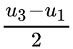 , 

 ***A1 N2***

***[2 marks]***

**3b.** *[2 marks]* Find  .

## Markscheme

correct substitution ***(A1)***

e.g.  , 

 ***A1 N2***

***[2 marks]***

**3c.** *[2 marks]* Find  .

## Markscheme

correct substitution ***(A1)***

e.g.  , 

 ***A1 N2***

***[2 marks]***

**4a.** *[3 marks]* In an arithmetic sequence  ,  and  .

Find the value of the common difference.

## Markscheme

evidence of choosing the formula for 20th term  ***(M1)***

e.g. 

correct equation ***A1***

e.g.  , 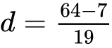

 ***A1 N2***

***[3 marks]***

**4b.** *[2 marks]* Find the value of *n* .

## Markscheme

correct substitution into formula for  ***A1***

e.g.  , 

 ***A1 N1***

***[2 marks]***

**5a.** *[1 mark]* The first three terms of an infinite geometric sequence are 32, 16 and 8.

Write down the value of *r* .

## Markscheme

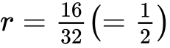 ***A1 N1***

***[1 mark]***

**5b.** *[2 marks]* Find  .

## Markscheme

correct calculation or listing terms ***(A1)***

e.g. 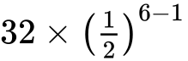 , 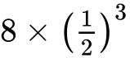 , 32,  4, 2, 1

 ***A1 N2***

***[2 marks]***

**5c.** *[2 marks]* Find the sum to infinity of this sequence.

## Markscheme

evidence of correct substitution in  ***A1***

e.g. 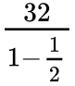 , 

 ***A1 N1***

***[2 marks]***

**6a.** *[1 mark]* Consider the arithmetic sequence 3, 9, 15,  , 1353 .

Write down the common difference.

## Markscheme

common difference is 6 ***A1 N1***

***[1 mark]***

**6b.** *[3 marks]* Find the number of terms in the sequence.

## Markscheme

evidence of appropriate approach ***(M1)***

e.g. 

correct working ***A1***

e.g.  , 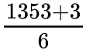

 ***A1 N2***

***[3 marks]***

**6c.** *[2 marks]* Find the sum of the sequence.

## Markscheme

evidence of correct substitution ***A1***

e.g. 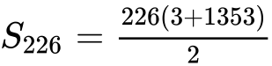 , 

 (accept 153000) ***A1 N1***

***[2 marks]***

**7a.** *[1 mark]* The following diagram shows  , where RQ = 9 cm,  and  .

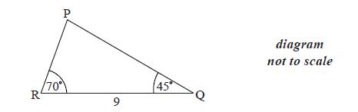

Find  .

## Markscheme

 ***A1 N1***

***[1 mark]***

**7b.** *[3 marks]* Find PR .

## Markscheme

evidence of choosing sine rule ***(M1)***

correct substitution ***A1***

e.g. 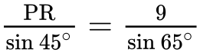

7.021854078

 ***A1 N2*** ***[3 marks]***

**7c.** *[2 marks]* Find the area of  .

## Markscheme

correct substitution  ***(A1)***

e.g. 



 ***A1 N2***

***[2 marks]***

**8a.** *[2 marks]*

Consider the following circle with centre O and radius 6.8 cm.

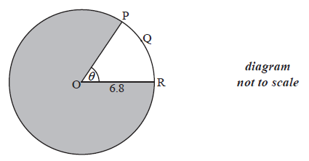

The length of the arc PQR is 8.5 cm.

Find the value of  .

## Markscheme

correct substitution ***(A1)***

e.g.  , 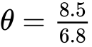

 (accept  ) ***A1 N2***

***[2 marks]***

**8b.** *[4 marks]*

Find the area of the shaded region.

## Markscheme

**METHOD 1**

correct substitution into area formula (seen anywhere)  ***(A1)***

e.g.  , 

correct substitution into area formula (seen anywhere) ***(A1)***

e.g.  , 28.9

valid approach ***M1***

e.g.  ;  ; 

 () ***A1 N2***

**METHOD 2**

attempt to find reflex angle ***(M1)***

e.g.  , 

correct reflex angle ***(A1)***

 ()

correct substitution into area formula ***A1***

e.g. 

 () ***A1 N2***

***[4 marks]***

**9a.** *[4 marks]*

Consider the triangle ABC, where AB =10 , BC = 7 and  =  .

Find the two possible values of  .

## Markscheme

**Note**: accept answers given in degrees, and minutes.

evidence of choosing sine rule ***(M1)***

e.g. 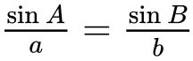

correct substitution ***A1***

e.g. 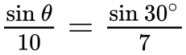 , 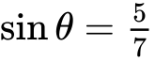

 ,  ***A1A1 N1N1***

**Note**: If candidates only find the acute angle in part (a), award no marks for (b).

***[4 marks]***

**9b.** *[2 marks]*

Hence, find  , given that it is acute.

## Markscheme

attempt to substitute their larger value into angle sum of triangle ***(M1)***

e.g. 

 ***A1 N2***

***[2 marks]***

**10a.** *[3 marks]*

The following diagram shows triangle ABC .

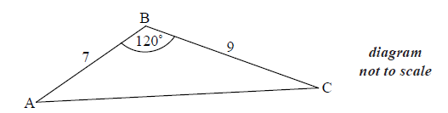

AB = 7 cm, BC = 9 cm and  .

Find AC .

## Markscheme

evidence of choosing cosine rule ***(M1)***

e.g. 

correct substitution ***A1***

e.g. 

  ***A1 N2***

***[3 marks]***

**10b.** *[3 marks]*

Find  .

## Markscheme

**METHOD 1**

evidence of choosing sine rule ***(M1)***

e.g. 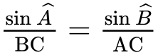

correct substitution  ***A1***

e.g. 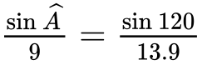

 ***A1 N2***

**METHOD 2**

evidence of choosing cosine rule ***(M1)***

e.g. 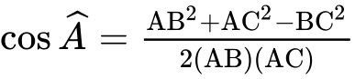

correct substitution ***A1***

e.g. 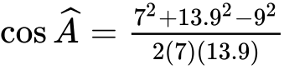

 ***A1 N2***

***[3 marks]***

**11a.** *[4 marks]*

The following diagram shows the triangle ABC.

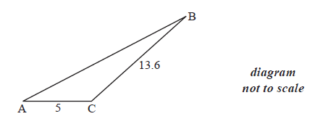

The angle at C is obtuse, ,  and the area is  .

Find  .

## Markscheme

correct substitution into the formula for the area of a triangle ***A1***

e.g.  , 

attempt to solve ***(M1)***

e.g.  , 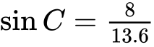

 () ***(A1)***

  ***A1 N3***

***[4 marks]***

**11b.** *[3 marks]*

Find AB.

## Markscheme

evidence of choosing the cosine rule  ***(M1)***

correct substitution ***A1***

e.g. 

 ***A1 N2***

***[3 marks]***

**12a.** *[5 marks]*

Let  , for  .

Use the quotient rule to show that 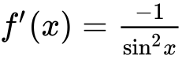 .

## Markscheme

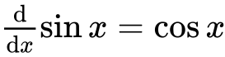 , 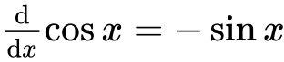 (seen anywhere) ***(A1)(A1)***

evidence of using the quotient rule ***M1***

correct substitution ***A1***

e.g. 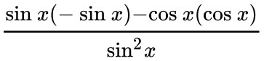 , 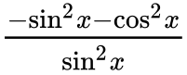

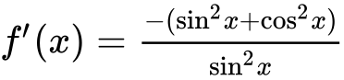 ***A1***

 ***AG N0***

***[5 marks]***

**12b.** *[3 marks]*

Find  .

## Markscheme

**METHOD 1**

appropriate approach ***(M1)***

e.g. 

 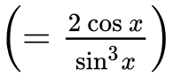 ***A1A1 N3***

**Note**: Award ***A1*** for  , ***A1*** for  .

**METHOD 2**

derivative of  (seen anywhere) ***A1***

evidence of choosing quotient rule ***(M1)***

e.g.  ,  , 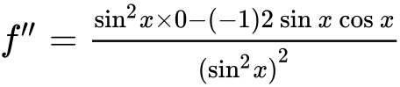

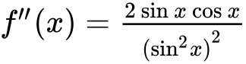  ***A1 N3***

***[3 marks]***

**12c.** *[3 marks]*

In the following table,  and  . The table also gives approximate values of  and  near  .

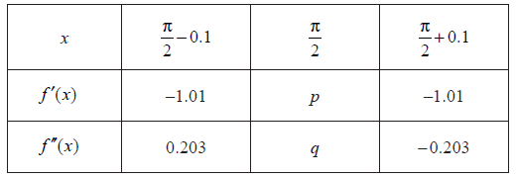

Find the value of *p* and of *q*.

## Markscheme

evidence of substituting  ***M1***

e.g. 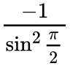 , 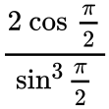

 ,  ***A1A1 N1N1***

***[3 marks]***

**12d.** *[2 marks]*

Use information from the table to explain why there is a point of inflexion on the graph of *f* where  .

## Markscheme

second derivative is zero, second derivative changes sign ***R1R1 N2***

***[2 marks]***

**13a.** *[2 marks]*

Let  and  .

Find  .

## Markscheme

 ***(A1)***

 ***A1 N2***

***[2 marks]***

**13b.** *[2 marks]*

Find  .

## Markscheme

  ***(A1)***

 ***A1 N2***

***[2 marks]***

**13c.** *[3 marks]*

Given that  can be written as  , find the value of *k*,  .

## Markscheme

  ***A1***

evidence of  (seen anywhere) ***(M1)***



 ***A1 N2***

***[3 marks]***