# 1208CW Vector + Calculus

**1.** *[7 marks]*

Line  has equation 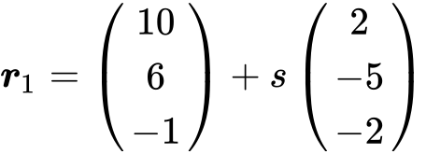 and line  has equation 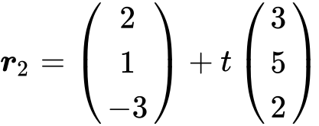 .

Lines  and  intersect at point A. Find the coordinates of A.

**2a.** *[2 marks]*

The line *L* passes through the point  and is parallel to the vector 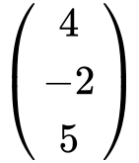 .

Write down a vector equation for line *L* .

**2b.** *[6 marks]*

The line *L* intersects the *x*-axis at the point P. Find the *x*-coordinate of P.

**3a.** *[2 marks]*

Consider points A(, , ) , B(, , ) and C(, , ) . The line  passes through C and is parallel to  .

Find  .

**3b.** *[2 marks]*

Hence, write down a vector equation for  .

**3c.** *[3 marks]*

Consider points A(, , ) , B(, , ) and C(, , ) . The line  passes through C and is parallel to  .

A second line,  , is given by 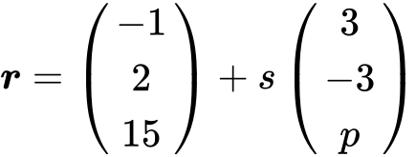 .

Given that  is perpendicular to  , show that  .

**3d.** *[7 marks]*

Consider points A(, , ) , B(, , ) and C(, , ) . The line  passes through C and is parallel to  .

A second line,  , is given by  .

The line  intersects the line  at point Q. Find the -coordinate of Q.