BECA / Huson / IB Math Name:

22 November 2017

Pre-Exam: Vectors+Calculus - **Markscheme**

**1a.** *[2 marks]* In the following diagram,  = ***p***, 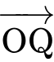 = ***q*** and 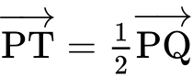.

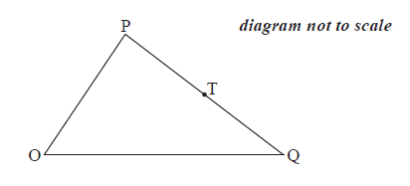

Express each of the following vectors in terms of ***p*** and ***q***,

;

## Markscheme

appropriate approach ***(M1)***

*eg* 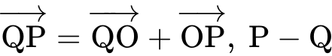

 = ***p*** – ***q*** ***A1 N2*** ***[2 marks]***

**1b.** *[3 marks]* 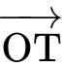.

## Markscheme

recognizing correct vector for 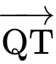 or  ***(A1)***

*eg* 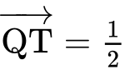(***p*** – ***q***), 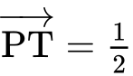(***q*** – ***p***)

appropriate approach ***(M1)***

*eg* 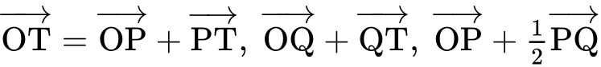

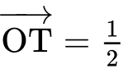(***p*** + ***q***) 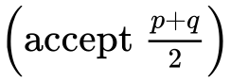 ***A1 N2*** ***[3 marks]***

**2a.** *[3 marks]*

Consider the points A(, , ) , B(, , ) , and C(, , ) ,  .

Find

(i)  ;

(ii)  .

## Markscheme

(i) appropriate approach ***(M1)***

*eg*  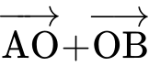 , 

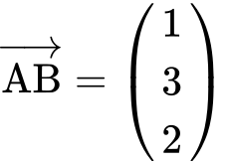 ***A1 N2***

(ii) 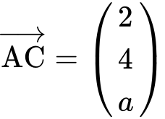 ***A1 N1***

***[3 marks]***

**2b.** *[4 marks]*

Let  be the angle between  and  .

Find the value of  for which  .

## Markscheme

valid reasoning (seen anywhere) ***R1***

*eg*  scalar product is zero, 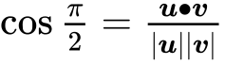

correct scalar product of **their**  and  (may be seen in part (c))  ***(A1)***

*eg*  

correct working for **their**  and  ***(A1)***

*eg*   , 

 ***A1 N3***

***[4 marks]***

**2c.** *[8 marks]*

i. Show that 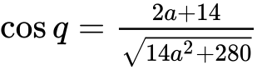 .

ii. Hence, find the value of a for which  .

## Markscheme

correct magnitudes (may be seen in (b)) ***(A1)(A1)***

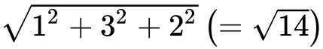 , 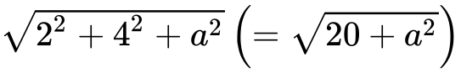

substitution into formula ***(M1)***

*eg*  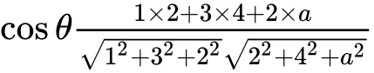 , 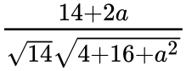

simplification leading to required answer ***A1***

*eg*  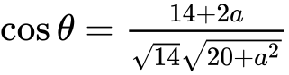

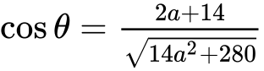 ***AG N0***

***[4 marks]***

correct setup ***(A1)***

*eg*  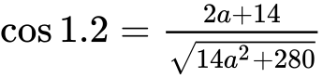

valid attempt to solve ***(M1)***

*eg* sketch, 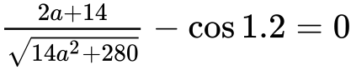 , attempt to square

 ***A2 N3***

***[4 marks]***

**2d.** *[4 marks]*

Hence, find the value of a for which  .

## Markscheme

correct setup ***(A1)***

*eg*  

valid attempt to solve ***(M1)***

*eg* sketch,  , attempt to square

 ***A2 N3***

***[4 marks]***

**3a.** *[2 marks]*

The following diagram shows quadrilateral ABCD, with 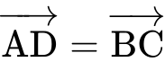 , 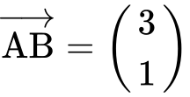 , and 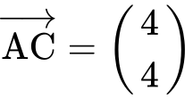 .

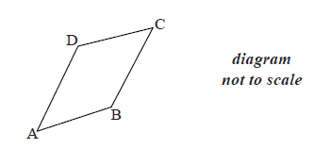

Find  .

## Markscheme

evidence of appropriate approach ***(M1)***

e.g. 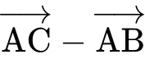 , 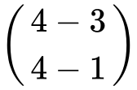

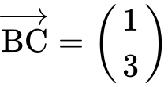 ***A1 N2***

***[2 marks]***

**3b.** *[2 marks]*

Show that 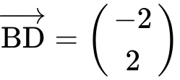 .

## Markscheme

**METHOD 1**

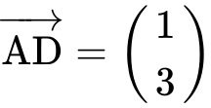 ***(A1)***

correct approach ***A1***

e.g. 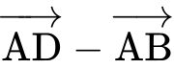 , 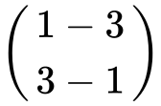

 ***AG N0***

**METHOD 2**

recognizing 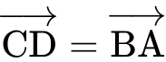 ***(A1)***

correct approach ***A1***

e.g. 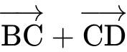 , 

 ***AG N0***

***[2 marks]***

**3c.** *[3 marks]*

Show that vectors  and  are perpendicular.

## Markscheme

**METHOD 1**

evidence of scalar product ***(M1)***

e.g. 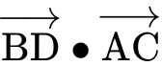 , 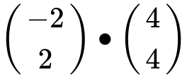

correct substitution ***A1***

e.g.  , 

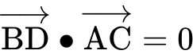 ***A1***

therefore vectors  and  are perpendicular ***AG N0***

**METHOD 2**

attempt to find angle between two vectors ***(M1)***

e.g. 

correct substitution ***A1***

e.g. 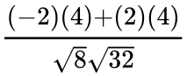 , 

 ***A1***

therefore vectors  and  are perpendicular ***AG N0***

***[3 marks]***

**4a.** *[2 marks]*

Let  , where *a* , *b* and *c* are real numbers. The graph of *f* passes through the point (2, 9) .

Show that  .

## Markscheme

attempt to substitute coordinates in *f* ***(M1)***

e.g. 

correct substitution ***A1***

e.g. 

 ***AG N0***

***[2 marks]***

**4b.** *[7 marks]*

The graph of *f* has a local minimum at  .

Find two other equations in *a* , *b* and *c* , giving your answers in a similar form to part (a).

## Markscheme

recognizing that  is on the graph of *f* ***(M1)***

e.g. 

correct equation ***A1***

e.g. 

recognizing that  at minimum (seen anywhere) ***(M1)***

e.g. 

 (seen anywhere) ***A1A1***

correct substitution into derivative ***(A1)***

e.g. 

correct simplified equation ***A1***

e.g. 

***[7 marks]***

**4c.** *[4 marks]*

Find the value of *a* , of *b* and of *c* .

## Markscheme

valid method for solving system of equations ***(M1)***

e.g. inverse of a matrix, substitution

 ,  ,  ***A1A1A1 N4***

***[4 marks]***

**5a.** *[4 marks]*

Let 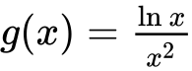 , for  .

Use the quotient rule to show that 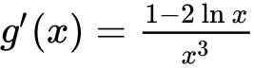 .

## Markscheme

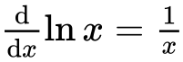 , 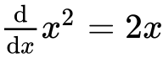 (seen anywhere) ***A1A1***

attempt to substitute into the quotient rule (do **not** accept product rule) ***M1***

e.g. 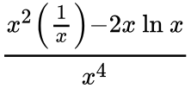

correct manipulation that clearly leads to result ***A1***

e.g. 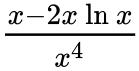 , 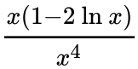 ,  , 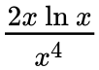

 ***AG N0***

***[4 marks]***

**5b.** *[3 marks]*

The graph of *g* has a maximum point at A. Find the *x*-coordinate of A.

## Markscheme

evidence of setting the derivative equal to zero ***(M1)***

e.g.  , 

 ***A1***

 ***A1 N2***

***[3 marks]***

**6a.** *[2 marks]*

The following diagram shows part of the graph of a quadratic function *f* .

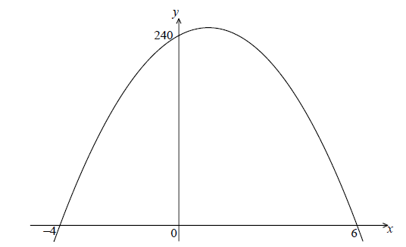

The *x*-intercepts are at  and  , and the *y*-intercept is at  .

Write down  in the form  .

## Markscheme

 ***A1A1 N2***

***[2 marks]***

**6b.** *[4 marks]*

Find another expression for  in the form  .

## Markscheme

**METHOD 1**

attempting to find the *x*-coordinate of maximum point ***(M1)***

e.g. averaging the *x*-intercepts, sketch,  , axis of symmetry

attempting to find the *y*-coordinate of maximum point  ***(M1)***

e.g. 

 ***A1A1 N4***

**METHOD 2**

attempt to expand  ***(M1)***

e.g. 

attempt to complete the square ***(M1)***

e.g. 

 ***A1A1 N4***

***[4 marks]***

**6c.** *[2 marks]*

Show that  can also be written in the form  .

## Markscheme

attempt to simplify ***(M1)***

e.g. distributive property, 

correct simplification ***A1***

e.g.  , 

 ***AG N0***

***[2 marks]***

**6d.** *[7 marks]*

A particle moves along a straight line so that its velocity,  , at time *t* seconds is given by  , for  .

(i) Find the value of *t* when the speed of the particle is greatest.

(ii) Find the acceleration of the particle when its speed is zero.

## Markscheme

(i) valid approach ***(M1)***

e.g. vertex of parabola, 

 ***A1 N2***

(ii) recognizing  ***(M1)***

 ***A1A1***

speed is zero  ***(A1)***

 () ***A1 N3***

***[7 marks]***

**7a.** *[2 marks]*

The following diagram shows the graph of  .

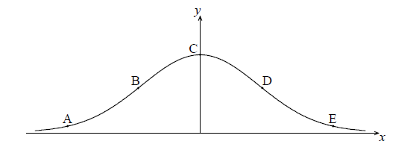

The points A, B, C, D and E lie on the graph of *f* . Two of these are points of inflexion.

Identify the **two** points of inflexion.

## Markscheme

B, D ***A1A1 N2***

***[2 marks]***

**7b.** *[5 marks]*

(i) Find  .

(ii) Show that  .

## Markscheme

(i)  ***A1A1 N2***

**Note**: Award ***A1*** for  and ***A1*** for  .

(ii) finding the derivative of  , i.e.  ***(A1)***

evidence of choosing the product rule ***(M1)***

e.g.  

 ***A1***

 ***AG N0***

***[5 marks]***

**7c.** *[4 marks]*

Find the *x*-coordinate of each point of inflexion.

## Markscheme

valid reasoning ***R1***

e.g. 

attempting to solve the equation ***(M1)***

e.g.  , sketch of 

 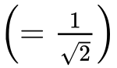 ,  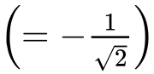 ***A1A1 N3***

***[4 marks]***

**7d.** *[4 marks]*

Use the second derivative to show that one of these points is a point of inflexion.

## Markscheme

evidence of using second derivative to test values on either side of POI ***M1***

e.g. finding values, reference to graph of  , sign table

correct working ***A1A1***

e.g. finding any two correct values either side of POI,

checking sign of  on either side of POI

reference to sign change of  ***R1 N0***

***[4 marks]***

**8a.** *[4 marks]*

Let  .

Find  .

## Markscheme

evidence of choosing the product rule  ***(M1)***

e.g. 

correct derivatives  , 2 ***(A1)(A1)***

 ***A1 N4***

***[4 marks]***

**8b.** *[3 marks]*

Find the gradient of the graph of *g* at  .

## Markscheme

attempt to substitute into gradient function ***(M1)***

e.g. 

correct substitution ***(A1)***

e.g. 

 ***A1 N2***

***[3 marks]***

**9a.** *[3 marks]*

Let  .

There are two points of inflexion on the graph of *f* . Write down the *x*-coordinates of these points.

## Markscheme

valid approach ***R1***

e.g.  , the max and min of  gives the points of inflexion on *f*

 (accept () and () ***A1A1 N1N1***

***[3 marks]***

**9b.** *[2 marks]*

Let  . Explain why the graph of *g* has no points of inflexion.

## Markscheme

**METHOD 1**

graph of *g* is a quadratic function ***R1 N1***

a quadratic function does not have any points of inflexion ***R1 N1***

**METHOD 2**

graph of *g* is concave down over entire domain ***R1 N1***

therefore no change in concavity ***R1 N1***

**METHOD 3**

 ***R1 N1***

therefore no points of inflexion as   ***R1 N1***

***[2 marks]***

**10a.** *[8 marks]*

Let  . Part of the graph of *f* is shown below.

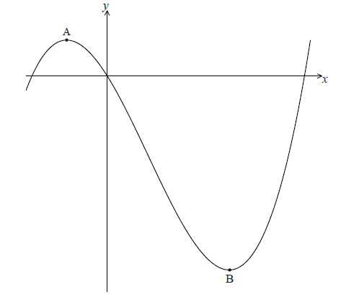

There is a maximum point at A and a minimum point at B(3, − 9) .

Find the coordinates of A.

## Markscheme

 ***A1A1A1***

evidence of solving  ***(M1)***

e.g. 

evidence of correct working ***A1***

e.g.  , 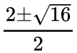

 (ignore  ) ***(A1)***

evidence of substituting **their** negative *x*-value into  ***(M1)***

e.g. 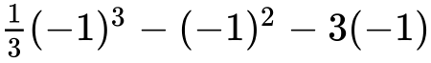 , 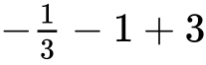

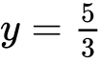 ***A1***

coordinates are 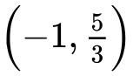 ***N3***

***[8 marks]***

**10b.** *[6 marks]*

Write down the coordinates of

(i) the image of B after reflection in the *y*-axis;

(ii) the image of B after translation by the vector 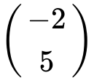 ;

(iii) the image of B after reflection in the *x*-axis followed by a horizontal stretch with scale factor  .

## Markscheme

(i)  ***A1 N1***

(ii)  ***A1A1 N2***

(iii) reflection gives  ***(A1)***

stretch gives 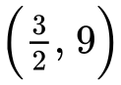 ***A1A1 N3***

***[6 marks]***

**11a.** *[5 marks]*

Let  , for  .

Use the quotient rule to show that 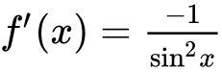 .

## Markscheme

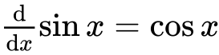 , 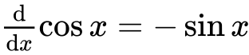 (seen anywhere) ***(A1)(A1)***

evidence of using the quotient rule ***M1***

correct substitution ***A1***

e.g. 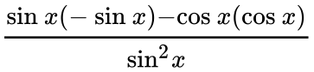 , 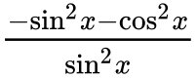

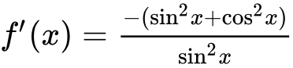 ***A1***

 ***AG N0***

***[5 marks]***

**11b.** *[3 marks]*

Find  .

## Markscheme

**METHOD 1**

appropriate approach ***(M1)***

e.g. 

 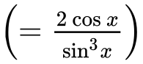 ***A1A1 N3***

**Note**: Award ***A1*** for  , ***A1*** for  .

**METHOD 2**

derivative of  (seen anywhere) ***A1***

evidence of choosing quotient rule ***(M1)***

e.g.  ,  , 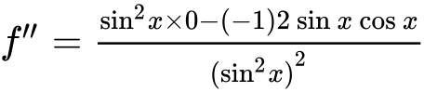

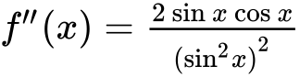  ***A1 N3***

***[3 marks]***

**11c.** *[3 marks]*

In the following table,  and  . The table also gives approximate values of  and  near  .

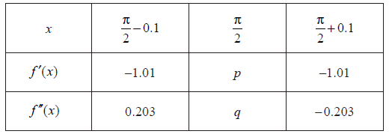

Find the value of *p* and of *q*.

## Markscheme

evidence of substituting  ***M1***

e.g. 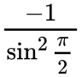 , 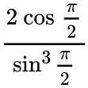

 ,  ***A1A1 N1N1***

***[3 marks]***

**11d.** *[2 marks]*

Use information from the table to explain why there is a point of inflexion on the graph of *f* where  .

## Markscheme

second derivative is zero, second derivative changes sign ***R1R1 N2***

***[2 marks]***

**12.** *[6 marks]*

Let  . The point  lies on the curve of *f* . At P, the normal to the curve is parallel to 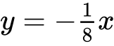 . Find the value of *k*.

## Markscheme

gradient of tangent  (seen anywhere) ***(A1)***

 (seen anywhere) ***A1***

recognizing the gradient of the tangent is the derivative  ***(M1)***

setting the derivative equal to 8  ***(A1)***

e.g.  , 

substituting  (seen anywhere) ***(M1)***

 ***A1 N4***

***[6 marks]***

**13a.** *[2 marks]*

Let . The equation  has two equal roots.

Write down the **value** of the discriminant.

## Markscheme

correct value , or  ***A2 N2***

***[2 marks]***

**13b.** *[1 mark]*

Hence, show that .

## Markscheme

correct equation which clearly leads to  ***A1***

*eg* 

 ***AG N0***

***[1 mark]***

**13c.** *[4 marks]*

The graph of has its vertex on the -axis.

Find the coordinates of the vertex of the graph of .

## Markscheme

**METHOD 1**

valid approach ***(M1)***

*eg* 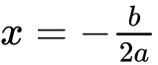

correct working ***A1***

*eg* 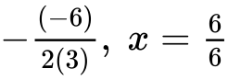

correct answers ***A1A1 N2***

*eg* 

**METHOD 2**

valid approach ***(M1)***

*eg* , factorisation, completing the square

correct working ***A1***

*eg* 

correct answers ***A1A1 N2***

*eg* 

**METHOD 3**

valid approach using derivative ***(M1)***

*eg* 

correct equation ***A1***

*eg* 

correct answers ***A1A1 N2***

*eg* 

***[4 marks]***

**13d.** *[1 mark]*

The graph of  has its vertex on the -axis.

Write down the solution of .

## Markscheme

 ***A1 N1***

***[1 mark]***

**13e.** *[1 mark]*

The graph of  has its vertex on the -axis.

The function can be written in the form . Write down the value of .

## Markscheme

 ***A1 N1***

***[1 mark]***

**13f.** *[1 mark]*

The graph of  has its vertex on the -axis.

The function can be written in the form . Write down the value of .

## Markscheme

 ***A1 N1***

***[1 mark]***

**13g.** *[1 mark]*

The graph of  has its vertex on the -axis.

The function can be written in the form . Write down the value of .

## Markscheme

 ***A1 N1***

***[1 mark]***

**13h.** *[4 marks]*

The graph of  has its vertex on the -axis.

The graph of a function  is obtained from the graph of  by a reflection of  in the -axis, followed by a translation by the vector 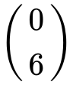. Find , giving your answer in the form .

## Markscheme

attempt to apply vertical reflection ***(M1)***

*eg* , sketch

attempt to apply vertical shift 6 units up ***(M1)***

*eg* , vertex 

transformations performed correctly (in correct order) ***(A1)***

*eg* 

 ***A1 N3***

***[4 marks]***

**14.** *[8 marks]*

The equation  has two distinct real roots.

Find the possible values of .

## Markscheme

evidence of discriminant ***(M1)***

*eg* 

correct substitution into discriminant ***(A1)***

*eg* 

correct discriminant ***A1***

*eg* 

recognizing discriminant is positive ***R1***

*eg* 

attempt to solve **their** quadratic in  ***(M1)***

*eg* factorizing, 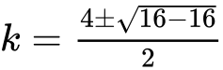

correct working ***A1***

*eg* , sketch of positive parabola on the *x*-axis

correct values ***A2 N4***

*eg* 

***[8 marks]***

**15a.** *[2 marks]*

Let  and 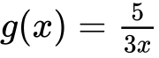, for .

Find .

## Markscheme

interchanging  and  ***(M1)***

*eg* 

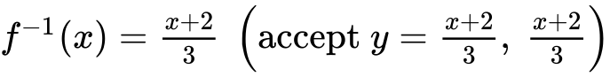 ***A1 N2***

***[2 marks]***

**15b.** *[2 marks]*

Show that 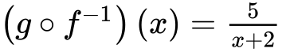.

## Markscheme

attempt to form composite (in any order) ***(M1)***

*eg* 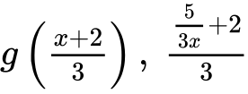

correct substitution ***A1***

*eg* 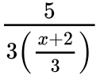

 ***AG N0***

***[2 marks]***

**15c.** *[2 marks]*

Let 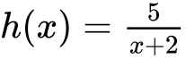, for . The graph of *h* has a horizontal asymptote at .

Find the -intercept of the graph of .

## Markscheme

valid approach ***(M1)***

*eg* 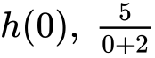

 ***A1 N2***

***[2 marks]***

**15d.** *[3 marks]*

Hence, sketch the graph of .

## Markscheme

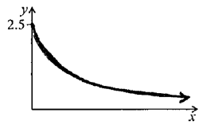 ***A1A2 N3***

**Notes:** Award ***A1*** for approximately correct shape (reciprocal, decreasing, concave up).

**Only** if this ***A1*** is awarded, award ***A2*** for all the following approximately correct features: *y*-intercept at , asymptotic to *x*-axis, correct domain .

If only two of these features are correct, award ***A1***.

***[3 marks]***

**15e.** *[1 mark]*

For the graph of , write down the -intercept;

## Markscheme

 ***A1 N1***

***[1 mark]***

**15f.** *[1 mark]*

For the graph of , write down the equation of the vertical asymptote.

## Markscheme

 (must be an equation) ***A1 N1***

***[1 mark]***

**15g.** *[3 marks]*

Given that , find the value of .

## Markscheme

**METHOD 1**

attempt to substitute  into  (seen anywhere) ***(M1)***

*eg* 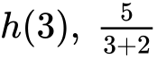

correct equation ***(A1)***

*eg* 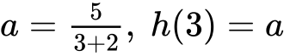

 ***A1 N2***

***[3 marks]***

**METHOD 2**

attempt to find inverse (may be seen in (d)) ***(M1)***

*eg* 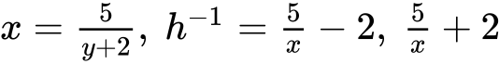

correct equation,  ***(A1)***

 ***A1 N2***

***[3 marks]***

**16a.** *[3 marks]*

Let .

Find the -intercepts of the graph of .

## Markscheme

valid approach ***(M1)***

*eg* , sketch of parabola showing two -intercepts

 ***A1A1 N3***

***[3 marks]***

**16b.** *[3 marks]*

The region enclosed by the graph of  and the -axis is rotated  about the -axis.

Find the volume of the solid formed.

## Markscheme

attempt to substitute either limits or the function into formula involving  ***(M1)***

*eg* 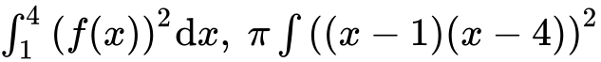

 ***A2 N3***

***[3 marks]***

Printed for Bronx Early College Academy

© International Baccalaureate Organization 2017

International Baccalaureate® - Baccalauréat International® - Bachillerato Internacional®