* 1. Angle Addition Postulate Classwork & HW

*10 points*

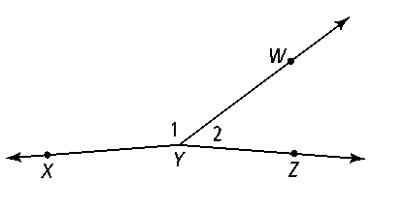**1.** What is another name for ∠*XYW?*

**2.** What is another name for ∠*WYZ?*

**Use the figure at the right for Exercises 3–6. *m*∠*FXH* = 130 and *m*∠*FXG* = 49.**

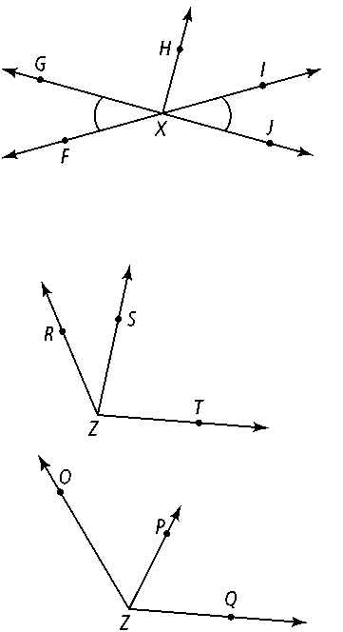**3.** ∠*FXG* ≅ 

**4.** *m*∠*GXH =* 

**5.** Name a straight angle in the figure.

**6.** ∠*IXJ* ≅



**7.** If *m*∠*RZT* = 110, *m*∠*RZS* = 3*s,* and *m*∠*TZS* = 8*s,* what are *m*∠*RZS* and *m*∠*TZS?*



**8.** *m*∠*OZP* = 4*r* + 2, *m*∠*PZQ* = 5*r* − 12, and *m*∠*OZQ* = 125. What are *m*∠*OZP* and*m*∠*PZQ?*