* 1. Solving for Angle Pairs Classwork & HW

*10 points*

**More Practice with the Angle Addition Postulate**

1. 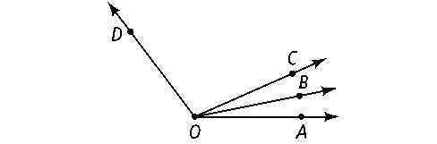*m*∠*AOB* = 4*x* − 1; *m*∠*BOC* = 2*x* + 15; *m*∠*AOC* = 8*x* + 8. Solve for *x.* Find the angle measures.

**2.** *m*∠*COD* = 8*x* + 13; *m*∠*BOC* = 3*x* − 10; *m*∠*BOD* = 12*x* − 6. Solve for *x.* Find the angle measures.

**Practice with Angle Relationships**

**3.** ∠*ABC* and ∠*EBF* are a pair of vertical angles; *m*∠*ABC* = 3*x* + 8 and *m*∠*EBF* = 2*x* + 48. What are *m*∠*ABC* and *m*∠*EBF?*

**4.** ∠*JKL* and ∠*MNP* are complementary; *m*∠*JKL* = 2*x* − 3 and *m*∠*MNP* = 5*x* + 2. What are *m*∠*JKL* and *m*∠*MNP?*

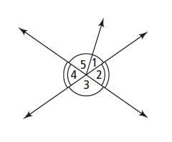**For Exercises 5–8, can you make each conclusion from the information in the diagram? Explain.**

**5.** ∠3 ≅ ∠4 **6.** ∠2 ≅ ∠4

**7.** *m*∠1 + *m*∠5 = *m*∠3 **8.** *m*∠3 = 90

**9.** ∠*MLN* and ∠*JLK* are complementary, *m*∠*MLN* = 7*x* − 1, and   
*m*∠*JLK* = 4*x* + 3.

**a.** Solve for *x.*

**b.** Find *m*∠*MLN* and *m*∠*JKL.*

**c.** Show how you can check your answer.

**10.** Write and solve an equation using *one of the angle relationships* to find the measure of an angle.