1b-3 Homework: Angle Pairs

**Use the diagram below. Is each statement true?**

1. 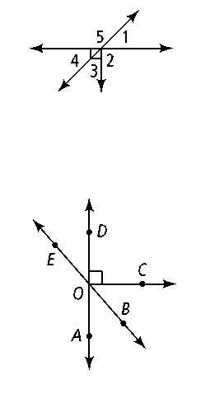**∠**2 and ∠5 are adjacent angles.

1. ∠1 and ∠4 are vertical angles.
2. ∠4 and ∠5 are complementary.

**Name an angle or angles in the diagram described by each of the following.**

1. complementary to ∠*BOC*

1. supplementary to ∠*DOB*

**6.** adjacent and supplementary to ∠*AOC*

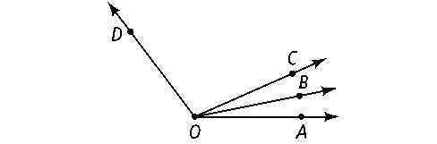**Use the diagram below for Exercise 7. Solve for *x.* Find the angle measures.**

**7.** *m*∠*COD* = 8*x* + 13; *m*∠*BOC* = 3*x* − 10; *m*∠*BOD* = 12*x* − 6

**8.** ∠*ABC* and ∠*EBF* are a pair of vertical angles; *m*∠*ABC* = 3*x* + 8 and *m*∠*EBF* = 2*x* + 48. What are *m*∠*ABC* and *m*∠*EBF?*

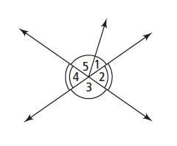**For Exercises 9–12, can you make each conclusion from the information in the diagram? Explain.**

**9.** ∠3 ≅ ∠4 **10.** ∠2 ≅ ∠4

**11.** *m*∠1 + *m*∠5 = *m*∠3 **12.** *m*∠3 = 90

 bisects ∠*PQR.* Solve for *x* and find *m*∠*PQR.***

**13.** *m*∠*PQS* = 3*x; m*∠*SQR* = 5*x* − 20