Homework:

1. Construct a perpendicular bisector of the given segment.

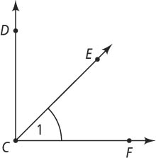

**Use the figure at the right.**

**2.** What are two other names for ∠1?

**3.** If *m*∠*DCF =* 90, *m*∠*DCE =* 3*x +* 12, and *m*∠*FCE =* 4*x +* 1, find the value of *x.*

**4.** Are ∠*DCE* and ∠*ECF* vertical, complementary, or supplementary angles, if *m*∠*DCF =* 90?

5. Construct the angle bisector of the given angle.