**1b-8 Pre-test: Constructions**

*Section 1: Show your knowledge of Euclid’s Elements.*

*Make the required construction using only a compass and straightedge*

*Extra: State the steps of the construction*

**Construct a perpendicular bisector of the given line segment**

A

B

**Construct an angle bisector of the given angle.**

A

*Section 2:* **Vocabulary**

Write the term that best completes each statement.

1. Points that are all located on the same line are __________________________.
2. A flat surface is a(n) ____________________.
3. The sum of the measures of supplementary angles is ___________________________.
4. Two angles with a common side and vertex, but no overlap are called _________________. In other words, they are next to each other.
5. Two or more line segments of equal measure are _______________________.
6. A(n) _______________________________ is a portion of a line that includes two points and all of the collinear points between the two points.
7. A(n) _______________________ is a portion of a line that begins with a single point and extends infinitely in one direction.
8. The measures of complementary angle sum to __________________________.
9. Two or more lines located in the same plane are __________________________.

**Homework: Pre-Quiz problems**

**1.** In the figure, given that , *AB* = *x* + 7, *BC* = 11. Solve for *x, AB, and BC.* Show each step.

Geometry (1 pt):



Substitute (1 pt):

Solve algebra:

*x =* (1 pt)

*AB =* (1 pt)

*BC =* (1 pt)

Check (1 pt):

**2.** Given two complementary angles,  and . If  then solve for the measure of . Show the steps.

Geometry (1 pt):

Substitute (1 pt):

Solve algebra (1 pt):

 *=*

Check (1 pt):

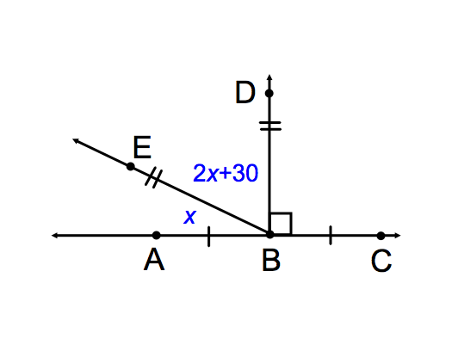**3)**Given the figure,  and . Solve for *x* and the angle measures. Show each the step.

Geometry (1 pt):

Substitute (1 pt):

Solve algebra:

*x =* (1 pt)

 *=* (1 pt)

 *=* (1 pt)

Check (1 pt):

**4)** Given that *JK =* 5*x*, *KL = x* + 2, and *JL = 20*. Find the value of *x, JK,* and *KL.* Show steps.

*K*

*L*

*J*

Geometry (1 pt):

Substitute (1 pt):

Solve algebra:

*x =* (1 pt)

*JK =* (1 pt)

*KL =* (1 pt)

Check (1 pt):

**18)**  and  are congruent angles. , and . Find *x* and the measure of each angle.

Geometry:

Substitute:

Solve algebra:

*x =*

**

**

Check:

**19)** Given  as shown in the figure. Solve for *x* and the measures of the two angles. Show the steps and check your result.

Geometry:

1 2

Substitute:

Solve algebra:

*x =*

**

**

Check:

**20)** Given *PQ* = 12 and *QR* = 3*x* + 3. Points *P, Q,* and *R* are collinear and *Q* bisects . Solve, check.

Geometry:

Substitute:

Solve algebra:

*x =*

*PQ =*

*QR =*

Check:

*The following pairs do not mean the same thing. Explain what they mean and what the difference is. Use complete sentences.*

**21)  , **

**22)  , **