**Homework**

**Find the perimeter of each figure.**

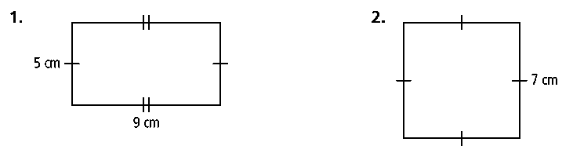**1. 2.**

**3.** An 8-ft-by-10-ft rug leaves 1 ft of the bedroom floor exposed on all four sides. Find the perimeter of the bedroom floor.

**Find the area of each shaded region. All angles are right angles.**

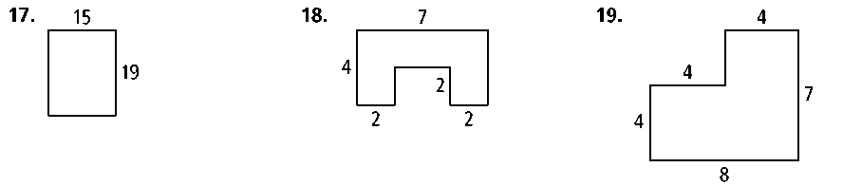**4. 5. 6.**