**Distance and Midpoint Task**

*20 points*

Ms. Guarnaccia and Ms. Johnsen want to take a trip to the mall to buy Beats for a friend who is moving. However, they have a very short time to shop for their friend. Ms. Guarnaccia printed a layout of the mall to map out their route. Use the map to answer the following questions. The black dots represent the doors to the mall or stores. You must use straight lines to answer the questions. Show all computations that lead up to your solutions.

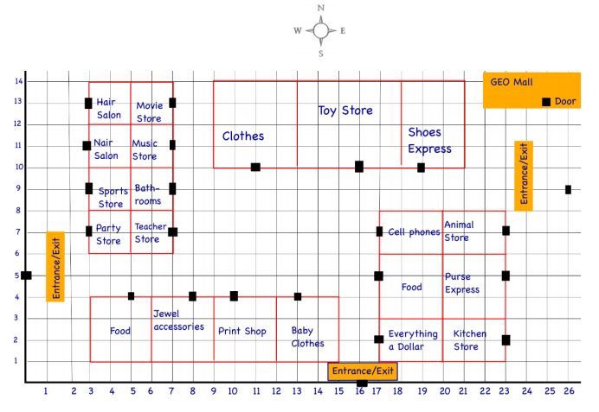Use the information and map above to answer the questions on the next page. Make sure to explain your work (whether it is algebraic or work done on the graph).

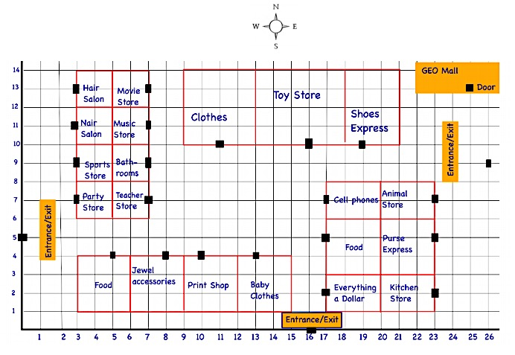

y

All units in feet!

x

**Distance and Midpoint Task**

*20 points*

1. Ms. Guarnaccia enters the mall at the East entrance to go to the Cell Phone store. After looking around for a while at the Cell Phone store, Ms. Johnsen calls Ms. Guarnaccia to say she is at the West entrance and wants to meet Ms. Guarnaccia at the midpoint of their two locations. Where would they meet? Use coordinates to represent their meeting location.

Ms. Guarnaccia’s Location ( _______ , ________ )

Ms. Johnsen’s Location ( ________ , ________ )

Formula to use: _____________________

Final Answer: ( ________, ________ )

1. After meeting at ( ______ , ______ ), are they closer to the Toy store or Music store? Write your answer in a ***complete*** sentence and include ***mathematical computations*** to justify your answer.

Toy Store Location (______ , ______ )

Music Store Location ( ______ , ______ )

Formula to use: _______________________________

Final Answer: ______________________________________________________________________  
__________________________________________________________________________________ __________________________________________________________________________________

1. After meeting up at the midpoint in part a ( _______ , ______ ), Ms. Guarnaccia and Ms. Johnsen decide to get some food before shopping for music. What is the distance they will travel to get to the door of the closest food place ( _______ , _______ )? *Round to the nearest tenth if necessary.*

Final Answer: _______________

1. After they finished eating at the food place ( _______ , _______ ) they went to the music store ( ______ , ______ ), bought some Beats for their friend, and then left the mall.

After leaving the music store, Ms. Johnsen went back to the original meeting place   
( _______ , _______ ), and then to the entrance she came in ( _______ , _______ ) .

* + 1. Illustrate Ms. Johnsen’s route on the map provided.
    2. What was Ms. Johnsen’s total distance that she traveled inside the mall (from entering the mall to leaving the mall? *Hint: Figure out each distance separately, then add them to get the total! Round to the nearest tenth if necessary.*

Final Answer: _______________

2.5: Applications of Midpoint & Distance Homework

**For Exercises 1–5, use the map at the right. The units of the map are in miles. Find the distance between the cities to the nearest tenth and show all of your work.**

1. 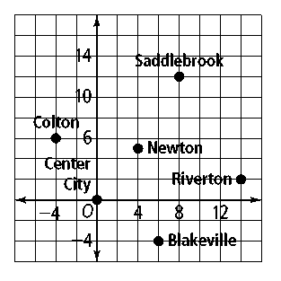Colton and Riverton
2. Saddlebrook and Riverton
3. Saddlebrook and Colton
4. Blakeville and Newton

**5.** List the cities in order of greatest to least distance from Center City.

**The units of the trail map at the right are in kilometers. Suppose the trails are straight. Find the distance you would travel along each trail to the nearest tenth of a kilometer and show all your work.**

1. 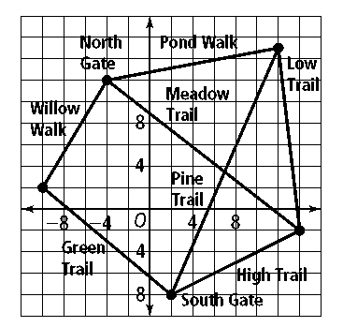Low Trail
2. Willow Walk
3. Pond Walk
4. Meadow Trail

10. Starting at South Gate, you walk to North Gate on Green Trail and Willow Walk. How much farther would you have to walk if you took High Trail to Meadow Trail?