

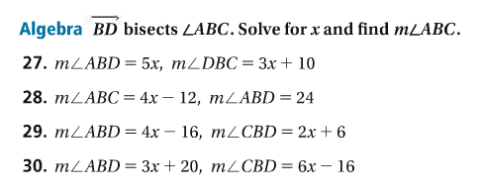















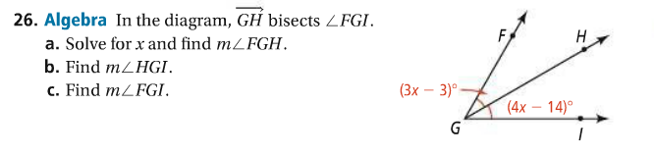

Screen%20Shot%202017-09-13%20at%206.29.27%20PM.png

